**MINISTRY OF EDUCATION AND TRAINING**

**FPT UNIVERSITY**

Capstone Project Document

Student and Business Website

|  |  |
| --- | --- |
| **Group 4** | |
| **Group member** | Nguyen Van Linh – Team Leader – SE60914  Hoang Ngoc Anh – Member – SE61099  Luong Quoc Trung – Team Member – SE60903 (dropped out)  Tran Hoang Hai – Member – SE60739  Vu The Anh – Member – 60111 (dropped out) |
| **Supervisor** | Mr. Nguyen Trong Tai |
| **Ext. Supervisor** | N/A |
| **Capstone Project code** | SBW |

-Ho Chi Minh City, 01/2015-

*This page is intentionally left blank*

***ACKNOWLEDGEMENTS***

We wish to thank various people for their contribution to this project: Our teachers for their advice and participation in the final review, our friends for their valuable technical support.

Special thanks should be given to Mr. Nguyen Trong Tai, ME our research supervisor for his professional guidance and the useful, constructive recommendations throughout the course of this project.

# Table of Contents

Table of Contents 4

Definitions, Acronyms, and Abbreviations 7

A. Introduction 8

1. Project Information 8

2. Introduction 8

3. Problem Definition 8

4. Proposed Solution 8

4.1 Feature functions 8

4.2 Advantage and disadvantage 8

5. Functional Requirement 10

5.1 User: 10

5.2 Admin: 10

5.3 Staff: 10

5.4 System: 10

6. Role and Responsibility 10

B. Software Project Management Plan 11

1. Problem Definition 11

1.1 Name of this Capstone Project 11

1.2 Problem Abstract 11

1.3 Project Overview 11

2. Project organization 13

2.1 Software Process Model 13

2.2 Roles and responsibilities 13

2.3 Tools and Techniques 14

3. Project Management Plan 15

3.1 Iteration 15

3.2 Iteration Detail 17

3.3 All Meeting Minutes 19

4. Coding Convention 20

C. Software Requirement Specification 21

5. User Requirement Specification 21

5.1 Guest Requirement 21

5.2 User Requirement 21

5.3 Staff Requirement 21

5.4 Administrator Requirement 21

5.5 System Requirement 21

6. System Requirement Specification 22

6.1 External Interface Requirement 22

6.2 System Overview Use Case 23

6.3 List of Use Case 24

7. Software System Attribute 67

7.1 Usability 67

7.2 Reliability 67

7.3 Availability 67

7.4 Security 68

7.5 Maintainability 68

7.6 Portability 68

7.7 Performance 68

8. Conceptual Diagram 69

Data Dictionary 69

D. Software Design Description 69

1. Design Overview 69

2. System Architectural Design 71

2.1 Web Architecture 71

2.2 Mobile Architecture 72

2.3 Webservice Architecture 73

3. Component Diagram 74

4. Detailed Description of Components 74

4.1 Class Diagram 75

4.2 Class Diagram Explanation 76

4.3 Sequence Diagram 80

5. User Interface Design 89

5.1 Web application 89

5.2 Mobile Application 96

6. Database Design 110

6.1 Webservice 110

6.2 Mobile Application 112

6.3 Web Application 112

7. Algorithms 112

7.1 Reconigze book on Web (JS Toolkit) 112

7.2 Reconigze book on mobile (Vuforia platform) 112

E. System Implementation & Test 112

1. Introduction 112

1.1 System Overview 112

1.2 Test Approach 112

2. Database Relationship Diagram 113

2.1 Diagram 113

2.2 Data Dictionary 114

3. Performance Measures 119

3.1 Vuforia recognize 119

3.2 JS Toolkit recognize 119

3.3 Send request to REST Web service 119

4. Test Plan 119

4.1 Features to be tested 119

4.2 Features not to be tested 119

4.3 Acceptance test criteria 120

5. System Testing Test Case 121

5.1 Web application 122

5.2 Mobile application 129

F. Software User’s Manual 137

1. Installation guide 137

1.1 Setting up environment at server side and client side 137

1.2 Deployment at server side 138

1.3 Deploy at client side 139

2. User Guide 143

2.1 Web application guide 143

2.2 Mobile User Guide 150

G. Appendix 173

# List of figures

Figure 1: Modified Waterfall Development Model 17

Figure 2: System Overview Use Case 27

Figure 3: < Administrator > Overview Use Case 28

Figure 4: < Administrator > Manage user account – Create staff account use case diagram 28

Figure 5: <Administrator> Manage user account – Deactivate user use case diagram 30

Figure 6<Administrator> Manage user account – Activate user use case diagram 32

Figure 7: <Administrator> Logout use case diagram 33

Figure 8: <System> Overview Use Case 34

Figure 9: <System>Notify suggestion book use case diagram 35

Figure 10: <System> Notify reading schedule use case diagram 36

Figure 11: <System> Notify book’s license expired use case diagram 37

Figure 12: <System> Auto parse use case diagram 39

Figure 13: <System>Streaming use case diagram 41

Figure 14: <Staff> Overview Use Case 42

Figure 15: <Staff> Insert resource use case diagram 42

Figure 16: <Staff> Delete resource use case diagram 46

Figure 17: <Staff> Update resource use case diagram 48

Figure 18: <User> Overview Use Case 52

Figure 19: <User>Read Book Use case diagram 53

Figure 20: <User> Read book – Play sound use case diagram 53

Figure 21: <User> Read book - Watch video 55

Figure 22: <User> Read book - Watch video use case specification table 56

Figure 23: <User> Add to Cart Use case diagram 60

Figure 24: <User> Configure schedule use case diagram 62

Figure 25: <User> Add to favourite books list use case diagram 64

Figure 26: <User> View history books use case diagram 66

Figure 27: <User> Suggest book use case diagram 68

Figure 28: <Guest> Login use case diagram 70

Figure 29: <Guest> Register Use case diagram 71

Figure 30: Conceptual diagram 74

Figure 31: MVC Architecture 76

Figure 32: Mobile application architecture diagram 77

Figure 33: Webservice architecture diagram 78

Figure 34: Component Diagram 79

Figure 35: Class Diagram 80

Figure 36: Notify reading schedule sequence diagram 86

Figure 37: Notify expired book sequence diagram 86

Figure 38: Notify suggested book sequence diagram 87

Figure 39: Recognize book sequence diagram 88

Figure 40: Read book – Play audio sequence diagram 89

Figure 41:: Read book – watch video sequence diagram 90

Figure 42:: Read book - read ebook sequence diagram 91

Figure 43: Search book sequence diagram 91

Figure 44: Buy book online sequence diagram 92

Figure 45: Upgrade license sequence diagram 92

Figure 46: Configure reading schedule sequence diagram 93

Figure 47: View history book sequence diagram 93

Figure 48: Suggest book sequence diagram 94

Figure 49: Web App - Home page user interface 95

Figure 50: Web App - Login Page user interface 96

Figure 51: Web App - Setting schedule page user interface 97

Figure 52: Web App - Recognize user interface 98

Figure 53: Web App - Read book user interface 99

Figure 54: Web App - Read ebook user interface 100

Figure 55: Web App - Read book - watch video user interface 100

Figure 56: Web App - Read book - play audio 101

Figure 57: Web App - Upgrade license user interface 101

Figure 58: Mobile App – Login user interface 102

Figure 59: Mobile App - Recognize book user interface 104

Figure 60: Mobile App - Book detail user interface 105

Figure 61: Mobile App - Enter license code user interface 106

Figure 62: Mobile App - Read ebook user interface 107

Figure 63: Mobile App - watch video user interface 109

Figure 64: Mobile App - Play audio user interface 110

Figure 65: Mobile App - Enter secondary password user interface 112

Figure 66: Mobile App - Set schedule user interface 113

Figure 67: Mobile App - choose time user interface 115

Figure 68: Mobile App - Choose working day user interface 116

Figure 69: Mobile App - Recognize image 3D user interface 117

Figure 70: Mobile App - 3D model user interface 118

Figure 71: Entity Relationship Diagram 119

Figure 72: Database Relationship Diagram 135

Figure 73: GUEST CORE FLOW 143

Figure 74: USER CORE FLOW 144

Figure 75: CPM package and deploy directory 160

Figure 76: Installation - Change security setting 161

Figure 77: Installation - Copy arbmobile.arb to sdCard 162

Figure 78: Installation - choose package installer 162

Figure 79: Installation - Instal Mobile App 163

Figure 80: Finish install 163

Figure 81: Login Page 164

Figure 82: Setting schedule page 165

Figure 83: Recognize UI 166

Figure 84: Read book page 167

Figure 85: Update license page 168

Figure 86: View Cart Page 169

Figure 87: Mobile App – Login user guide 170

Figure 88: Mobile App - Recognize book user guide 171

Figure 89: Mobile App - Book detail user guide 172

Figure 90: Mobile App - Enter license code user guide 173

Figure 91: Mobile App - Read ebook user guide 174

Figure 92: Mobile App - watch video user guide 175

Figure 93: Mobile App - Play audio user guide 176

Figure 94: Mobile App - Enter secondary password user guide 177

Figure 95: Mobile App - Set schedule user guide 178

Figure 96: Mobile App - choose time user guide 179

Figure 97: Mobile App - Choose working day user guide 180

Figure 98: Mobile App - Recognize image 3D user guide 181

Figure 99: Mobile App - 3D model user guide 181

# List of Tables

Table 1: Definitions, Acronyms and Abbreviations 12

Table 2: Roles and Responsibility 14

Table 3: Hardware Requirement for Server 16

Table 4: Hardware Requirement for Mobile App 16

Table 5: Roles and Responsibility Details 18

Table 6: Iteration 20

Table 6: Phase 1: Preliminary Investigation or Analysis 21

Table 7: Phase 2: Data Management 21

Table 8: Phase 3: Main User’s Functions 23

Table 9: Phase 4: Suggestion Algorithm 23

Table 10: < Administrator > Manage user account – Create staff account use case specification table 30

Table 11: <Administrator> Manage user account – Deactivate user use case specification table 31

Table 12: <Administrator> Manage user account – Activate user use case specification table 33

Table 13: <Administrator> Logout use case specification table 34

Table 14: <System>Notify suggestion book use case specification table 36

Table 15: <System> Notify reading schedule use case specification table 37

Table 16: <System> Notify book’s license expired use case specification table 38

Table 17: Auto parse use case specification table 40

Table 18: <System>Streaming use case specification table 42

Table 19: <Staff> Insert resource use case specification table 46

Table 20: <Staff> Delete resource use case specification table 47

Table 21: <Staff> Update resource use case specification table 51

Table 22: <User> Read book – Play sound use case specification table 54

Table 23: <User> Read book - Read ebook 56

Table 24: <User> Configure schedule use case specification 64

Table 25: <User> Add to favourite books list use case specification table 65

Table 26: <User> View history books use case specification table 67

Table 27: <User> Suggest book use case specification table 69

Table 28: <System> Overview Use Case 69

Table 29: Login use case specification table 71

Table 30: <Guest> Register Use case specification table 72

Table 31: Entity Data dictionary - Describe content of all entities 74

Table 32: Data dictionary 120

Table 33: Data Dictionary 136

Table 34: Attribute data dictionary 140

Table 35: Web App - Search book test case 145

Table 36: Web App - Input code to read book test case 147

Table 37: Web App - Setting schedule test case 150

Table 38: Web App - Read book test case 150

Table 39: Web App - Add to cart test case 151

Table 40: Web App - Update license test cases 151

Table 41: Mobile App - <Guest>Recoginze book test case 152

Table 42: Mobile App - <Guest>Read ebook test case 152

Table 43: Mobile App - <Guest>Watch video test case 153

Table 44: Mobile App - <Guest> Play audio test case 154

Table 45: Mobile App - 3D dictionary test case 154

Table 46: Mobile App - <User> Setting schedule test case 155

Table 47: Mobile App - <User> Read ebook test case 157

Table 48: Mobile App - <User> Watch video test case 158

Table 49: Mobile App - <User> Play audio 159

Table 50: Hardware Requirement for Server 160

Table 51: Hardware Requirement for Mobile App 160

Table 52: Login Steps 164

Table 53: Setting schedule Steps 165

Table 54: Recognize steps 166

Table 55: Read book info 167

Table 56: Update license info 168

Table 57: View Cart Info 169

Table 58: Mobile App - Login user guide steps 170

Table 59: Mobile App - Recognize book user guide steps 171

Table 60: Mobile App - Read book user guide steps 172

Table 61: Mobile App - Enter license code user guide steps 173

Table 62: Mobile App - Read ebook user guide steps 174

Table 63: Mobile App - watch video user guide steps 175

Table 64: Mobile App - Play audio user guide steps 176

Table 65: Mobile App - Enter secondary password user guide steps 177

Table 66: Mobile App - Set schedule user guide steps 178

Table 67: Mobile App - choose time user guide steps 179

Table 68: Mobile App - choose working day steps 180

Table 69: Mobile App - Recognize image 3D user guide steps 181

Table 70: Mobile App - 3D model user guide steps 181

# Definitions, Acronyms, and Abbreviations

|  |  |  |
| --- | --- | --- |
| **No.** | **Abbreviation & Acronym** | **Definition** |
|  |  |  |

**Table 1: Definitions, Acronyms and Abbreviations**

# Introduction

## Project Information

* Project name: **Student and Business Website**
* Project Code: **SBW**
* Product Type: **Website Application**
* Start Date: **: Jan 6th, 2015**
* End Date: **May 2nd, 2015**

## Introduction

Nowadays, student have free time and want to find job get more income and experience. In other side, employers need to recruit suitable candidates in the shortest time. Our system automatic search candidates and notify for them.

Also, websites can support online contest in other to help business decrease time instead of traditional interview. Business, school can create an event and system will announce to students. System supports sharing material between students depending on hobbies, skills and jobs.

The goal of the website is to facilitate communication and sharing information between students and businesses, and also between students together.

## Current Situation

User must have register to use this web application. User can search job want to join or create a job to employ. After that, business can meet student to discussion about their job.

In Vietnam, all most websites don’t support all the features that we extend to provide, such as: jobstreet.vn only support job recruiting, freelancer.com don’t support event…

So inclusion, we create all-sided solution to solve above problems.

## Problem Definition

Users want to find job, and suppliers want to find out candidates for their work. But the interaction between them is not efficient, such as employees need to find jobs, but they don’t have chance to review or heard from others about the job that employers provide.

People who want to take job do not have place to discuss about the job or career that they care together.

students want to share information and some knowledge for group or anyone have same hobby or jobs, but almost websites for job seeking not have function share or comment to people know or learn skill for that job.

## Proposed Solution

Website will auto find candidate for job which had been created on website, after website will notify information’s students about that job to employer and notify to all students had been match with that job. Help employer can make a contest online to filter candidate if have more than they needs. When a student upload a material, system will auto suggest students’ needs that material, they have same hobbies, group or companies.

### Feature functions

* Create form recruitment online with skill, category, age, time …
* Auto suggest students base on skill, category, age, time... From form recruitment.
* Auto notify for both students and employer about jobs, list candidate.
* Auto suggest student have same skill, categories... to share material.
* Create test for students if employer need small quantity while website have more.

### Advantage and disadvantage

The advantages and disadvantages of the proposed solution:

* Advantages:
* Help employer can find candidates in short time, may be some minutes. And can help them contact with those candidates.
* Quick select candidates after employer have a large list candidates.
* Share material between students with other student.

+ Disadvantages:

* Cannot manage result contest because they can do contest with help of other people.
* Not support for students after they graduate.

## Functional Requirement

Function requirement of the system are listed as below:

* User:
* View all employer post.
* Apply job, event.
* Search job posted.
* Employer:
* Manage job, contest, and event.
* Manage student apply job, event, contest.
* Send message to student.
* Staff:
* Manage all job, event.
* Admin:
* Mange all accounts.
* System:
* Make notification.
* Suggestion or recommendation job for student, student for employer.

## Role and Responsibility

|  |  |  |  |  |
| --- | --- | --- | --- | --- |
| No | Full Name | Role | Position | Contact |
| 1 | Nguyen Trong Tai | Project Manager | Instructor | TaiNT@fpt.edu.vn |
| 2 | Nguyen Van Linh | Developer | Leader | Linhnvse60914@fpt.edu.vn |
| 3 | Hoang Ngoc Anh | Developer | Member | Anhhnse61099@fpt.edu.vn |
| 4 | Luong Quoc Trung | Developer | Member | Trunglqse60903@fpt.edu.vn |
| 5 | Tran Hoang Hai | Developer | Member | Haithse60739@fpt.edu.vn |
| 6 | Vu The Anh | Developer | Member | AnhVT60111@fpt.edu.vn |

Table 2: Roles and Responsibility anhd

# Software Project Management Plan

## Problem Definition

### Name of this Capstone Project

Student and Business Website (SBW)

### Problem Abstract

Nowadays, the unemployment rate for students in Viet Nam is quite high. Having a part-time job allows students to get life experiences and work skills, which will help them have solid foundations to work after graduating. But the most difficulty is how students can find jobs easily and how employers can recruit suitable students quickly. Therefore, this website will help both students and employers be able to connect to each other.

The website will manage users and recruitments. Besides, the website can find the applicants with hiring jobs, events or competitions automatically.

Furthermore, the website also holds the online competitions for students or supports online tests for the recruitments, which helps decrease recruitment time of some jobs having the large number of applicants.

### Project Overview

#### Problem Definition

(Tiếng việt)

Hiện tại website chỉ tập trung hỗ trợ sinh viên trong thời gian đi học nên chưa giải quyết dc vấn đề lớn hơn là sinh viên sau khi ra trường.

At the moment, web only support for student while studying at shool,

Ưu điểm :

Giup sinh vien tim dc viec lam phu hop nhanh chong.

Doanh nghiệp có thể tìm kiếm đc nguồn sinh viên có nhu cầu làm them cho nhưng công việc cần người gấp.

Nhược điểm :

#### The Proposed System

##### Web Application

**Student Requirement**

* Manage Profile
* Manage Job
* Manage Material
* Manage Contest
* Manage Test Bank
* Manage All Events
* Manage Account
* Automatic random questions for contest
* Automatic suggest questions for contest
* Automatic suggest candidates for employer
* Automatic suggest event for students
* Automatic suggest job for students
* Admin can manage the systems, manage account, and configure systems.
* Staff can manage content resources.
* System can timer reading schedule depend on user’s license, configuration.

##### Mobile Application

#### Boundaries of the System

Language : Vietnamese.

Website, server,…

#### Development Environment

##### Hardware requirements

**For Server**

|  |  |  |
| --- | --- | --- |
| Windows | Minimum Requirements | Recommended |
| Internet Connection | Cable, Wifi (8 Mbps) | Cable, Wifi (20 Mbps) |
| Operating System | XP, Vista, 7, 8 | XP, Vista, 7, 8 |
| Computer Processor | Intel® Core 2 Quad | Intel® Core(TM) i5 CPU , M 460 @ 2.53GHz |
| Computer Memory | 4GB RAM | 8GB or more |

Table 2: Hardware Requirement for Server

##### Software requirements

**For Client :**

* Internet explorer 8 and above, google chrome, fire fox.

**For develop website :**

* **SQL Server 2008 Enterprise R2**: used to create and manage the database for system.
* **Visual Studio 2013**: used to implement website and web service.
* **StarUML 2.0** : used to create models and diagrams.
* **Skype, facebook.com**: used for communication and meeting.
* **Dropbox**: sharing document.

## Project organization

### Software Process Model

Figure 1: Modified Waterfall Development Model

For more information: <http://www.waterfall-model.com/sashimi-waterfall-model/>

### Roles and responsibilities

|  |  |  |  |
| --- | --- | --- | --- |
| **No** | **Full name** | **Role in Group** | **Responsibilities** |
| **1** | Nguyen Trong Tai | Project manager | * Specify user requirement * Control the development process * Give out technique and business analysis support |
| **2** | Nguyen Van Linh | Leader | * Managing process * Prepare documents * Create test plan * GUI Design * Designing database |
| **3** | Luong Quoc Trung | Team member | * Coding, testing * Prepare documents * GUI Design |
| **4** | Hoang Ngoc Anh | Team member | * Coding, testing * Prepare documents |
| **5** | Tran Hoang Hai | Team member | * Coding, testing * Prepare documents |
| **6** | Vu The Anh | Team member | * Coding, testing * Prepare documents |

Table 4: Roles and Responsibility Details

### Tools and Techniques

- Front-end technologies: HTML5, CSS3, JavaScript, jQuery, AJAX.

- Back-end:

* Website: J2EE MVC.
* Web Service: Web API RESTFUL.
* Mobile App: Android - Java.
* Analysis image capture: Vuforia platform.

- Web Server: Apache Tomcat 6.

- Database Management System: My SQL Server.

## Project Management Plan

### Iteration

|  |  |  |  |  |  |
| --- | --- | --- | --- | --- | --- |
| **Phase**  **/Iteration** | **Description** | **Deliverables** | **Resource needed** | **Dependencies and Constrains** | **Risks** |
| **Inception Phase** | * [Stakeholder](http://en.wikipedia.org/wiki/Stakeholder_(corporate)#In_management) concurrence on scope definition and cost/schedule estimates. * Requirements understanding as evidenced by the fidelity of the primary use cases. * Credibility of the cost/schedule estimates, priorities, risks, and development process. * Depth and breadth of any architectural prototype that was developed. * Establishing a baseline by which to compare actual expenditures versus planned expenditures. | -Introduction of proposed system.  -Main functions.  -Project Iteration Plan. | 15 man-days | N/A | Project may  not be feasible  for developing  because lack of technologies  and/or data |
| **Elaboration Phase** | * A use-case model in which the use-cases and the actors have been identified and most of the use-case descriptions are developed. The use-case model should be 80% complete. * A description of the software architecture in a software system development process. * An [executable architecture](http://en.wikipedia.org/wiki/Executable_Architecture) that realizes architecturally significant use cases. * Business case and risk list which are revised. * A development plan for the overall project. * Prototypes that demonstrably mitigate each identified technical risk. * A preliminary user manual (optional) | - Prototype design  - Software requirement specification  - Data management service. | 15 man-days | N/A | Poor design |
| **Construction Phase** | * The primary objective is to build the software system. In this phase, the main focus is on the development of components and other features of the system. This is the phase when the bulk of the coding takes place. In larger projects, several construction iterations may be developed in an effort to divide the use cases into manageable segments that produce demonstrable prototypes. * This phase produces the first external release of the software. Its conclusion is marked by the Initial Operational Capability Milestone. | - Main user’s functions on web and mobile.  - User account management system  - Suggestion services | 30 man-days | Depend on “Data management”. | Lack of experience.  Not have a clear understanding about business process. |
| **Transition Phase** | * The primary objective is to 'transit' the system from development into production, making it available to and understood by the end user. The activities of this phase include training the end users and maintainers and beta testing the system to validate it against the end users' expectations. The product is also checked against the quality level set in the Inception phase. * If all objectives are met, the Product Release Milestone is reached and the development cycle is finished. | - Test and release.  - Build future plan. | 20 man-days | Depends on “main functions’ development”. | The implemented algorithm is not the best.  Lack of test data. Lack of experience on making and deploying web service. |

Table 5: Iteration

### Iteration Detail

#### Phase 1: Inception

|  |  |  |
| --- | --- | --- |
| **Task** | **Description** | **Author** |
| **1. Identifying and studying existing systems** | Find which systems currently provide similar service, their strengths and weakness. | HienPNB, VuTV, TrungPT, AnhMHT |
| **2. Identifying and clarifying main functions.** | Define which main functions system should provide. | HienPNB |
| **3. Introduction.** | Complete Introduction Report. | TrungPT, AnhMHT, HienPNB |
| **1. Identifying Requirement and Planning** | Which feature this function should have and how to implement. | HienPNB |
| **4. Project Management**  **Plan.** | Prepare Project  Management Plan. | HienPNB, TrungPT |

Table 6: Phase 1: Preliminary Investigation or Analysis

#### Phase 2: Elaboration

|  |  |  |
| --- | --- | --- |
| **Task** | **Description** | **Author** |
| **5. Website Prototype.** | Build a prototype of proposed system (Website). | TrungPT, AnhMHT |
| **6. Mobile Prototype.** | Build a prototype of proposed system (Mobile App). | HienPNB |
| **7. Webservice.** | Build a demo webservice of proposed system. | VuTV |
| **8. Design ER diagram.** | Design ER diagram. | HienPNB, VuTV |
| **2. Manage data on cloud** | Create/Edit targets as the schema on cloud of Vuforia platform | VuTV, HienPNB |
| **3. Build up webservice** | Build a webservice that manage database on clould | VuTV |
| **4. Build up android application** | Build an application to reconigze image and get target on cloud of Vuforia. | HienPNB |
| **4. Implement GUI** | Create the interface for user. | HienPNB, AnhMHT, TrungPT |
| **5. Testing** | Test system behavior and  performance  Test user behavior and  performance | HienPNB, VuTV, TrungPT, AnhMHT |
| **6. Document** | Adding SRS, SDD,  Installation Guide, Manual  Guide | HienPNB, VuTV, TrungPT, AnhMHT |

Table 7: Phase 2: Data Management

#### Phase 3: Contruction

|  |  |  |  |
| --- | --- | --- | --- |
| **Task** | **System Component** | **Description** | **Author** |
| **1. Identifying Requirement and Planning** |  | Which feature this function should have and how to implement. | HienPNB, VuTV, TrungPT, AnhMHT |
| **2. Manage User** | Webservice | Provides service for manage user | VuTV |
| **3. Manage Book** | Provides service for manage resource |
| **4. Manage target on cloud** | Provides service for manage targets on cloud |
| **5. Recorgnize image and read book** | Android | Allow user using camera to capture image and read book | HienPNB |
| **6. Search books** | Allow user search book to buy |
| **7. Load next chapter** | Load next chapter when view previos chapter |
| **8. Keep track reading status** | Record status of user (pages of reading, time of viewing) for the next reading. |
| **9. Schedule for parents** | Allows user to set reading schedule daily. |
| **10. Buy license** | Allow user buy/ extend license |
| **11. Manage user’s books** | Allow user manage their books |
| **12. Manage user** | Web application | Allow admin manage user | AnhMHT, TrungPT |
| **13. Load next chapter** | Load next chapter when view previos chapter |
| **14. Keep track reading status** | Record status of user (pages of reading, time of viewing) for the next reading. |
| **15. Schedule for parents** | Allows user to set reading schedule daily. |
| **16. Manage inbox** | Allow user manage their inbox |
| **17. Search book** | Allow user search book’s information |
| **18. Suggest book** | Recommend books for user |
| **19. Testing** | N/A | Test system behavior and  performance  Test user behavior and  performance | HienPNB, VuTV, TrungPT, AnhMHT |
| **20. Document** | N/A | Adding SRS, SDD,  Installation Guide, Manual  Guide | HienPNB, VuTV, TrungPT, AnhMHT |

Table 8: Phase 3: Main User’s Functions

#### Phase 4: Transition

|  |  |  |
| --- | --- | --- |
| **Task** | **Description** | **Author** |
| **1. Identifying Requirement and Planning** | Which feature this function should have and how to implement. | HienPNB, VuTV, TrungPT, AnhMHT |
| **2. Testing** | Test system behavior and performance. | HienPNB, VuTV, TrungPT, AnhMHT |
| **3. Document** | Adding SRS, SDD,  Installation Guide, Manual  Guide | HienPNB, VuTV, TrungPT, AnhMHT |

Table 9: Phase 4: Suggestion Algorithm

### All Meeting Minutes

Refer to Meeting Minutes folder.

## Coding Convention

Summary:

* Naming Convention.
  + Use camel case for both variable and function name.
  + Use pascal case for class name.
* Indentation.
  + Four spaces should be used as the unit of indentation. The exact construction of the indentation (spaces vs. tabs) is unspeciﬁed. Tabs must be set exactly every 8 spaces (not 4).
  + Avoid lines longer than 80 characters, since they’re not handled well by many terminals and tools.
* Declaration.
  + One declaration per line is recommended since it encourages commenting.
  + In absolutely no case should variables and functions be declared on the same line.
  + Do not put different types on the same line.
* Code Examples

Follow “Code Conventions for the Java TM Programming Language, by Sun Microsystems, rev April 20, 1999”.

<http://www.oracle.com/technetwork/java/codeconventions-150003.pdf>

# Software Requirement Specification

## User Requirement Specification

### Guest Requirement

Guest is a person who doesn’t have access to the system. Guest can use some functions in the system. To use all functions, guest must login. These are some functions guest can use:

* Register.
* Search books.
* Login.

### User Requirement

User is guest who uses his account to login to the system. User can use additional functions, such as:

* Read books.
* Suggest books.
* Buy reading license.
* Upgrade license.
* Configure schedule.
* Add book to favourite list.
* Update profile.
* View history books.
* Logout

### Staff Requirement

Staff is the person who manages all Books. Staff can use these functions:

* Manage resource
  + Audio (support .mp3, .wma, .wav extension file from other website video streaming)
  + Video (support .mp4, .avi, .wmv, .flv extension file from other website video streaming)
  + E-book (support .jpg, .png, .gif extension file download from storage server)

### Administrator Requirement

Administrator is the person who manages all users and staffs. Administrator can use these functions:

* Manage user account.

### System Requirement

System is also an actor, run in the background to keep the system working. System can do functions:

* Send notification to user.
  + Notify user of suggested books basing on category that user read book, view number of a book and recent added book.
  + Notify user when they have read the final chapter in their reading license.
  + Notify user of reading time-out basing on their reading schedule.
* Get streaming from other sources.

## System Requirement Specification

### External Interface Requirement

#### User Interface

* The interface of website is clear, easy for user to use (Firefox Browser, Chromes with Resolution 1024*768 or bigger).
* The interface of mobile app must be clear and colorful to impress children, and must be compatible with touch screen. The size of controls must be big enough to touch on smartphone (70 x 120 mm or bigger).

#### Hardware Interface

* N/A

#### Software Interface

* Firefox Browser, Chromes with Resolution 1024*768 or bigger and support JavaScript and HTML5
* Smartphone with Android 4.0 or above. Screen size 70 x 120 mm or bigger.

#### Communication Protocol

* Website using HTTP protocol for communication between the web browser and the web server.
* Mobile app using HTTP protocol for communicating between app and web service.

### System Overview Use Case



Figure 2: System Overview Use Case

### List of Use Case

#### < Administrator >Overview Use Case



Figure 3: < Administrator > Overview Use Case

##### <Administrator > Manage user account – Create staff account

Use Case Diagram



Figure 4: < Administrator > Manage user account – Create staff account use case diagram

Use Case Specification

|  |  |  |  |
| --- | --- | --- | --- |
| **USE CASE – ARB01** | | | |
| **Use Case No.** | ARB01 | **Use Case Version** | 1.0 |
| **Use Case Name** | Create staff account | | |
| **Author** | Pham Nguyen Bich Hien | | |
| **Date** | 31/05/2014 | **Priority** | High |
| **Actor:**   * Administrator.   **Summary:**   * This use case allows Administrator to create new staff.   **Goal:**   * Add new staff to system.   **Triggers:**   * Administrator want to add more staffs to manage books.   **Preconditions:**   * Login to system with role Administrator.   **Post Conditions:**   * **Success**: New staff will be created in database. * **Fail:** No staffs will be created. Show error message.   **Main Success Scenario:**   |  |  |  | | --- | --- | --- | | Step | Actor Action | System Response | | 1 | User choose “Tạo nhân viên” function | Navigate to administrator page which contains:   * Tên đăng nhập: textbox, min length: 6, max length: 30, required. * Vai trò: drop-down list, raw source: “Người quản trị”, “Nhân viên” và “Người dùng”, default value: “Nhân viên”, required. * Tên đầy đủ: textbox, min length: 6, max length: 50, required * Email: textbox, min length: 6, max length: 50, regular expression: “^[_A-Za-z0-9-\\+]+(\\.[_A-Za-z0-9-]+)*@[A-Za-z0-9-]+(\\.[A-Za-z0-9]+)*(\\.[A-Za-z]{2,})$”, required * Tạo tài khoản: button. * Xóa trắng: button. | | 2 | Admistrator fills data to the form. |  | | 3 | Administrator clicks “Tạo nhân viên” button. [Alternative 1], [Exception 1, 2, 3, 4, 6, 7] | Insert new user account to the database and redirect to administrator page. |   **Alternative Scenario:**   |  |  |  | | --- | --- | --- | | No | Actor Action | System Response | | 1 | Administrator clicks “Xóa trắng button”. | Clear all input data. |   **Exceptions:**   |  |  |  | | --- | --- | --- | | No | Actor Action | System Response | | 1 | Length of username is not in range. | Show error message: “Độ dài username phải từ 6-30 ký tự!” | | 4 | Role is not specified. | Show error message: “Phải phân quyền cho user!” | | 5 | Email is not match regular expression | Show error message: “Email phải có dạng abc@example.com!” | | 6 | Length of fullname is not in range. | Show error message: “Độ dài tên đầy đủ phải từ 6-50 ký tự!” | | 7 | Username’s existed already. | Show error message: “Trùng tên đăng nhập! Vui lòng chọn tên khác!” |   **Relationships:** Manage user account.  **Business Rules:**   * Each created account must be in active state when insert to database. * Password is generated by system. * Password is sent to staff email automatically. * Staff must change password when they login system for the first time. | | | |

Table 10: < Administrator > Manage user account – Create staff account use case specification table

##### <Administrator> Manage user account – Deactivate user

Use Case Diagram



Figure 5: <Administrator> Manage user account – Deactivate user use case diagram

Use Case Specification

|  |  |  |  |
| --- | --- | --- | --- |
| **USE CASE – ARB02** | | | |
| **Use Case No.** | ARB02 | **Use Case Version** | 1.1 |
| **Use Case Name** | Deactivate User | | |
| **Author** | Pham Nguyen Bich Hien | | |
| **Date** | 31/05/2014 | **Priority** | Normal |
| **Actor:**   * Administrator.   **Summary:**   * This use case allows administrator to deactive staff account.   **Goal:**   * An account will be deactived.   **Triggers:**   * Administrator want to deactive a user account.   **Preconditions:**   * Administrator must login to system with role Administrator. * Staff account status is active.   **Post Conditions:**   * **Success**: A user will be deactived. * **Fail:** Nothing is updated. Show Error Message.   **Main Success Scenario:**   |  |  |  | | --- | --- | --- | | Step | Actor Action | System Response | | 1 | Choose manage staff account function | Navigate to administrator page which contains:   * A table with 4 column:   + Số thứ tự.   + Tên đăng nhập.   + Tên đầy đủ.   + Trạng thái: drop-down list, raw source: “Không hoạt động”, “Hoạt động”, default value: “Hoạt động”.//check box or radio button * Lưu trạng thái: button. | | 2 | User change account information to “Không hoạt động”. Click on “Lưu trạng thái” button. | System will show message box:   * “Bạn có muốn thay đổi trạng thái nhân viên này?” | | 3 | Click “Có” button. | A user account will be deactived  [Exception 1] |   **Alternative Scenario:** N/A  **Exceptions:**   |  |  |  | | --- | --- | --- | | No | Actor Action | System Response | | 1 | Cannot deactivate the account due to database connection. | Show error message: “Không thể khóa hoạt động! Vui lòng thử lại sau.” |   **Relationships:** Manage user account.  **Business Rules:** Administrator can’t deactivate account of themselves or other administrator.  // bo sung business rules | | | |

Table 11: <Administrator> Manage user account – Deactivate user use case specification table

##### <Administrator> Manage user account – Activate user

Use Case Diagram



Figure 6<Administrator> Manage user account – Activate user use case diagram

Use Case Specification

|  |  |  |  |
| --- | --- | --- | --- |
| **USE CASE – ARB03** | | | |
| **Use Case No.** | ARB03 | **Use Case Version** | 1.0 |
| **Use Case Name** | Active User | | |
| **Author** | Pham Nguyen Bich Hien | | |
| **Date** | 31/05/2014 | **Priority** | Normal |
| **Actor:**   * Administrator.   **Summary:**   * This use case allows Administrator to active user account.   **Goal:**   * An account will be actived.   **Triggers:**   * Administrator want to active a user account.   **Preconditions:**   * Administrator must login to system with role Administrator. * Staff account status is inactive.   **Post Conditions:**   * **Success**: A user will be activated. * **Fail:** Nothing is updated. Show Error Message.   **Main Success Scenario:**   |  |  |  | | --- | --- | --- | | Step | Actor Action | System Response | | 1 | Choose manage staff account function | Navigate to administrator page which contains:   * A table with 4 column:   + Số thứ tự.   + Tên đăng nhập.   + Tên đầy đủ.   + Trạng thái: drop-down list, raw source: “Không hoạt động”, “Hoạt động”, default value: “Không hoạt động”. * Lưu trạng thái: button. | | 2 | User change account information to “Hoạt động”. Click on “Lưu trạng thái” button. | System will show message box:   * “Bạn có muốn thay đổi trạng thái nhân viên này?” | | 3 | Click “Có” button. | A user account will be deactived  [Exception 1] |   **Alternative Scenario:** N/A  **Exceptions:**   |  |  |  | | --- | --- | --- | | No | Actor Action | System Response | | 1 | Cannot activate the account due to database connection. | Show error message: “Không thể kích hoạt! Vui lòng thử lại sau.” |   **Relationships:** Manage user account.  **Business Rules:** Administrators can’t activate account of themselves or other Administrators. | | | |

Table 12: <Administrator> Manage user account – Activate user use case specification table

##### <Administrator> Logout

Use Case Diagram



Figure 7: <Administrator> Logout use case diagram

Use Case Specification

|  |  |  |  |
| --- | --- | --- | --- |
| **USE CASE – ARB04** | | | |
| **Use Case No.** | **ARB04** | **Use Case Version** | 2.0 |
| **Use Case Name** | Logout | | |
| **Author** | Pham Nguyen Bich Hien | | |
| **Date** | 6/6/2014 | **Priority** | Normal |
| **Actor:**   * Administrator. * Staff. * User.   **Summary:**   * This use case allows user to log out of the system.   **Goal:**   * User logs out of the system. User’s current session is destroyed.   **Triggers:**   * User wants to log out. * User clicks “Đăng xuất” link.   **Preconditions:**   * User has logged in to the system.   **Post Conditions:**   * **Success**: User’s current session is destroyed. Redirect to homepage. * **Fail:** Show error message.   **Main Success Scenario:**   |  |  |  | | --- | --- | --- | | Step | Actor Action | System Response | | 1 | User clicks “Thoát” link. | Destroy user’s session. Redirect to homepage. [Exception 1] |   **Alternative Scenario:** N/A  **Exceptions:**   |  |  |  | | --- | --- | --- | | No | Actor Action | System Response | | 1 | Fail to destroy user’s session | Redirect to error page. |   **Relationships:** Login  **Business Rules:** N/A | | | |

Table 13: <Administrator> Logout use case specification table

#### <System> Overview Use Case



Figure 8: <System> Overview Use Case

##### <System> Notify suggestion book

Use Case Diagram



Figure 9: <System>Notify suggestion book use case diagram

Use Case Specification

|  |  |  |  |
| --- | --- | --- | --- |
| **USE CASE – ARB05** | | | |
| **Use Case No.** | ARB05 | **Use Case Version** | 2.0 |
| **Use Case Name** | Notify suggestion book | | |
| **Author** | Trinh Van Vu | | |
| **Date** | 30/05/2014 | **Priority** | High |
| **Actor:**   * System   **Summary:**   * System can notify suggestion book to user at 0:00 daily.   **Goal:**   * Notify users to suggest new books and most views books to user.   **Triggers:**   * Run at 0:00 daily.   **Preconditions:**   * N/A   **Post Conditions:**   * **Success:** Information of new books and most views books will be notify to user at 0:00 daily. * **Fail:** Log error to administrator.   **Main Success Scenario:**   |  |  |  | | --- | --- | --- | | Step | Actor Action | System Response | | 1 | Server checks new books in week, books in top 10 most view | Send response information of books to client [Exception 1] |   **Alternative Scenario:** N/A  **Exceptions:**   |  |  |  | | --- | --- | --- | | No | Actor Action | System Response | | 1 | Cannot send notification | Log error message |   **Relationships:** N/A  **Business Rules:**   * At 0:00 daily, system gets information of new books which have create time in week and books in top 10 most recent then response to user * User can receive notifications at the time when system sends notification. * System will save content notification | | | |

Table 14: <System>Notify suggestion book use case specification table

##### <System> Notify reading schedule

Use Case Diagram

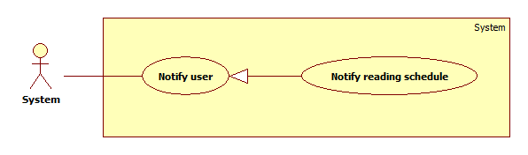

Figure 10: <System> Notify reading schedule use case diagram

Use Case Specification

|  |  |  |  |
| --- | --- | --- | --- |
| **USE CASE – ARB06** | | | |
| **Use Case No.** | ARB06 | **Use Case Version** | 2.0 |
| **Use Case Name** | Notify reading schedule | | |
| **Author** | Trinh Van Vu | | |
| **Date** | 30/05/2014 | **Priority** | High |
| **Actor:**   * System   **Summary:**   * System can notify reading schedule to user when user login   **Goal:**   * Notify user when reading time start and end.   **Triggers:**   * User log in the system   **Preconditions:**   * User bought book * User configured schedule * User log in the system   **Post Conditions:**   * **Success:** Notify user reading time at start reading time and end reading time. * **Fail:** Log error to administrator.   **Main Success Scenario:**   |  |  |  | | --- | --- | --- | | Step | Actor Action | System Response | | 1 | Server checks user reading schedule. | Send response when the time reach start and end time [Alternative 1][Exception 1] |   **Alternative Scenario:**   |  |  |  | | --- | --- | --- | | No | Actor Action | System Response | | 1 | Time is out of start time and end time. | Show notification “Bạn đã hết giờ đọc sách” |   **Exceptions:**   |  |  |  | | --- | --- | --- | | No | Actor Action | System Response | | 1 | Cannot send notify from server | Log error message to administrator |   **Relationships:** N/A  **Business Rules:**   * System compares current time and end time in schedule which is configured by user. (from server)   + Current time is more than end time in schedule: Response reading time at start reading time and end reading time which is configured by user.  + Current time is less than end time in schedule: Response to user is time’s out of start time and end time   * User can receive notifications at the time when system sends notification. * //System will save content notification. | | | |

Table 15: <System> Notify reading schedule use case specification table

##### <System> Notify book’s license expired

Use Case Diagram



Figure 11: <System> Notify book’s license expired use case diagram

Use Case Specification

|  |  |  |  |
| --- | --- | --- | --- |
| **USE CASE – ARB07** | | | |
| **Use Case No.** | ARB07 | **Use Case Version** | 2.0 |
| **Use Case Name** | Notify book’s license expired | | |
| **Author** | Trinh Van Vu | | |
| **Date** | 30/05/2014 | **Priority** | High |
| **Actor:**   * System   **Summary:**   * System can notify book’s license expired to user   **Goal:**   * Notify user when book’s license expired   **Triggers:**   * //User reading book   **Preconditions:**   * User bought book * User log in the system * User reading book   **Post Conditions:**   * **Success:** Notify license is expired and ask user for extending license * **Fail:** Log error message to administrator   **Main Success Scenario:**   |  |  |  | | --- | --- | --- | | Step | Actor Action | System Response | | 1 | Server checks license books that is bought by user when user read book. | Send response to inform license is expired to client [Alternative 1] [Exception 1] |   **Alternative Scenario:**   |  |  |  | | --- | --- | --- | | No | Actor Action | System Response | | 1 | Server checks license books that is bought by user when user read book. | Send response license is uexpired [Exception 1] |   **Exceptions:**   |  |  |  | | --- | --- | --- | | No | Actor Action | System Response | | 1 | Cannot send notify from server | Log error message to administrator |   **Relationships:** Notify user  **Business Rules:**   * System compares chapter which is reading and number of chapter which is bought by user:   + Chapter which is reading is equal or is more than the before the last chapter which is bought by user: Response license is expired and ask user for extending license  + //Chapter which is reading is more less than the before the last chapter which is bought by user: Response license is unexpired   * User can receive notifications at the time when system sends notification. * System will save content notification. * //log file ghi ở đâu, log file co cau truc | | | |

Table 16: <System> Notify book’s license expired use case specification table

##### <System> Auto parse

Use Case Diagram



Figure 12: <System> Auto parse use case diagram

Use Case Specification

|  |  |  |  |
| --- | --- | --- | --- |
| **USE CASE – ARB08** | | | |
| **Use Case No.** | ARB08 | **Use Case Version** | 2.0 |
| **Use Case Name** | Auto parse | | |
| **Author** | Pham Nguyen Bich Hien | | |
| **Date** | 30/05/2014 | **Priority** | Normal |
| **Actor:**   * System.   **Summary:**   * System can parse resource automatically from many websites at specified time.   **Goal:**   * Get resource from many websites.   **Triggers:**   * The time hits configured time.   **Preconditions:**   * Parse time has been configured.   **Post Conditions:**   * **Success:** New data is inserted to database. Log file is generated. * **Fail:** Nothing is changed in the database. Log file is generated.   **Main Success Scenario:**   |  |  |  | | --- | --- | --- | | Step | Actor Action | System Response | | 1 | Server checks the current time. If it hits configured time, parse process starts. | * Send request to the parsed link. * Fetch data from the response based on the inputted XPaths. * Validate data [Exception 1]. * If data is valid, insert to database [Alternative 1]. * Generate log file. |   **Alternative Scenario:**   |  |  |  | | --- | --- | --- | | Step | Actor Action | System Response | | 1 | Server checks the current time. If it hits configured time, parse process starts. | * If fetched link resource is already in the database, update its information. * Generate log file. |   **Exceptions:**   |  |  |  | | --- | --- | --- | | No | Actor Action | System Response | | 1 | Data is invalid. | * Don’t insert to database. * Generate log file. |   **Relationships:** N/A  **Business Rules:**   * If link resource exists in database, do not insert to database. * If link resource is not active, do not insert to database. * Log file structure:   ARB LOG FILE  Tạo file lúc: {Created date}, {Created time}   |  |  |  |  |  |  |  | | --- | --- | --- | --- | --- | --- | --- | | STT | Link | Thời gian parse | Dạng dữ liệu | Tổng số sách nhận được | Insert thành công | Insert thất bại | |  |  |  |  |  |  |  | |  |  |  |  |  |  |  |   Tổng thời gian parse dạng {Data type}: {Elapsed time}  Tổng thời gian parse: {Total elapsed time}  Tổng sản phẩm parse được: {Total parsed books} | | | |

Table 17: Auto parse use case specification table

##### <System> Streaming

Use Case Diagram



Figure 13: <System>Streaming use case diagram

Use Case Specification

|  |  |  |  |
| --- | --- | --- | --- |
| **USE CASE – ARB09** | | | |
| **Use Case No.** | ARB09 | **Use Case Version** | 2.0 |
| **Use Case Name** | Streaming | | |
| **Author** | Pham Nguyen Bich Hien | | |
| **Date** | 30/05/2014 | **Priority** | Normal |
| **Actor:**   * System.   **Summary:**   * System read streaming URL of resource.   **Goal:**   * Stream success to URL of resource   **Triggers:**   * The time hits configured time.   **Preconditions:**   * Streaming time has been configured.   **Post Conditions:**   * **Success:** Record streaming data to response. * **Fail:** Remove resource link which can not stream.   **Main Success Scenario:**   |  |  |  | | --- | --- | --- | | Step | Actor Action | System Response | | 1 | Server checks the current time. If it hits configured time, stream process starts. | * Send request to the streaming link. * Fetch data from the response. [Exception 1] * Record streaming result to system. |   **Alternative Scenario:**N/A  **Exceptions:**   |  |  |  | | --- | --- | --- | | No | Actor Action | System Response | | 1 | Cannot stream link | * Remove link out of system * Generate log file. |   **Relationships:** N/A  **Business Rules:**   * If resource link is not valid, remove from system. * If there is no resource link for a book, require staff to input at least one. | | | |

Table 18: <System>Streaming use case specification table

#### <Staff >Overview Use Case



Figure 14: <Staff> Overview Use Case

##### <Staff> Insert resource

Use Case Diagram



Figure 15: <Staff> Insert resource use case diagram

Use Case Specification

|  |  |  |  |
| --- | --- | --- | --- |
| **USE CASE – ARB10** | | | |
| **Use Case No.** | ARB10 | **Use Case Version** | 1.0 |
| **Use Case Name** | Insert resource | | |
| **Author** | Pham Nguyen Bich Hien | | |
| **Date** | 31/05/2014 | **Priority** | High |
| **Actor:**   * Staff.   **Summary:**   * This use case allows Staff to insert new (video, ebook, audio).   **Goal:**   * Add a new video, ebook, audio.   **Triggers:**   * Staff want to add more resource to database.   **Preconditions:**   * Book didn’t contain in system. * Staff must login to system with role staff. * Staff choose add book function.   **Post Conditions:**   * **Success**: A new video, ebook or sound will be added * **Fail:** No resource will be added. Show error message.   **Main Success Scenario:**   |  |  |  | | --- | --- | --- | | Step | Actor Action | System Response | | 1 | Staff choose add book function | System will show “Thêm Sách” which includes:   * Video * Ebook * Audio | | 2 | Staff choose “Video” [Alternative 1], [Alternative 2], [Alternative 3] | Navigate to add book pages. |   **Alternative Scenario:**   * Alternative 1: “Video”  |  |  |  | | --- | --- | --- | | Step | Actor Action | System Response | | 1 | Click “Video” | System wil show “Thêm video” page   * Tên sách: textbox, min length: 1, max length: 100, required * Thể loại: drop down list, raw source from database – Category table, required. * Vuforia texture: Upload controller. * JS Toolkit texture: Upload controller. * Tác giả: textbox, min length: 1, max length: 100, required * Nhà xuất bản: textbox, min length: 1, max length: 100, required * Số tập: spinner, min length: 1, max length: 4, range: [1, 9999], required. * Giá tiền/ tập: textbox, regular expression: “\d*[.]?\d+”, min length: 5, max length: 100, required. * Mô tả: text field, required. * Video stream URL: textbox, min length: 6, max length: 500, required. * Thêm link: button [Alternative 1.1] * Thêm sách: button | | 2 | Input fields.  [Exception 1, 2, 3, 4, 5, 6, 7, 8, 9, 10] |  | | 3 | Click on “Thêm sách” button | Book will be added to database and show: “Bạn đã thêm sách thành công” |  * + Alternative 1.1:  |  |  |  | | --- | --- | --- | | Step | Actor Action | System Response | | 1 | Click “Thêm link” | One more text box show:  Video stream URL: textbox, min length: 6, max length: 500. |  * Alternative 2: “Ebook”  |  |  |  | | --- | --- | --- | | Step | Actor Action | System Response | | 1 | Click “Ebook” | System wil show “Thêm ebook” page   * Tên sách: textbox, min length: 1, max length: 100, required * Thể loại: drop down list, raw source from database – Category table, required. * Vuforia texture: Upload controller. * JS Toolkit texture: Upload controller. * Tác giả: textbox, min length: 1, max length: 100, required * Nhà xuất bản: textbox, min length: 1, max length: 100, required * Số tập: spinner, min length: 1, max length: 4, range: [1, 9999], required. * Giá tiền/ tập: textbox, regular expression: “\d*[.]?\d+”, min length: 5, max length: 100, required. * Mô tả: text field, required. * Ebook contain URL: textbox, min length: 6, max length: 500, required. | | 2 | Input fields.  [Exception 1, 2, 3, 4, 5, 6, 7, 8, 9, 10] |  | | 3 | Click on “Thêm sách” button | Book will be added to database and show: “Bạn đã them sách thành công” |  * Alternative 3: “Audio”  |  |  |  | | --- | --- | --- | | Step | Actor Action | System Response | | 1 | Click “Audio” | System wil show “Thêm audio” page   * Tên sách: textbox, min length: 1, max length: 100, required * Thể loại: drop down list, raw source from database – Category table, required. * Vuforia texture: Upload controller. * JS Toolkit texture: Upload controller. * Tác giả: textbox, min length: 1, max length: 100, required * Nhà xuất bản: textbox, min length: 1, max length: 100, required * Số tập: spinner, min length: 1, max length: 4, range: [1, 9999], required. * Giá tiền/ tập: textbox, regular expression: “\d*[.]?\d+”, min length: 5, max length: 100, required. * Mô tả: text field, required. * Audio stream URL: textbox, min length: 6, max length: 500, required. * Thêm link: button [Alternative 3.1] | | 2 | Input fields.  [Exception 1, 2, 3, 4, 5, 6, 7, 8, 9, 10] |  | | 3 | Click on “Thêm sách” button | Book will be added to database and show: “Bạn đã them sách thành công” |  * + Alternative 3.1:  |  |  |  | | --- | --- | --- | | Step | Actor Action | System Response | | 1 | Click “Thêm link” | One more text box show:  Audio stream URL: textbox, min length: 6, max length: 500. |   **Exceptions:**   |  |  |  | | --- | --- | --- | | No | Actor Action | System Response | | 1 | Length of book name is not in range. | Show error message: “Độ dài tên sách phải từ 6-30 ký tự!” | | 2 | Category is not specificed | Show error message: “Hãy chọn thể loại!” | | 3 | Vuforia texture is not specified | Show error message: “Vui lòng chọn ảnh nhận diện mobile!” | | 4 | JSToolkit texture is not specified | Show error message: “Vui lòng chọn ảnh nhận diện cho webcam!” | | 5 | Length of author is not in range. | Show error message: “Độ dài tên tác giả phải từ 6-30 ký tự!” | | 6 | Length of publisher is not in range. | Show error message: “Độ dài tên nhà xuất bản phải từ 6-30 ký tự!” | | 7 | Number of chapter is “0” | Show error message: “Sách phải có ít nhất 1 tập” | | 8 | Price is not in range. | Show error message: “Giá sách phải từ ~1.000 đồng trở lên” | | 9 | Description is blank | Show error message: “Không được để trống mô tả” | | 10 | Video stream/ audio stream/ ebook contain URL is not valid | Show error message: “URL không hợp lệ” |   **Relationships:** Manage resource  **Business Rules:**   * Book to be added didn’t exist in database. * Image to be added to vuforia target image and jstoolkit target image must be unique. * In case of video/ audio resource, resource link must be stored as a list of video/ audio stream link. This list is arranged in order of book chapters. * In case of ebook resource, images are stored as a list in a cloud container. This list is arranged in order of book pages and chapters. Images are downloaded when user start reading book. | | | |

Table 19: <Staff> Insert resource use case specification table

##### <Staff> Delete resource

Use Case Diagram



Figure 16: <Staff> Delete resource use case diagram

Use Case Specification

|  |  |  |  |
| --- | --- | --- | --- |
| **USE CASE – ARB11** | | | |
| **Use Case No.** | ARB11 | **Use Case Version** | 1.0 |
| **Use Case Name** | Delete resource | | |
| **Author** | Pham Nguyen Bich Hien | | |
| **Date** | 31/05/2014 | **Priority** | Normal |
| **Actor:**   * Staff.   **Summary:**   * This use case allows Staff to delete resource (video, ebook, audio).   **Goal:**   * Delete a video, ebook, audio.   **Triggers:**   * Staff want to delete resource from database.   **Preconditions:**   * Staff must login to system with role staff.   **Post Conditions:**   * **Success**: A video, ebook or sound will be deleted * **Fail:** No resource will be added. Show error message.   **Main Success Scenario:**   |  |  |  | | --- | --- | --- | | Step | Actor Action | System Response | | 1 | Choose “Danh mục sách” | Show “Danh mục sách” page with the table of list books. | | 2 | Choose book to delete then click “Xóa” | System will show message:”Bạn có muốn xóa?” | | 3 | Click on “OK” button  [Exception 1] | A video, ebook or audio will be deleted |   **Alternative Scenario:** N/A  **Exceptions:**   |  |  |  | | --- | --- | --- | | No | Actor Action | System Response | | 1 | Book is in used | Show error message: “Sách đang được sử dụng. Bạn không thể xóa!” |   **Relationships:** Manage resource.  **Business Rules:**   * Cannot delete the book used by user. * Deleted book will be deleted from system. | | | |

Table 20: <Staff> Delete resource use case specification table

##### <Staff> Update resource

Use Case Diagram



Figure 17: <Staff> Update resource use case diagram

Use Case Specification

|  |  |  |  |
| --- | --- | --- | --- |
| **USE CASE – ARB12** | | | |
| **Use Case No.** | ARB12 | **Use Case Version** | 1.0 |
| **Use Case Name** | Update resource | | |
| **Author** | Pham Nguyen Bich Hien | | |
| **Date** | 31/05/2014 | **Priority** | Normal |
| **Actor:**   * Staff.   **Summary:**   * This use case allows Staff to update resource (video, ebook, audio).   **Goal:**   * Update a video, ebook, audio.   **Triggers:**   * Staff want to update resource from database.   **Preconditions:**   * Staff must login to system with role staff.   **Post Conditions:**   * **Success**: A video, ebook or sound will be updated * **Fail:** No resource will be added. Show error message.   **Main Success Scenario:**   |  |  |  | | --- | --- | --- | | Step | Actor Action | System Response | | 1 | Choose “Danh mục sách” | Show “Danh mục sách” page with the table of list books. | | 2 | Choose book to edit. Click on “Chỉnh sửa” button. | Navigate to edit book pages  [Alternative 1, 2, 3] |   **Alternative Scenario:**   * Alternative 1  |  |  |  | | --- | --- | --- | | Step | Actor Action | System Response | | 1 | Choosed resource is Video | System wil show “Sửa thông tin” page   * Tên sách: textbox, min length: 1, max length: 100, required, disabled. * Thể loại: drop down list, raw source from database – Category table, required. * Vuforia texture: Upload controller, disabled. * JS Toolkit texture: Upload controller, disabled. * Tác giả: textbox, min length: 1, max length: 100, required * Nhà xuất bản: textbox, min length: 1, max length: 100, required * Số tập: spinner, min length: 1, max length: 4, range: [1, 9999], required. * Giá tiền/ tập: textbox, regular expression: “\d*[.]?\d+”, min length: 5, max length: 100, required. * Mô tả: text field, required. * Video stream URL: textbox, min length: 6, max length: 500, required. * Thêm link: button [Alternative 1.1] * Hoàn thành: button | | 2 | Input fields.  [Exception 1, 2, 3, 4, 5, 6] |  | | 3 | Click on “Hoàn thành” button | Book will be added to database and show: “Bạn đã sửa sách thành công” |  * + Alternative 1.1:  |  |  |  | | --- | --- | --- | | Step | Actor Action | System Response | | 1 | Click “Thêm link” | One more text box show:  Video stream URL: textbox, min length: 6, max length: 500. |  * Alternative2  |  |  |  | | --- | --- | --- | | Step | Actor Action | System Response | | 1 | Choosed resource is Ebook | System wil show “Sửa thông tin” page   * Tên sách: textbox, min length: 1, max length: 100, required, disabled. * Thể loại: drop down list, raw source from database – Category table, required. * Vuforia texture: Upload controller, disabled. * JS Toolkit texture: Upload controller, disabled. * Tác giả: textbox, min length: 1, max length: 100, required * Nhà xuất bản: textbox, min length: 1, max length: 100, required * Số tập: spinner, min length: 1, max length: 4, range: [1, 9999], required. * Giá tiền/ tập: textbox, regular expression: “\d*[.]?\d+”, min length: 5, max length: 100, required. * Mô tả: text field, required. * Ebook contain URL: textbox, min length: 6, max length: 500, required. * Hoàn thành: button | | 2 | Input fields.  [Exception 1, 2, 3, 4, 5, 6] |  | | 3 | Click on “Hoàn thành” button | Book will be added to database and show: “Bạn đã sửa sách thành công” |  * Alternative 3  |  |  |  | | --- | --- | --- | | Step | Actor Action | System Response | | 1 | Choosed resource is Audio | System wil show “Sửa thông tin” page   * Tên sách: textbox, min length: 1, max length: 100, required. * Thể loại: drop down list, raw source from database – Category table, required. * Vuforia texture: Upload controller, disabled. * JS Toolkit texture: Upload controller, disabled. * Tác giả: textbox, min length: 1, max length: 100, required * Nhà xuất bản: textbox, min length: 1, max length: 100, required * Số tập: spinner, min length: 1, max length: 4, range: [1, 9999], required. * Giá tiền/ tập: textbox, regular expression: “\d*[.]?\d+”, min length: 5, max length: 100, required. * Mô tả: text field, required. * Audio stream URL: textbox, min length: 6, max length: 500, required. * Thêm link: button [Alternative 1.1] * Hoàn thành: button | | 2 | Input fields.  [Exception 1, 2, 3, 4, 5, 6] |  | | 3 | Click on “Hoàn thành” button | Book will be added to database and show: “Bạn đã sửa sách thành công” |  * + Alternative 1.1:  |  |  |  | | --- | --- | --- | | Step | Actor Action | System Response | | 1 | Click “Thêm link” | One more text box show:  Audio stream URL: textbox, min length: 6, max length: 500. |   **Exceptions:**   |  |  |  | | --- | --- | --- | | No | Actor Action | System Response | | 1 | Length of author is not in range. | Show error message: “Độ dài tên tác giả phải từ 6-30 ký tự!” | | 2 | Length of publisher is not in range. | Show error message: “Độ dài tên nhà xuất bản phải từ 6-30 ký tự!” | | 3 | Number of chapter is “0” | Show error message: “Sách phải có ít nhất 1 tập” | | 4 | Price is not in range. | Show error message: “Giá sách phải từ ~1.000 đồng trở lên” | | 5 | Description is blank | Show error message: “Không được để trống mô tả” | | 6 | Video stream/ audio stream/ ebook contain URL is not valid | Show error message: “URL không hợp lệ” |   **Relationships:** Manage resource  **Business Rules:**   * Cannot edit book used by user. * Cannot edit vuforia target image and js toolkit target image. * In case of video resource, resource link must be stored as a list of video stream link. This list is arranged in order of book chapter. * In case of ebook resource, images are stored as a list in a cloud container. This list is arranged in order of book pages and chapters. Images are downloaded when user start reading book. | | | |

Table 21: <Staff> Update resource use case specification table

##### <Staff>Logout

* Reference use case ARB04.

#### <User>Overview Use Case



Figure 18: <User> Overview Use Case

##### <User> Read book

Use Case Diagram



Figure 19: <User>Read Book Use case diagram

##### <User> Read book – Play sound

Use Case Diagram



Figure 20: <User> Read book – Play sound use case diagram

Use Case Specification

|  |  |  |  |
| --- | --- | --- | --- |
| **USE CASE – ARB13** | | | |
| **Use Case No.** | ARB13 | **Use Case Version** | 1.1 |
| **Use Case Name** | Read Book – Play sound | | |
| **Author** | Pham Nguyen Bich Hien, Phan Thanh Trung | | |
| **Date** | 28/05/2014 | **Priority** | High |
| **Actor:**   * User.   **Summary:**   * This use case allows user to read audio book.   **Goal:**   * Book resource will be loaded.   **Triggers:**   * User want to read audio book.   **Preconditions:**   * User must log in the system with user role. * User has the license of book. * The license of book must not be expired.   **Post Conditions:**   * **Success**: Book Resource will be loaded. * **Fail:** Nothing is loaded. Show Error Message   **Main Success Scenario:**   |  |  |  | | --- | --- | --- | | Step | Actor Action | System Response | | 1 | Choose “Đọc sách” function | Open camera to begin recognize image. | | 2 | Show an image in front of webcam mobile device | Navigate to “Nội dung số” page which contains a menu of options:  _ “Đọc eBook”  _ “Xem Video”  _ “Nghe Audio”  _ “Thoát” | | 3 | Click “Nghe Audio” | Navigate to “Nghe Audio” which contains Audio content of the book, and a panel of Audio chapters list. The system will continue the last unfinished Audio chapter or play next Audio chapter. |   **Alternative Scenario:** N/A  **Exceptions:**   |  |  |  | | --- | --- | --- | | No | Actor Action | System Response | | 1 | Cannot get image recognition. | “Chưa nhận diện được hình ảnh” | | 2 | Cannot read the lasted content | “Bạn chưa mua license nội dung này.” | | 3 | Cannot access to book webservice. | “Nội dung bạn truy cập không tồn tại. Vui lòng thử lại sau.” |   **Relationships:** Read Book  **Business Rules:**   * Book must be bought. * Reading chapter must be in license. * System checks reading schedule not to allow user read book in the time (which) is not in reading schedule. If reading is not in reading schedule, notify user and stop reading book function. * System will record what chapter user read and current time of chapter. | | | |

Table 22: <User> Read book – Play sound use case specification table

##### <User> Read book – Watch video

Use Case Diagram



Figure 21: <User> Read book - Watch video

Use Case Specification

|  |  |  |  |
| --- | --- | --- | --- |
| **USE CASE – ARB14** | | | |
| **Use Case No.** | ARB14 | **Use Case Version** | 1.1 |
| **Use Case Name** | Read Book – Watch video | | |
| **Author** | Pham Nguyen Bich Hien, Phan Thanh Trung | | |
| **Date** | 28/05/2014 | **Priority** | High |
| **Actor:**   * User.   **Summary:**   * This use case allows user to read video book.   **Goal:**   * Book resource will be loaded.   **Triggers:**   * User want to read video book.   **Preconditions:**   * User must log in the system with user role. * User has the license of book. * The license of book must not be expired.   **Post Conditions:**   * **Success**: Book Resource will be loaded. * **Fail:** Nothing is loaded. Show Error Message   **Main Success Scenario:**   |  |  |  | | --- | --- | --- | | Step | Actor Action | System Response | | 1 | Choose “Đọc sách” function | Open camera to begin recognize image. | | 2 | Show an image in front of webcam mobile device | Navigate to “Nội dung số” page which contains a menu of options:  _ “Đọc eBook”  _ “Xem Video”  _ “Nghe Audio”  _ “Thoát” | | 3 | Click “Xem Video” | Navigate to “Xem Video” which contains Video content of the book, and a panel of Video chapters list. The system will continue the last unfinished Video chapter or play next Video chapter. |   **Alternative Scenario:** N/A  **Exceptions:**   |  |  |  | | --- | --- | --- | | No | Actor Action | System Response | | 1 | Cannot get image recognition. | “Chưa nhận diện được hình ảnh” | | 2 | Cannot read the lasted content | “Bạn chưa mua license nội dung này.” | | 3 | Cannot access to book webservice. | “Nội dung bạn truy cập không tồn tại. Vui lòng thử lại sau.” |   **Relationships:** Read Book  **Business Rules:**   * Book must be bought. * Reading chapter must be in license. * System checks reading schedule not to allow user read book in the time (which) is not in reading schedule. If reading is not in reading schedule, notify user and stop reading book function. * System will record what chapter user read and current time of chapter. | | | |

Figure 22: <User> Read book - Watch video use case specification table

##### <User> Read book – Read ebook

Use Case Diagram



Table 23: <User> Read book - Read ebook

Use Case Specification

|  |  |  |  |
| --- | --- | --- | --- |
| **USE CASE – ARB15** | | | |
| **Use Case No.** | ARB15 | **Use Case Version** | 1.1 |
| **Use Case Name** | Read Book – Watch video | | |
| **Author** | Pham Nguyen Bich Hien, Phan Thanh Trung | | |
| **Date** | 28/05/2014 | **Priority** | High |
| **Actor:**   * User.   **Summary:**   * This use case allows user to read ebook.   **Goal:**   * Book resource will be loaded.   **Triggers:**   * User want to read ebook.   **Preconditions:**   * User must log in the system with user role. * User has the license of book. * The license of book must not be expired.   **Post Conditions:**   * **Success**: Book Resource will be loaded. * **Fail:** Nothing is loaded. Show Error Message   **Main Success Scenario:**   |  |  |  | | --- | --- | --- | | Step | Actor Action | System Response | | 1 | Choose “Đọc sách” function | Open camera to begin recognize image. | | 2 | Show an image in front of webcam mobile device | Navigate to “Nội dung số” page which contains a menu of options:  _ “Đọc eBook”  _ “Xem Video”  _ “Nghe Audio”  _ “Thoát” | | 3 | Click “Đọc ebook” | Navigate to “Đọc eBook” which contains eBook content of the book, and a panel of eBook chapters list. The system will continue the last unfinished eBook chapter or play next eBook chapter. |   **Alternative Scenario:** N/A  **Exceptions:**   |  |  |  | | --- | --- | --- | | No | Actor Action | System Response | | 1 | Cannot get image recognition. | “Chưa nhận diện được hình ảnh” | | 2 | Cannot read the lasted content | “Bạn chưa mua license nội dung này.” | | 3 | Cannot access to book webservice. | “Nội dung bạn truy cập không tồn tại. Vui lòng thử lại sau.” |   **Relationships:** Read Book  **Business Rules:**   * Book must be bought. * Reading chapter must be in license. * System checks reading schedule not to allow user read book in the time (which) is not in reading schedule. If reading is not in reading schedule, notify user and stop reading book function. * System will record what page user read. | | | |

##### <User> Search Book.

Use Case Diagram

Search Book 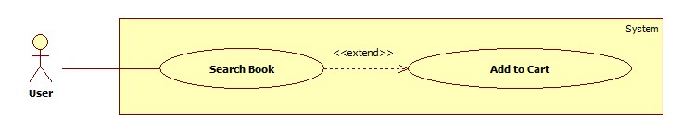

Figure 21: <User> Search Book use case diagram

Use Case Specification

|  |  |  |  |
| --- | --- | --- | --- |
| **USE CASE – ARB16** | | | |
| **Use Case No.** | ARB16 | **Use Case Version** | 1.0 |
| **Use Case Name** | Search Book | | |
| **Author** | Phan Thành Trung | | |
| **Date** | 28/05/2014 | **Priority** | Normal |
| **Actor:**   * User. * Guest   **Summary:**   * This use case allows user to search Book.   **Goal:**   * Searched Books will be shown.   **Triggers:**   * User want to search Book.   **Preconditions:**   * N/A   **Post Conditions:**   * **Success**: Searched Books will be shown. * **Fail:** Show Error Message.   **Main Success Scenario:**   |  |  |  | | --- | --- | --- | | Step | Actor Action | System Response | | 1 | Type keyword on Search bar. Click Search.[Alternative 1] | System will show the search result contain a list of book.  Each book display “tên sách”, “tác giả”, “giá”, “giảm giá” “Cho vào giỏ hàng”.  The list of book will by sorted by view, price, added date.  [Alternative 2] |   **Alternative Scenario:**  Alternative 1:   |  |  |  | | --- | --- | --- | | Step | Actor Action | System Response | | 1 | User choose “Tìm kiếm nâng cao”. | System will show advance search page:   * Tên sách: textbox, min length: 1, max length: 50, default value: “”. * Tác giả: textbox, min length: 1, max length: 100, default value: “”. * Thể loại: textbox, min length: 1, max length: 100, default value: “”. * Nhà xuất bản: textbox, min length: 1, max length: 100, default value: “”. * Tìm kiếm nâng cao: button | |  | Fill fields and click “Tìm kiếm nâng cao” | System will show the search result contain a list of book.  Each book display “tên sách”, “tác giả”, “giá”, “giảm giá”“Cho vào giỏ hàng”.  The list of book will by sorted by view, price, added date.  [Alternative 2] |   **Alternative 2:**   |  |  |  | | --- | --- | --- | | Step | Actor Action | System Response | | 1 | Cannot |  | |  |  |  |   **Exceptions: N/A**   |  |  |  | | --- | --- | --- | | No | Actor Action | System Response | | 1 | Cannot search Book. | “Chức năng tìm kiếm hiện thời đang bị lỗi. Mong quý khách thông cảm và vui long sử dụng vào dịp khác. |   **Relationships:** N/A  **Business Rules:**   * Searching book bases on book name, author, publisher, category of books. * In advance search, user can choose search book with each attribute: book name, author, publisher and category of books. * //khi field de null, search gan dung hay chinh xac | | | |

Table 15: <User> Search Book use case specification table

##### <User> Add to Cart.

Use Case Diagram

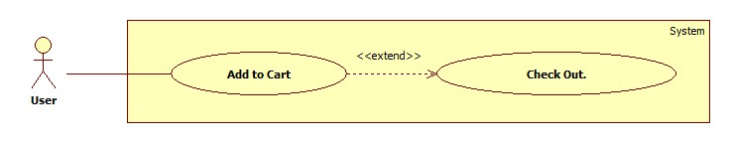

Figure 23: <User> Add to Cart Use case diagram

Use Case Specification

|  |  |  |  |
| --- | --- | --- | --- |
| **USE CASE – ARB17** | | | |
| **Use Case No.** | ARB17 | **Use Case Version** | 1.0 |
| **Use Case Name** | Add to Cart. | | |
| **Author** | Phan Thành Trung | | |
| **Date** | 28/05/2014 | **Priority** | Normal |
| **Actor:**   * User.   **Summary:**   * This use case allows user to add book to their cart.   **Goal:**   * Book will be added to user’s cart.   **Triggers:**   * User want to add book to their cart.   **Preconditions:**   * User must log in the system with user role. * User must access book list, book recommendation or book search results.   **Post Conditions:**   * **Success**: Book will be added to user’s cart. * **Fail:** Show Error Message.   **Main Success Scenario:**   |  |  |  | | --- | --- | --- | | Step | Actor Action | System Response | | 1 | Click on “Cho vào giỏ hàng” button. | System adds this book to the cart. |   **Alternative Scenario:** N/A  **Exceptions:**   |  |  |  | | --- | --- | --- | | No | Actor Action | System Response | | 1 | Cannot add to cart | “Chức năng cho vào giỏ hàng hiện đang bị lỗi. Mong quý khách thông cảm và vui làm sử dụng vào dịp khác.” |   **Relationships:** N/A.  **Business Rules:**   * Cannot add to card books that user already has. * Using payment service of third-party payment system. * //cau truc cua 1 item in cart * Provide promotion base on number of books user purchased.   + 1-5 books: 5%   + 5-10 books: 10%   + 10 ~: 15% | | | |

Table 16: <User> Add to Cart Use case specification table

##### <User> Check out.

Use Case Diagram

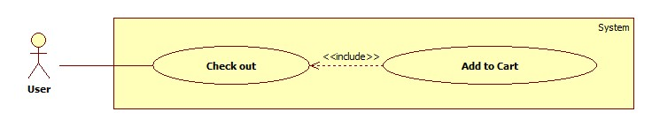

Figure 23: <User> Check out Use case diagram

Use Case Specification

|  |  |  |  |
| --- | --- | --- | --- |
| **USE CASE – ARB18** | | | |
| **Use Case No.** | ARB18 | **Use Case Version** | 1.0 |
| **Use Case Name** | Check out. | | |
| **Author** | Phan Thành Trung | | |
| **Date** | 28/05/2014 | **Priority** | Normal |
| **Actor:**   * User.   **Summary:**   * This use case allows user to check out.   **Goal:**   * User’s cart will be checked out.   **Triggers:**   * User want to check out their cart.   **Preconditions:**   * User must log in the system with user role. * User must add some books to their cart.   **Post Conditions:**   * **Success**: Book will be added to user’s cart. * **Fail:** Show Error Message.   **Main Success Scenario:**   |  |  |  | | --- | --- | --- | | Step | Actor Action | System Response | | 1 | Click on “Cho vào giỏ hàng” button. | System adds this book to the cart. | | 2 | Click “Thanh toán” button to check out. | System navigates to “Thanh toán” page of payment system using payment service of third-party payment system including textboxs:  _ “Tên”.  _ “Điện thoại”.  _ “Địa chỉ”  _ “Thành phố”  _ “Phương thức nhận hàng” | | 3 | Finish payment.[Exception 1] | System show a message “Giao dịch thành công”. Return to homepae. |   **Alternative Scenario:** N/A  **Exceptions:**   |  |  |  | | --- | --- | --- | | No | Actor Action | System Response | | 1 | Cannot check out | “Chức năng thanh toán hiện đang bị lỗi. Mong quý khách thông cảm và vui làm sử dụng vào dịp khác.” |   **Relationships:** N/A.  **Business Rules:**   * Cannot buy the book that user already has. // chi dc upgrade * Using payment service of third-party payment system. * Provide promotion base on number of books user purchased.   + 1-5 books: 5%   + 5-10 books: 10%   + 10 ~: 15% * System suggest book for users base on category of book they bought. | | | |

Table 18: <User> Check out Use case specification table

##### <User>Configure schedule

Use Case Diagram



Figure 24: <User> Configure schedule use case diagram

Use Case Specification

|  |  |  |  |
| --- | --- | --- | --- |
| **USE CASE – ARB20** | | | |
| **Use Case No.** | ARB20 | **Use Case Version** | 1.0 |
| **Use Case Name** | Configure schedule for parent | | |
| **Author** | Pham Nguyen Bich Hien | | |
| **Date** | 28/05/2014 | **Priority** | High |
| **Actor:**   * User.   **Summary:**   * This use case allows user set reading schedule for children.   **Goal:**   * Schedule will be updated   **Triggers:**   * User want to manage reading schedule of their children   **Preconditions:**   * User must log in the system with user role.   **Post Conditions:**   * **Success**: Schedule will be updated. * **Fail:** Nothing is updated. Show Error Message.   **Main Success Scenario:**   |  |  |  | | --- | --- | --- | | Step | Actor Action | System Response | | 1 | User touchs on “Cài đặt” menu | System requires password. | | 2 | User inputs password  [Exception 1][Alternative 1] | System show setting panel.   * Ngày thường: * Giờ bắt đầu: time picker, required. * Giờ kết thúc: time picker, required. * Thời gian đọc: time picker * Ngày nghỉ: * Giờ bắt đầu: time picker, required. * Giờ kết thúc: time picker, required. * Thời gian đọc: time picker * Lưu: button | | 3 | User changes settings, then choose “Lưu”[Alternative 2] | Save schedule of user.  Save schedule to shared preference (mobile device) |   **Alternative Scenario:**   * Alternative 1:  |  |  |  | | --- | --- | --- | | Step | Actor Action | System Response | | 1 | Session is timed-out | Return login page | | 2 | Input login information [References to use case ARB24]. | System show setting panel.  Countinue main flow. |  * Alternative 2:  |  |  |  | | --- | --- | --- | | Step | Actor Action | System Response | | 1 | User choose menu date setting | System shows setting panel:   * Ngày làm việc: * Thứ hai: checkbox, required. * Thứ ba: checkbox, required. * Thứ tư: checkbox, required. * Thứ năm: checkbox, required. * Thứ sáu: checkbox, required. * Thứ bảy: checkbox, required. * Chủ nhật: checkbox, required. * Lưu: button   All checkbox will be checked or not by loading database. | | 2 | User check working day. Click “Lưu” button. [Alternative 2.1] | System save new working days and holidays. |  * Alternative 2.1  |  |  |  | | --- | --- | --- | | Step | Actor Action | System Response | | 1 | User click back | Holiday will be saved as the previous settings. |   **Exceptions:**   |  |  |  | | --- | --- | --- | | No | Actor Action | System Response | | 1 | Input wrong password | Show message “Bạn không thể thay đổi cấu hình” |   **Relationships:** Login  **Business Rules:**   * User must know secondary password * User must login if session is timed-out * Reading schedule of user will be stored in data system. * User can access to reading schedule‘s history base on the date of setting. * Schedule can be set start reading time, end reading time and reading duration for working day and holiday. * Start time cannot be bigger than end time. * Duration does not exceed end time minus start time. * Working days and holidays can be chosen by user. | | | |

Table 24: <User> Configure schedule use case specification

##### <User>Add to favourite books list

Use Case Diagram



Figure 25: <User> Add to favourite books list use case diagram

Use Case Specification

|  |  |  |  |
| --- | --- | --- | --- |
| **USE CASE – ARB21** | | | |
| **Use Case No.** | ARB21 | **Use Case Version** | 1.0 |
| **Use Case Name** | Add to favourite books list | | |
| **Author** | Pham Nguyen Bich Hien | | |
| **Date** | 28/05/2014 | **Priority** | Low |
| **Actor:**   * User.   **Summary:**   * This use case allows user add a book to their favourite list.   **Goal:**   * Favorite list will be updated.   **Triggers:**   * User want to save their favourite books.   **Preconditions:**   * User must log in the system with user role. * User bought that book.   **Post Conditions:**   * **Success**: Book will be inserted to favourite list. * **Fail:** Nothing is inserted. Show Error Message.   **Main Success Scenario:**   |  |  |  | | --- | --- | --- | | Step | Actor Action | System Response | | 1 | User touchs on “Thêm vào danh sách yêu thích” menu  [Exception 1] | Toast show “Đã thêm vào danh sách yêu thích”. |   **Alternative Scenario:** N/A  **Exceptions:**   |  |  |  | | --- | --- | --- | | No | Actor Action | System Response | | 1 | User haven’t bought book | Show message “Bạn chưa mua sách này” |   **Relationships:** N/A  **Business Rules:**   * Users can see the book from home page and shopping page but they cannot add book to favourite list if they haven’t bought it yet. * Cannot add the book which have been in favourite list already. * Reading chapter must be in license. | | | |

Table 25: <User> Add to favourite books list use case specification table

##### <User>View history books

Use Case Diagram



Figure 26: <User> View history books use case diagram

Use Case Specification

|  |  |  |  |
| --- | --- | --- | --- |
| **USE CASE – ARB22** | | | |
| **Use Case No.** | ARB22 | **Use Case Version** | 1.0 |
| **Use Case Name** | View history books | | |
| **Author** | Pham Nguyen Bich Hien | | |
| **Date** | 28/05/2014 | **Priority** | Low |
| **Actor:**   * User.   **Summary:**   * This use case allows user to read a book again without scaning texture.   **Goal:**   * Access to the history book with the last access chapter.   **Triggers:**   * User want to read a book again without scaning texture.   **Preconditions:**   * User must log in the system with user role. * User bought that book.   **Post Conditions:**   * **Success**: Book will be loaded with the right chapter user want. * **Fail:** Load from the beginning of the book.   **Main Success Scenario:**   |  |  |  | | --- | --- | --- | | Step | Actor Action | System Response | | 1 | User touchs on “Lịch sử” button | List of history book in alphabet order. | | 2 | User choose a book in list  [Alternative 1][Alternative 2][Alternative 3] [Exception 1] | Go to reading page |   **Alternative Scenario:**   * Alternative 1:  |  |  |  | | --- | --- | --- | | Step | Actor Action | System Response | | 1 | Choosed book is video | Navigate to “Xem Video” which contains Video content of the book, and a panel of Video chapters list. The system will continue the last unfinished Video chapter or play next Video chapter. |  * Alternative2: “Nghe Audio”  |  |  |  | | --- | --- | --- | | Step | Actor Action | System Response | | 1 | Choosed book is audio | Navigate to “Nghe Audio” which contains Audio content of the book, and a panel of Audio chapters list. The system will continue the last unfinished Audio chapter or play next Audio chapter. |  * Alternative 3: “Đọc ebook”  |  |  |  | | --- | --- | --- | | Step | Actor Action | System Response | | 1 | Choosed book is ebook | Navigate to “Đọc eBook” which contains eBook content of the book, and a panel of eBook chapters list. The system will continue the last unfinished eBook chapter or play next eBook chapter. |   **Exceptions:**   |  |  |  | | --- | --- | --- | | No | Actor Action | System Response | | 1 | Fail load the right chapter | Load from the beginning of the book. |   **Relationships:** N/A  **Business Rules:**   * Book must be bought. * Reading chapter must be in license. * System check reading schedule not to allow user read book in the time which is not in reading schedule. If reading is not in reading schedule, notify user and stop reading book function. * In case of ebook resource, system will record what page user read. * In case of audio and video resource, system will record what chapter user read and current time of chapter. * List of history book will be loaded in order of last time reading. * Screen will show 15 books which user have read recently. | | | |

Table 26: <User> View history books use case specification table

##### <User>Suggest book

Use Case Diagram



Figure 27: <User> Suggest book use case diagram

Use Case Specification

|  |  |  |  |
| --- | --- | --- | --- |
| **USE CASE – ARB23** | | | |
| **Use Case No.** | ARB23 | **Use Case Version** | 1.0 |
| **Use Case Name** | View history books | | |
| **Author** | Pham Nguyen Bich Hien | | |
| **Date** | 28/05/2014 | **Priority** | Low |
| **Actor:**   * User.   **Summary:**   * This use case allows user to suggest book.   **Goal:**   * Save user’s suggestion to database.   **Triggers:**   * User want to suggest new book to system. * Choose “Đề nghị sách” menu.   **Preconditions:**   * User must log in the system with user role.   **Post Conditions:**   * **Success**: User’s suggestion is saved in database. * **Fail:** Nothing updated. Show error.   **Main Success Scenario:**   |  |  |  | | --- | --- | --- | | Step | Actor Action | System Response | | 1 | Choose “Đề nghị sách” menu | Navigate to “Đề nghị sách” page which contains:   * Tên sách: textbox, min length: 6, max length: 30, required. * Mô tả: text area, column:, row:, required. * Hoàn thành: button. * Xóa trắng: button. | | 2 | User fills data to the form. |  | | 3 | User clicks “Hoàn thành” button. [Alternative 1], [Exception 1, 2] | Insert new sugestion to the database and redirect to “Xem đề nghị” page.  Send email to thank user. |   **Alternative Scenario:**   |  |  |  | | --- | --- | --- | | No | Actor Action | System Response | | 1 | User clicks “Xóa trắng button”. | Clear all input data. |   **Exceptions:**   |  |  |  | | --- | --- | --- | | No | Actor Action | System Response | | 1 | Length of book name is not in range. | Show error message: “Độ dài tên sách phải từ 6-30 ký tự!” | | 2 | Description is blanked. | Show error message: “Không được để trống mô tả” |   **Relationships:** N/A  **Business Rules:**   * Suggest book will be recorded to database with status is not approved. * Book is exists in system will be sent the link to user’s email to suggest they buy and will be saved with status is not approved. | | | |

Table 27: <User> Suggest book use case specification table

##### <User>Logout

* Reference use case ARB04.

#### <Guest> Overview Use Case



Table 28: <System> Overview Use Case

##### <Guest> Login

Use Case Diagram



Figure 28: <Guest> Login use case diagram

Use Case Specification

|  |  |  |  |
| --- | --- | --- | --- |
| **USE CASE – ARB24** | | | |
| **Use Case No.** | ARB24 | **Use Case Version** | 2.0 |
| **Use Case Name** | Login | | |
| **Author** | Trinh Van Vu | | |
| **Date** | 30/05/2014 | **Priority** | Normal |
| **Actor:**   * Guest   **Summary:**   * This use case allows guest to login to the system.   **Goal:**   * Allow authentication and authorization of the system.   **Triggers:**   * Guest want to login into system. * To login: Guests go to the login page, enter username and password, and click “Đăng nhập” button to login.   **Preconditions:** N/A.  **Post Conditions:**   * **Success:** Guest is authorized, redirect to corresponding page. * **Fail:** System will show error on current page.   **Main Success Scenario:**   |  |  |  | | --- | --- | --- | | Step | Actor Action | System Response | | 1 | Guest goes to login page. | System show a login form, includes:   * Username: textbox, min length: 6, max length: 30, required. * Password: textbox, password box, min length: 6, max length: 20, required. * Đăng nhập: button. | | 2 | Guess enter username and password into textboxes.  Press “Đăng nhập” button. | Guest is logged into system, authorized with corresponding role. Redirect to corresponding page.  [Exception 1,2] |   **Alternative Scenario:** N/A  **Exceptions:**   |  |  |  | | --- | --- | --- | | No | Actor Action | System Response | | 1 | No input in “Username” or “Password” textboxes | Show error message: “Vui lòng điền đủ username và password!” | | 2 | Username/Password not in range [5,30] | Show error message: “Thông tin không hợp lệ. Vui lòng thử lại!” | | 3 | Input invalid “Username” and “Password” | Show error message: “Thông tin không hợp lệ. Vui lòng thử lại!” |   **Relationships:** N/A  **Business Rules:**   * Each user, staff, Administrator has an account. * Only active account can log in. | | | |

Table 29: Login use case specification table

Table 1: <Guest> Login

##### <Guest> Register

Use Case Diagram



Figure 29: <Guest> Register Use case diagram

Use Case Specification

|  |  |  |  |
| --- | --- | --- | --- |
| **USE CASE – ARB25** | | | |
| **Use Case No.** | ARB25 | **Use Case Version** | 2.0 |
| **Use Case Name** | Register | | |
| **Author** | Trinh Van Vu | | |
| **Date** | 30/05/2014 | **Priority** | Normal |
| **Actor:**   * Guest.   **Summary:**   * This use case allows guest to register.   **Goal:**   * User can register new account to become a user of the system.   **Triggers:**   * Guest wants to be a user of the system. * To register, click “Đăng ký” in menu bar.   **Preconditions:** N/A.  **Post Conditions:**   * **Success:** New user account is created. * **Fail:** Show error message.   **Main Success Scenario:**   |  |  |  | | --- | --- | --- | | Step | Actor Action | System Response | | 1 | Guest clicks “Đăng ký” link. | System show a register form which includes:   * Username: textbox, min length: 6, max length: 30, required. * Password: textbox, password box, min length: 6, max length: 20, required. * Đăng ký: button. * Xóa trắng: button. | | 2 | Guess enters required information, then clicks “Đăng ký” button. [Alternative 1] | Create new user account. Show success message.  [Exception 1,2, 3] |   **Alternative Scenario:**   |  |  |  | | --- | --- | --- | | No | Actor Action | System Response | | 1 | Guest clicks “Xóa trắng” button. | Clear all input fields. |   **Exceptions:**   |  |  |  | | --- | --- | --- | | No | Actor Action | System Response | | 1 | Length of username is not in range. | Show error message: “Độ dài username phải từ 6-30 ký tự!” | | 2 | Length of password is not in range. | Show error message: “Độ dài password phải từ 6-20 ký tự!” | | 3 | Username’s existed already. | Show error message: “Trùng tên đăng nhập! Vui lòng chọn tên khác!” |   **Relationships:** N/A  **Business Rules:**   * The role of new created account is “user”. | | | |

Table 30: <Guest> Register Use case specification table

Table 2: <Guest> Register

##### <Guest> Search book

* Reference use case ARB16.

## Software System Attribute

### Usability

#### Graphic User Interface

* All the texts, labels and should be written in Vietnamese.

#### Usability

* Administrator, staff should need less than one week of training to be productive with the system.
* Guest and member can use the system easily without training.

#### Installation

* The system must be easy to deploy.
* The mobile app must be easy to install. Compatible with almost mobile device running Android OS 4.0 or more.
* The attached manual guide must be clear. User can read and do themselves without developer’s help.

### Reliability

* The book and additional content must be updated regularly.
* Notification would be sent immediately for users to inform user about new contents.
* Rate of image recognization: 95% (test on 100 records)

### Availability

* N/A

### Security

* Privacy: Each role of user has a specific permission to interact with system.
* System always checks authorization and authentication before doing anything.
* Only administrator can grant permission to staff.

### Maintainability

* The system is divided into separated modules.
* The code is easy to maintain and upgrade.

### Portability

* N/A

### Performance

* N/A

## Conceptual Diagram



Figure 30: Conceptual diagram

### Data Dictionary

|  |  |
| --- | --- |
| Entity Name | Description |
| User | Describe all accounts in the system. |
| Book | Describe book‘s resource in system. |
| Schedule | Describe reading schedule of all users. |
| Suggestion | Describe book’s suggestion of users. |
| Category | Describe all categories of books in system. |
| ResourceType | Decribe all types of books. |
| Role | Decribe roles of users. |
| Path | Decribe paths of all resources. |
| TimeRead | Describe read book time of user. |
| Order | Describe all orders. |

Table 31: Entity Data dictionary - Describe content of all entities

# Software Design Description

## Design Overview

* This document describes the technical and user interface design of Augmented Reality Book System using mobile device. It includes the architectural design, the detailed design of common functions and business functions and the design of database model.
* The architectural design describes the overall architecture of the system and the architecture of each main component and subsystem.
* The detailed design describes static and dynamic structure for each component and functions. It includes class diagrams, class explanations and sequence diagrams for each use cases.
* The database design describes the relationships between entities and details of each entity.
* Document overview:
* Section 2: gives an overall description of the system architecture design.
* Section 3: gives component diagrams that describe the connection and integration of the system.
* Section 4: gives the detail design description which includes class diagram, class explanation, and sequence diagram to details the application functions.
* Section 5: describe an ERD with logical diagram.

## System Architectural Design

### Web Architecture

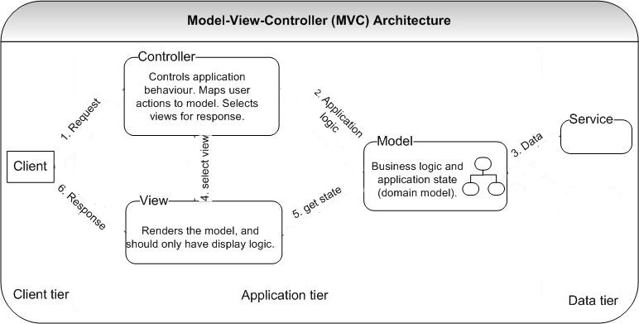

Figure 31: MVC Architecture

### Mobile Architecture



Figure 32: Mobile application architecture diagram

### Webservice Architecture

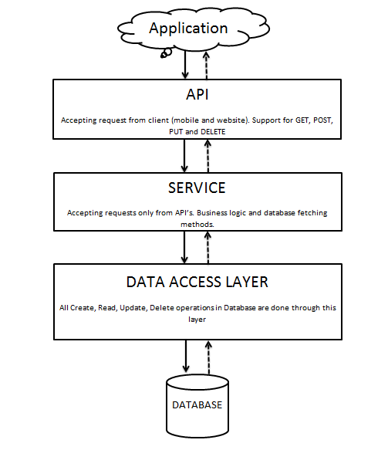

Figure 33: Webservice architecture diagram

## Component Diagram



Figure 34: Component Diagram

## Detailed Description of Components

### Class Diagram

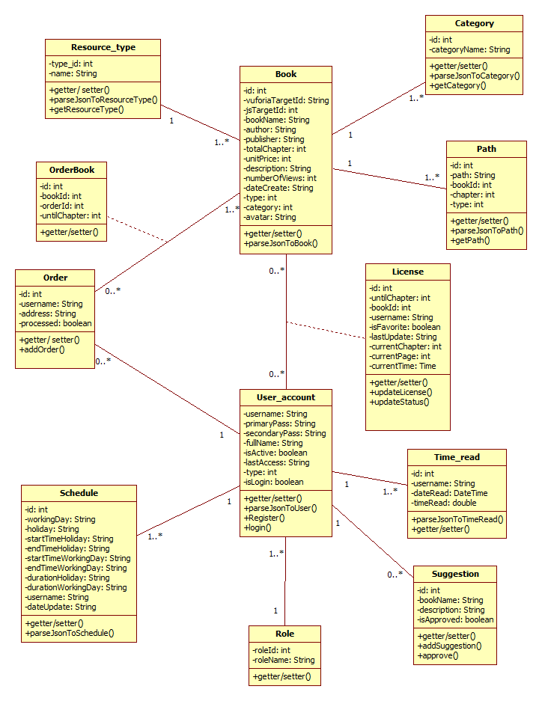

Figure 35: Class Diagram

### Class Diagram Explanation

#### UserAccount

**Attributes**

|  |  |  |  |
| --- | --- | --- | --- |
| **Attribute** | **Type** | **Visibility** | **Description** |
| username | String | Private | Username for each user. |
| primaryPassword | String | Private | User’s primary password. |
| secondaryPassword | String | Private | User’s secondary password. |
| fullName | String | Private | User’s full name. |
| isActive | Boolean | Private | User’s operation status. |
| lastAccess | DateTime | Private | User’s last access time. |
| Type | Int | Private | User’s type. |
| isLogin | Boolean | Private | User’s login status. |

**Methods**

|  |  |  |  |
| --- | --- | --- | --- |
| **Method** | **Return Type** | **Visibility** | **Description** |
| Register | Void | Public | For new user to register |
| Login | Boolean | Public | Used to log in the system |
| parseJsonToUser | UserAccount | Public | Parse json string to an user instant. |

#### Book

**Attributes**

|  |  |  |  |
| --- | --- | --- | --- |
| **Attribute** | **Type** | **Visibility** | **Description** |
| Id | int | Private | Book’s id. |
| vuforiaTargetId | String | Private | Book’s vuforia target Id. |
| JSTargetId | String | Private | Book’s JS AR Toolkit Id |
| bookName | String | Private | Book’s name. |
| author | String | Private | Book’s author. |
| publisher | String | Private | Book’s publisher. |
| totalChapter | Int | Private | Book’s total chapters. |
| unitPrice | Int | Private | Book’s unit price. |
| Description | String | Private | Book’s description. |
| numberOfViews | Int | Private | Book’s number of views. |
| dateCreate | String | Private | Book’s date created. |
| type | Int | Private | Book’s type. |
| categoryId | Int | Private | Book’s category Id. |
| Avatar | String | Private | Book’s avatar url. |

**Methods**

|  |  |  |  |
| --- | --- | --- | --- |
| **Method** | **Return Type** | **Visibility** | **Description** |
| parseJsonToBook | Book | Public | Parse json string to a book instant. |

#### License

**Attributes**

|  |  |  |  |
| --- | --- | --- | --- |
| **Attribute** | **Type** | **Visibility** | **Description** |
| Id | Int | Private | License’s Id. |
| untilChapter | Int | Private | License’s expired chapter |
| bookId | Int | Private | Liencse’s book id. |
| Username | String | Private | License’s username. |
| IsFavorite | Boolean | Private | Book is favourite or not |
| lastUpdate | String | Private | License’s last update date. |
| currentChapter | Int | Private | Current chapter user read |
| currentPage | Int | Private | Current page user read |
| currentTime | Int | Private | Current time user read |

**Methods**

|  |  |  |  |
| --- | --- | --- | --- |
| **Method** | **Return Type** | **Visibility** | **Description** |
| updateLicense | Void | Public | Update license |
| updateStatus | Void | Public | Update reading status |

#### Schedule

**Attributes**

|  |  |  |  |
| --- | --- | --- | --- |
| **Attribute** | **Type** | **Visibility** | **Description** |
| Id | Int | Private | License’s Id. |
| workingDay | String | Private | License’s expired chapter |
| holiday | String | Private | Liencse’s book id. |
| Username | String | Private | License’s username. |
| IsFavorite | Boolean | Private | Book is favourite or not |
| lastUpdate | String | Private | License’s last update date. |
| currentChapter | Int | Private | Current chapter user read |
| currentPage | Int | Private | Current page user read |
| currentTime | Int | Private | Current time user read |

**Methods**

|  |  |  |  |
| --- | --- | --- | --- |
| **Method** | **Return Type** | **Visibility** | **Description** |
| parseJsonToSchedule | Void | Public | Parse json string to a schedule instant. |

#### Role

**Attributes**

|  |  |  |  |
| --- | --- | --- | --- |
| **Attribute** | **Type** | **Visibility** | **Description** |
| roleId | Int | Private | Role’s Id |
| roleName | String | Private | Role’s Name |

#### Time Read

**Attributes**

|  |  |  |  |
| --- | --- | --- | --- |
| **Attribute** | **Type** | **Visibility** | **Description** |
| Id | Int | Private | Time Read’s Id |
| username | String | Private | Time Read’s username |
| dateRead | Date Time | Private | Read book date |
| timeRead | Double | Private | Read book time |

**Methods**

|  |  |  |  |
| --- | --- | --- | --- |
| **Method** | **Return Type** | **Visibility** | **Description** |
| parseJsonToTimeRead | Void | Public | Parse json string to a time read instant. |

#### Suggestion

**Attributes**

|  |  |  |  |
| --- | --- | --- | --- |
| **Attribute** | **Type** | **Visibility** | **Description** |
| Id | Int | Private | Suggestion’s Id |
| bookName | String | Private | Book’s name which is suggested by user |
| description | String | Private | Book’s description |
| isApprove | Boolean | Private | Approve suggestion |

**Methods**

|  |  |  |  |
| --- | --- | --- | --- |
| **Method** | **Return Type** | **Visibility** | **Description** |
| addSuggestion | Void | Public | User suggest book to system |
| approve | Void | Public | System approve suggestion |

#### Order

**Attributes**

|  |  |  |  |
| --- | --- | --- | --- |
| **Attribute** | **Type** | **Visibility** | **Description** |
| Id | Int | Private | Order’s Id |
| username | String | Private | User’s name |
| address | String | Private | User’s address |
| processed | Boolean | Private | Process order |

**Methods**

|  |  |  |  |
| --- | --- | --- | --- |
| **Method** | **Return Type** | **Visibility** | **Description** |
| addOrder | Void | Public | User order book to system |
| approve | Void | Public | System process order |

#### Order book

**Attributes**

|  |  |  |  |
| --- | --- | --- | --- |
| **Attribute** | **Type** | **Visibility** | **Description** |
| Id | Int | Private | Order’s Id |
| bookId | Int | Private | Book’s Id which is ordered by user |
| orderId | Int | Private | Order’s Id |
| unitlChapter | Int | Private | Number of chapter which is ordered |

#### Category

**Attributes**

|  |  |  |  |
| --- | --- | --- | --- |
| **Attribute** | **Type** | **Visibility** | **Description** |
| Id | Int | Private | Category’s Id |
| categoryName | String | Private | Category’s name |

**Methods**

|  |  |  |  |
| --- | --- | --- | --- |
| **Method** | **Return Type** | **Visibility** | **Description** |
| parseJsonToCategory | Void | Public | Parse json string to a category instant. |
| getCategory | Void | Public | Get all category |

#### Resource Type

**Attributes**

|  |  |  |  |
| --- | --- | --- | --- |
| **Attribute** | **Type** | **Visibility** | **Description** |
| Id | Int | Private | Resource type’s Id |
| name | String | Private | Resource type’s name |

**Methods**

|  |  |  |  |
| --- | --- | --- | --- |
| **Method** | **Return Type** | **Visibility** | **Description** |
| parseJsonToResourceType | Void | Public | Parse json string to a Resource type instant. |
| getResourceType | Void | Public | Get Book’s resource type |

#### Path

**Attributes**

|  |  |  |  |
| --- | --- | --- | --- |
| **Attribute** | **Type** | **Visibility** | **Description** |
| Id | Int | Private | Path’s Id |
| path | String | Private | Book’s path |
| bookId | Int | Private | Book’s Id |
| chapter | Int | Private | Book’s chapter |
| type | Int | Private | Path’s type |

**Methods**

|  |  |  |  |
| --- | --- | --- | --- |
| **Method** | **Return Type** | **Visibility** | **Description** |
| parseJsonToPath | Void | Public | Parse json string to a Path instant. |
| getPath | Void | Public | Get Book’s path |

### Sequence Diagram

#### Notify reading schedule

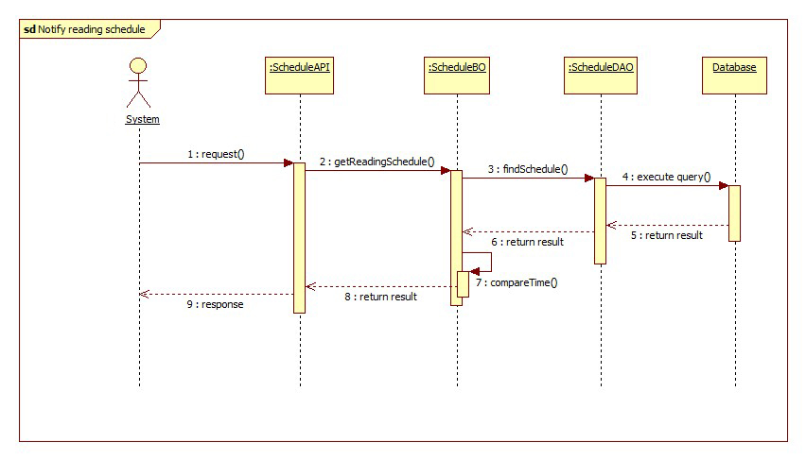

Figure 36: Notify reading schedule sequence diagram

#### Notify expired book

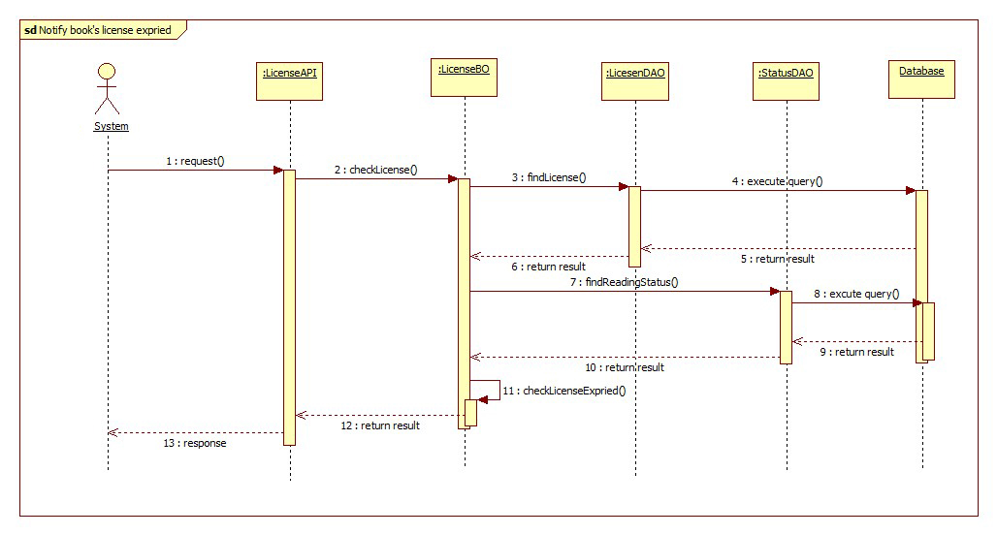

Figure 37: Notify expired book sequence diagram

#### Notify suggested book

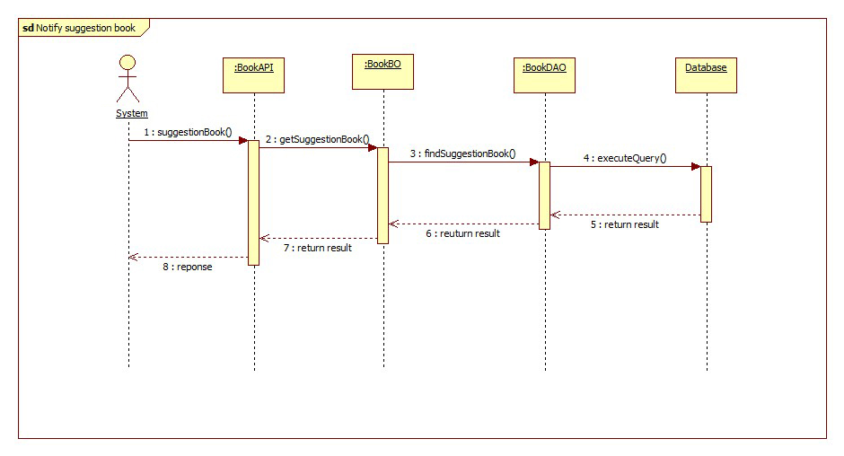

Figure 38: Notify suggested book sequence diagram

#### Recognize book

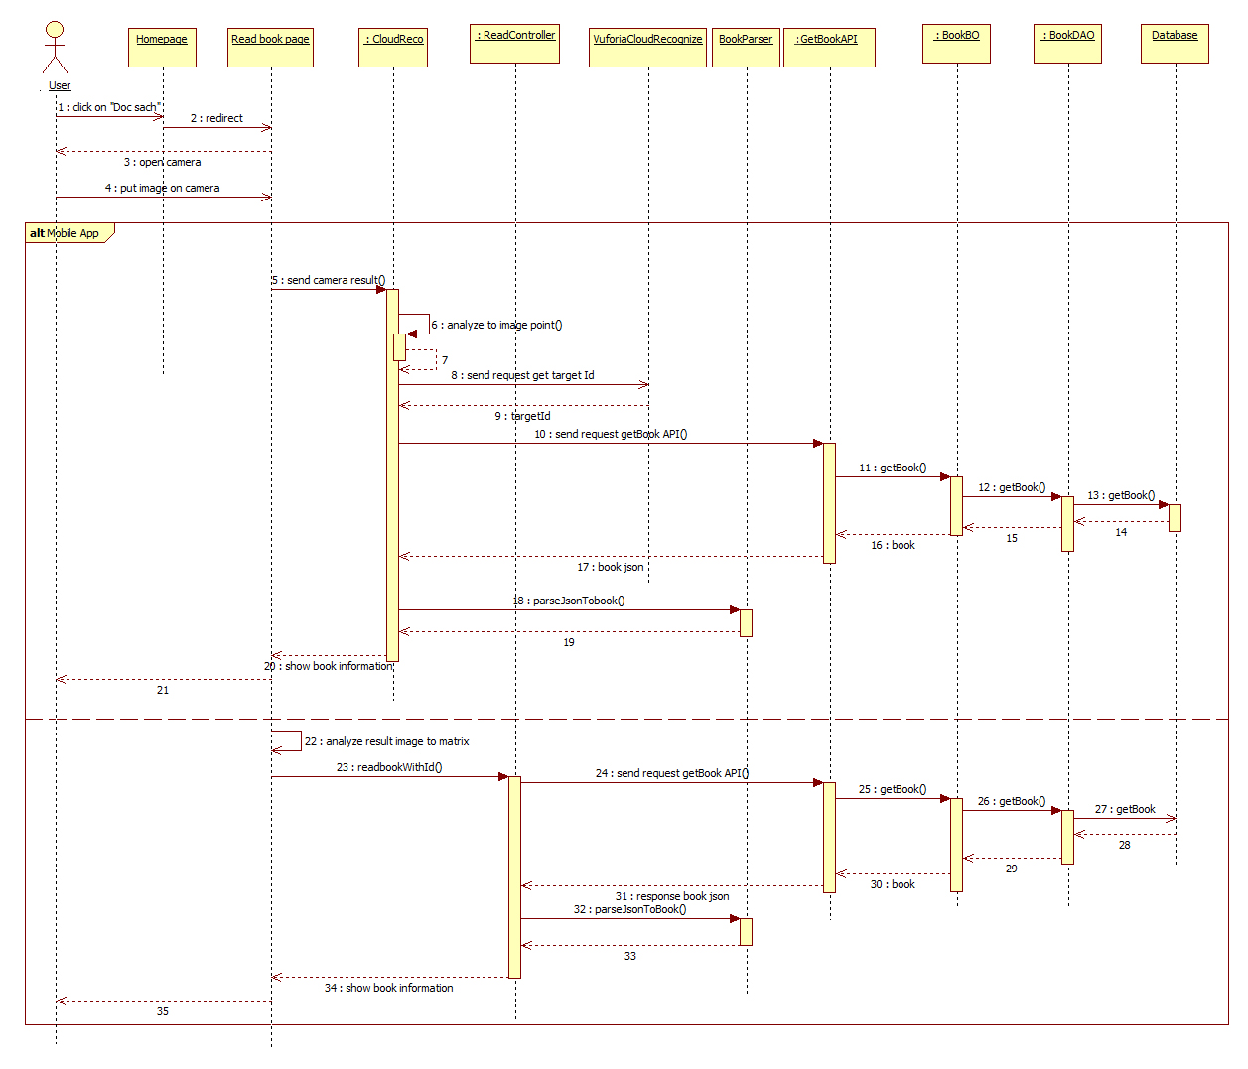

Figure 39: Recognize book sequence diagram

#### Read book – Play audio

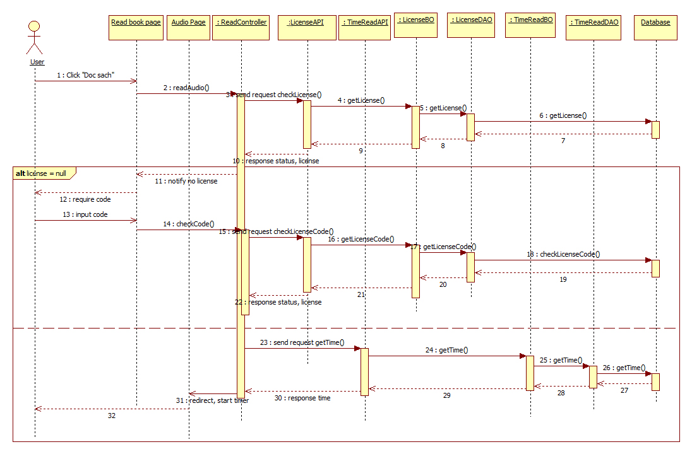

Figure 40: Read book – Play audio sequence diagram

#### Read book – Watch video

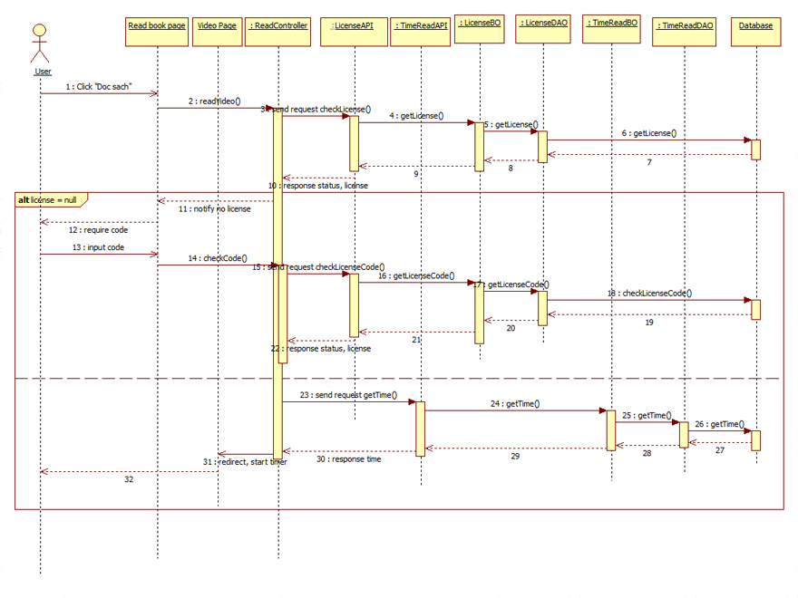

Figure 41:: Read book – watch video sequence diagram

#### Read book – Read ebook

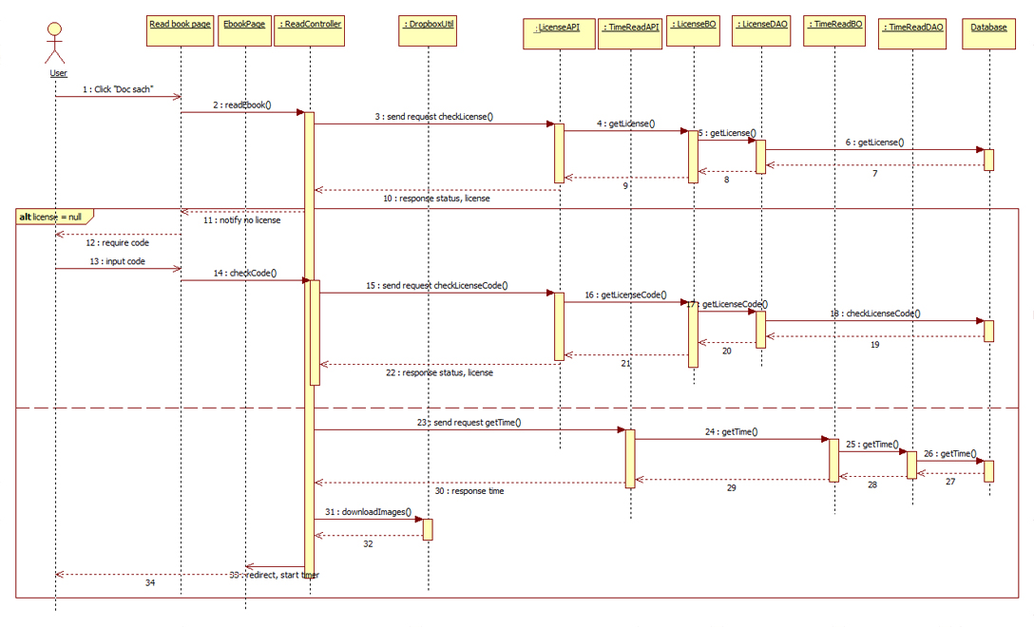

Figure 42:: Read book - read ebook sequence diagram

#### Search book

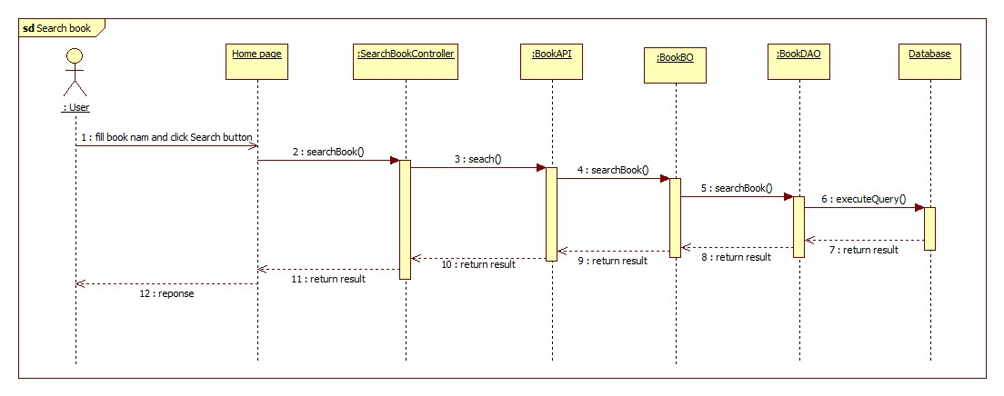

Figure 43: Search book sequence diagram

#### Buy book online

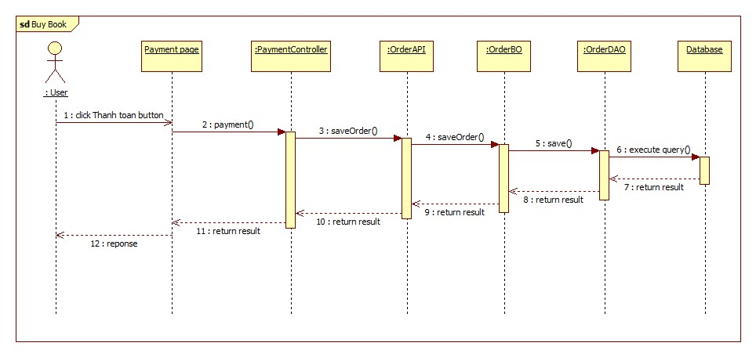

Figure 44: Buy book online sequence diagram

#### Upgrade licence

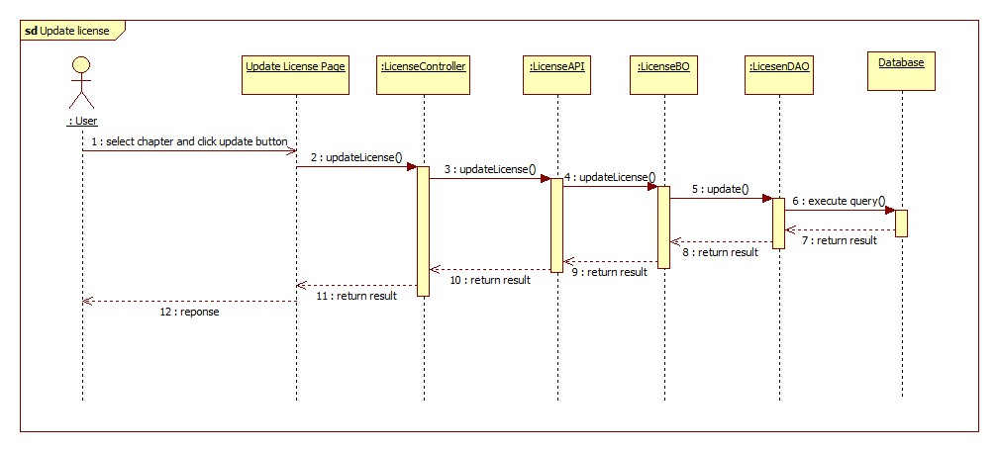

Figure 45: Upgrade license sequence diagram

#### Configure reading schedule

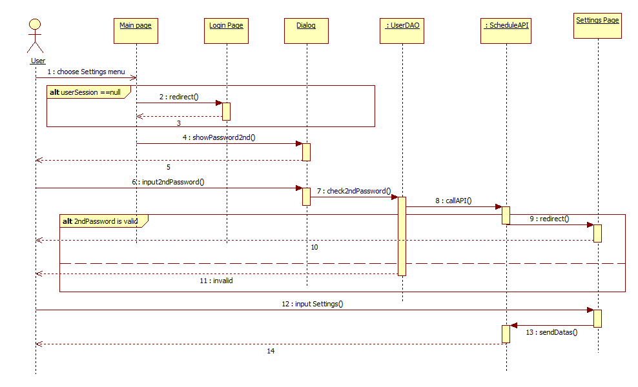

Figure 46: Configure reading schedule sequence diagram

#### View history books

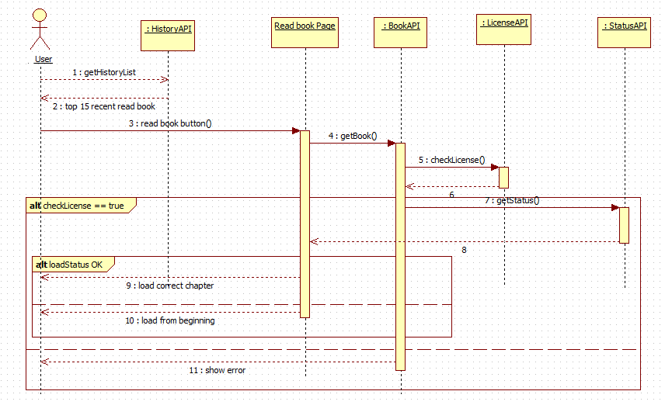

Figure 47: View history book sequence diagram

#### Suggest book

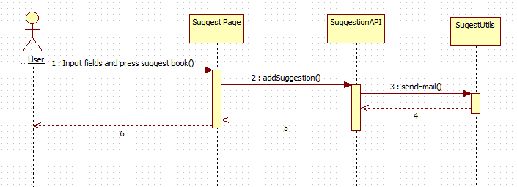

Figure 48: Suggest book sequence diagram

## User Interface Design

### Web application

#### Homepage

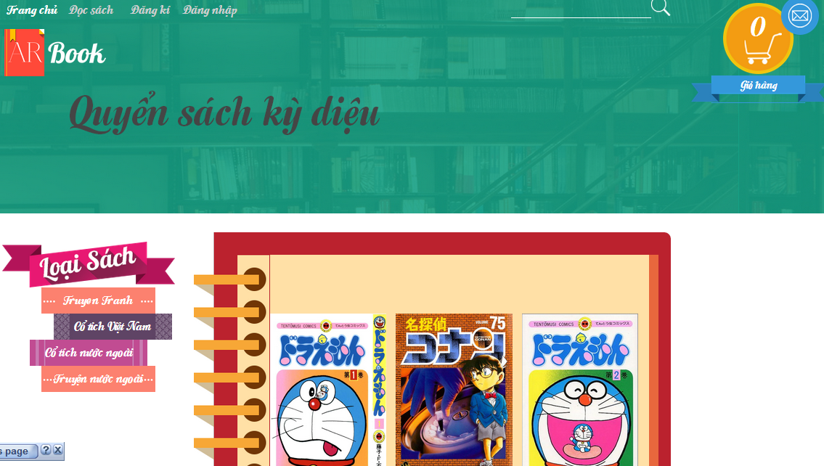

8

7

6

5

4

3

2

1

Figure 49: Web App - Home page user interface

**Buttons/Hyperlinks**

|  |  |  |  |  |
| --- | --- | --- | --- | --- |
| **No** | **Function** | **Description** | **Validation** | **Outcome** |
| 1 | Homepage link | Link to homepage | N/A | Navigate to home page. |
| 2 | Read book link | Link to read book page | N/A | Navigate to read book page. |
| 3 | Register link | Link to register page | N/A | Navigate to register page. |
| 4 | Login link | Link to login page | N/A | Navigate to login page |
| 5 | Shopping cart button | Open shopping cart | N/A | Open shopping cart |
| 6 | Inbox button | Open notification list | N/A | List all notification and show to user |
| 7 | Book detail link | Link to book detail information | N/A | Navigate to book detail page |
| 8 | Category link | Link to each category page | N/A | Navigate to each category books. |

#### Login

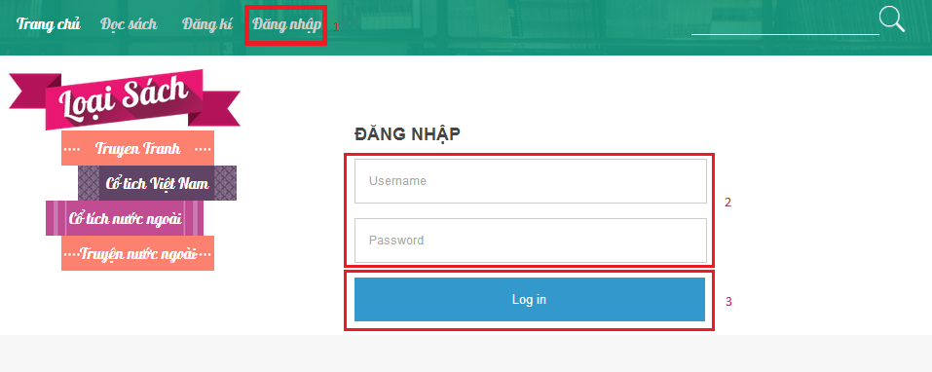

1

Figure 50: Web App - Login Page user interface

**Fields**

|  |  |  |  |  |  |  |  |
| --- | --- | --- | --- | --- | --- | --- | --- |
| **No** | **Field Name** | **Description** | **Read only** | **Mandatory** | **Control Type** | **Data Type** | **Length** |
| 1 | Username | Fill username | No | Yes | Edit Text | String | N/A |
| 2 | Password | Fill password | No | Yes | Edit Text | String | N/A |

**Buttons/Hyperlinks**

|  |  |  |  |  |
| --- | --- | --- | --- | --- |
| **No** | **Function** | **Description** | **Validation** | **Outcome** |
| 3 | Login button | Log-in into the system | N/A | Navigate to home page |

#### Setting schedule

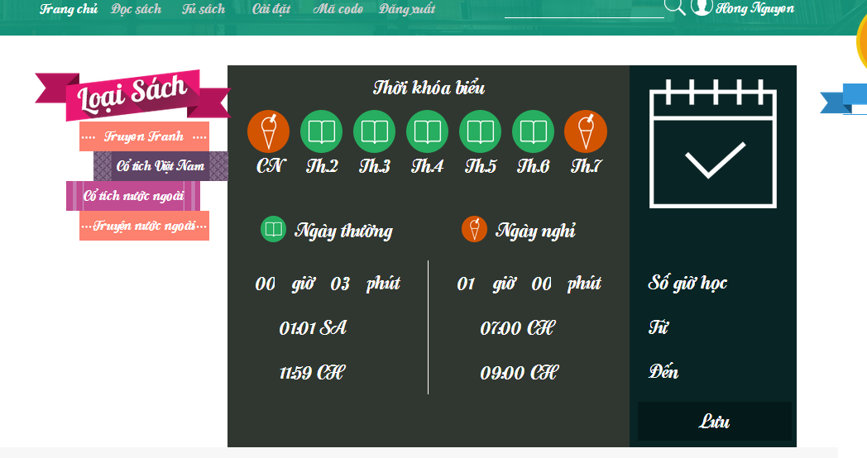

8

4

3

2

5

6

7

1

Figure 51: Web App - Setting schedule page user interface

**Fields:**

|  |  |  |  |  |  |  |  |
| --- | --- | --- | --- | --- | --- | --- | --- |
| **No** | **Field Name** | **Description** | **Read only** | **Mandatory** | **Control Type** | **Data Type** | **Length** |
| 1 | Working day chosen field | Choose which day in week is working day | No | Yes | Checkbox | ArrayList<String> | N/A |
| 2 | Start time reading for working day field | Choose reading start time for working day | No | Yes | Time Picker | Time | N/A |
| 3 | End time reading for working day field | Choose reading end time for working day | No | Yes | Time Picker | Time | N/A |
| 4 | Reading duration for working day field | Choose reading duration for working day | No | Yes | Time Picker | Time | N/A |
| 5 | Start time reading for holiday field | Choose reading start time for holiday | No | Yes | Time Picker | Time | N/A |
| 6 | End time reading for holiday field | Choose reading end time for holiday | No | Yes | Time Picker | Time | N/A |
| 7 | Reading duration for holiday field | Choose reading duration for holiday | No | Yes | Time Picker | Time | N/A |

**Buttons/Hyperlinks**

|  |  |  |  |  |
| --- | --- | --- | --- | --- |
| **No** | **Function** | **Description** | **Validation** | **Outcome** |
| 2 | Save button | Save schedule | N/A | Navigate to home page. |

#### Recognize book

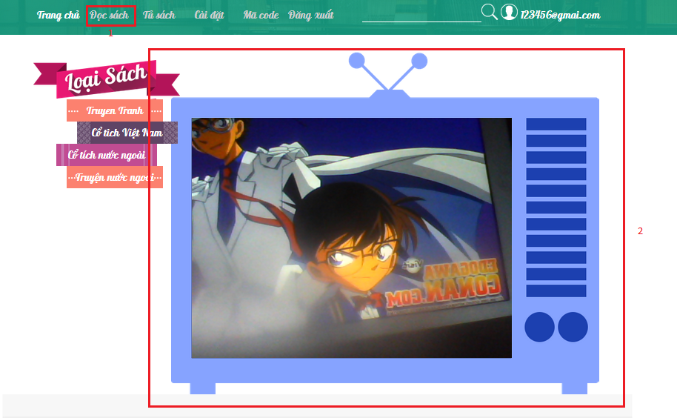

1

Figure 52: Web App - Recognize user interface

**Fields**

|  |  |  |  |  |  |  |  |
| --- | --- | --- | --- | --- | --- | --- | --- |
| **No** | **Field Name** | **Description** | **Read only** | **Mandatory** | **Control Type** | **Data Type** | **Length** |
| 1 | Camera | Put the camera on the image to recognize | Yes | Yes | N/A | View | N/A |

**Buttons/Hyperlinks**

Auto navigate to read book page

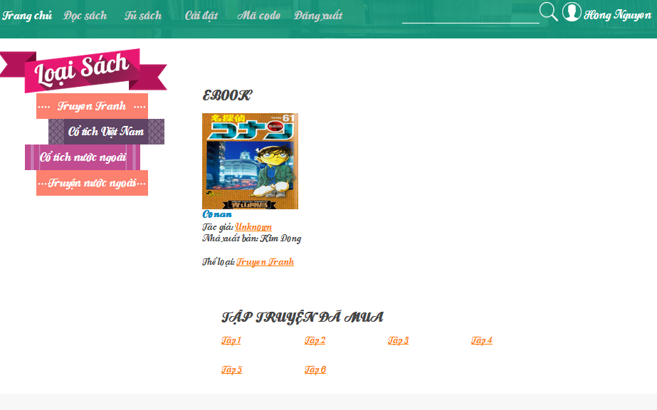

Figure 53: Web App - Read book user interface

#### <User> Read book – Watch video

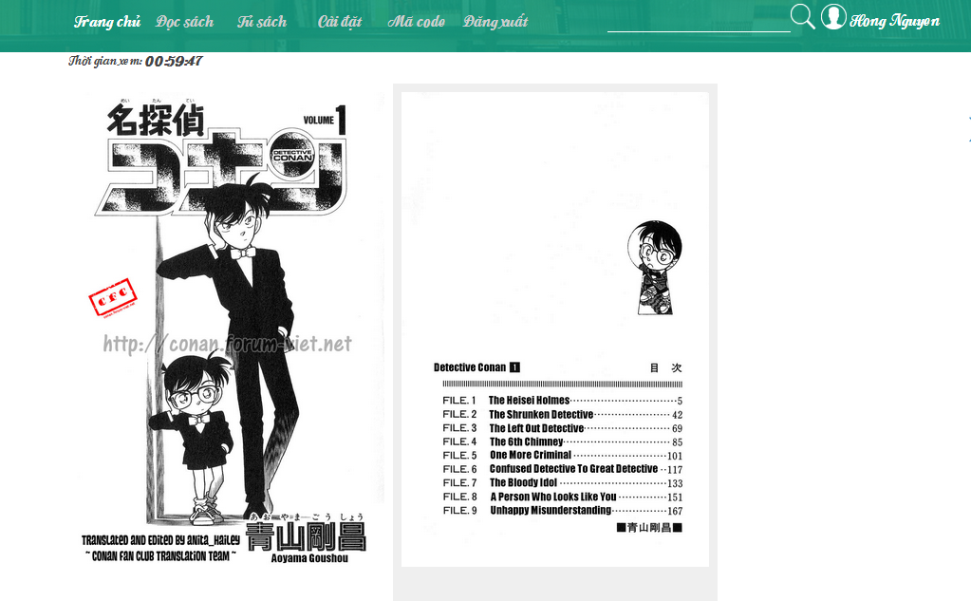

Figure 54: Web App - Read ebook user interface

#### <User> Read book – Read ebook

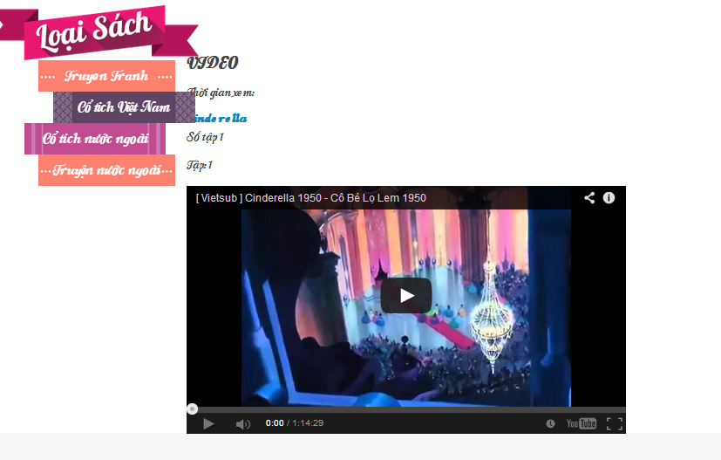

Figure 55: Web App - Read book - watch video user interface

#### <User> Read book – Play audio

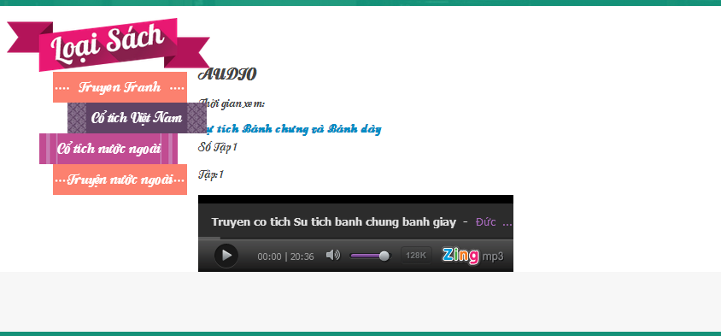

Figure 56: Web App - Read book - play audio

#### <User> Upgrade license

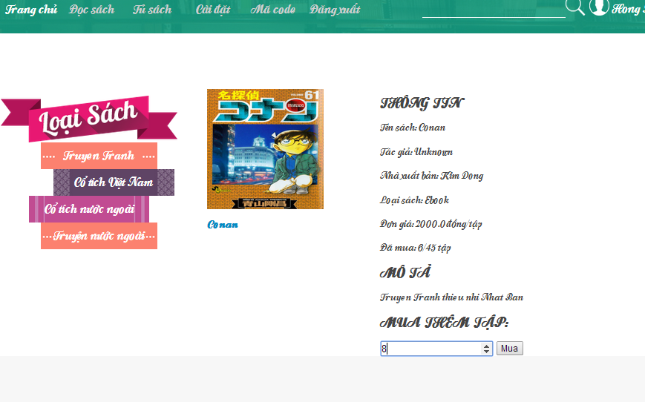

2

1

Figure 57: Web App - Upgrade license user interface

**Fields**

|  |  |  |  |  |  |  |  |
| --- | --- | --- | --- | --- | --- | --- | --- |
| **No** | **Field Name** | **Description** | **Read only** | **Mandatory** | **Control Type** | **Data Type** | **Length** |
| 1 | Number of chapters | Choose number of chapter to upgrade | No | Yes | Spinner | String | N/A |

**Buttons/Hyperlinks**

|  |  |  |  |  |
| --- | --- | --- | --- | --- |
| **No** | **Function** | **Description** | **Validation** | **Outcome** |
| 2 | Buy button | Upgrade license button | N/A | Redirect to nganluong.vn page. |

### Mobile Application

#### <Guest> Login

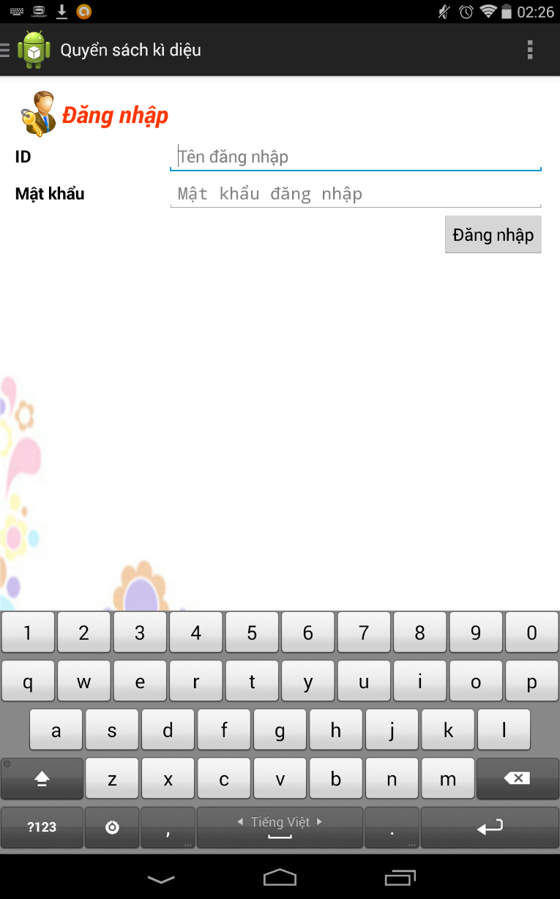

**3**

**2**

**1**

Figure 58: Mobile App – Login user interface

**Fields**

|  |  |  |  |  |  |  |  |
| --- | --- | --- | --- | --- | --- | --- | --- |
| **No** | **Field Name** | **Description** | **Read only** | **Mandatory** | **Control Type** | **Data Type** | **Length** |
| 1 | Username | Fill username | No | Yes | Edit Text | String | N/A |
| 2 | Password | Fill password | No | Yes | Edit Text | String | N/A |

**Buttons/Hyperlinks**

|  |  |  |  |  |
| --- | --- | --- | --- | --- |
| **No** | **Function** | **Description** | **Validation** | **Outcome** |
| 3 | Login button | Log-in into the system | N/A | Navigate to home page |

#### <User/ Guest> Recognize book



**1**

Figure 59: Mobile App - Recognize book user interface

**Fields**

|  |  |  |  |  |  |  |  |
| --- | --- | --- | --- | --- | --- | --- | --- |
| **No** | **Field Name** | **Description** | **Read only** | **Mandatory** | **Control Type** | **Data Type** | **Length** |
| 1 | Camera | Put the camera on the image to recognize | Yes | Yes | N/A | View | N/A |

**Buttons/Hyperlinks**

Auto navigate to read book page

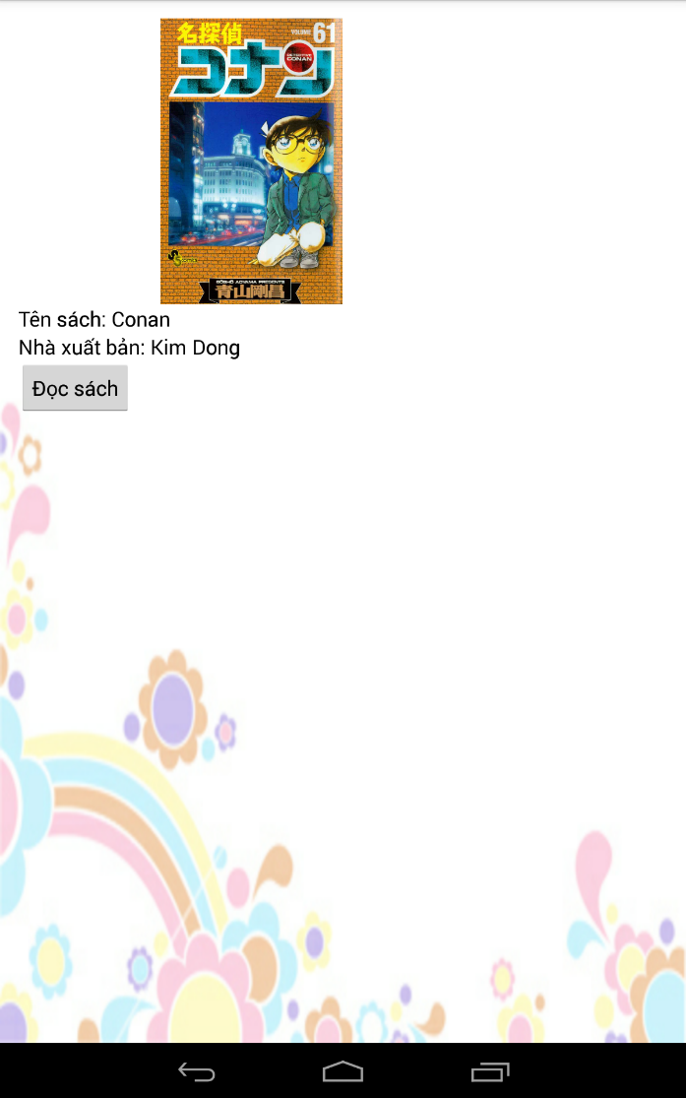

**1**

Figure 60: Mobile App - Book detail user interface

**Buttons/Hyperlinks**

|  |  |  |  |  |
| --- | --- | --- | --- | --- |
| **No** | **Function** | **Description** | **Validation** | **Outcome** |
| 1 | Read book button | Access read book page, check license, reading status. | N/A | Case 1: User has book’s license:  Navigate to reading page (ebook/ video/ audio).  Trigger timer countdown  Case 2: User doesn’t have book’s license:  Require license code. |

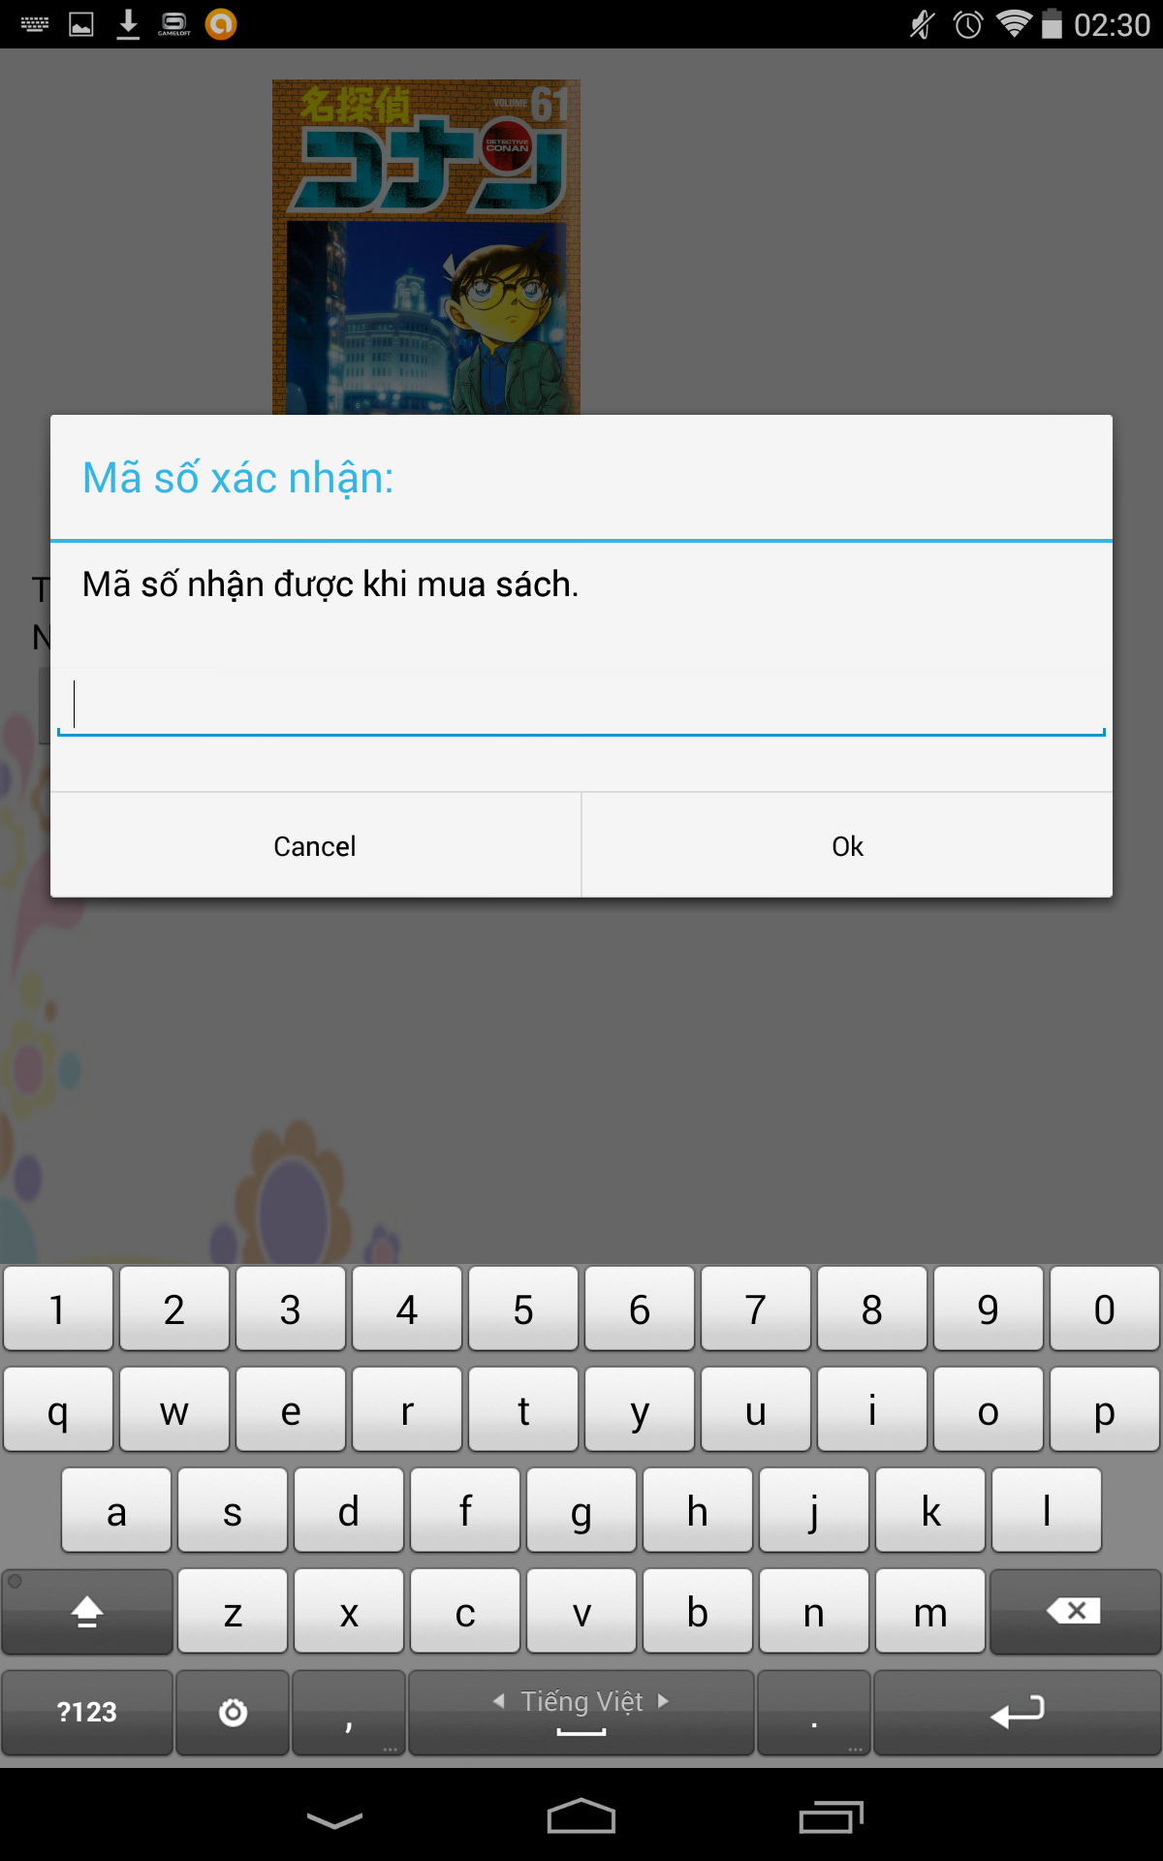

**3**

**2**

**1**

Figure 61: Mobile App - Enter license code user interface

**Fields:**

|  |  |  |  |  |  |  |  |
| --- | --- | --- | --- | --- | --- | --- | --- |
| **No** | **Field Name** | **Description** | **Read only** | **Mandatory** | **Control Type** | **Data Type** | **Length** |
| 1 | Input code | Input the reading code when buying books offline | No | Yes | Edit Text | String | N/A |

**Buttons/Hyperlinks**

|  |  |  |  |  |
| --- | --- | --- | --- | --- |
| **No** | **Function** | **Description** | **Validation** | **Outcome** |
| 2 | OK button | Confirm and send check code request | N/A | Navigate to reading book page (ebook/ video/ audio) |
| 3 | Cancel button | Cancel input code | N/A | Return read book page. |

#### <User/ Guest> Read book – Read ebook

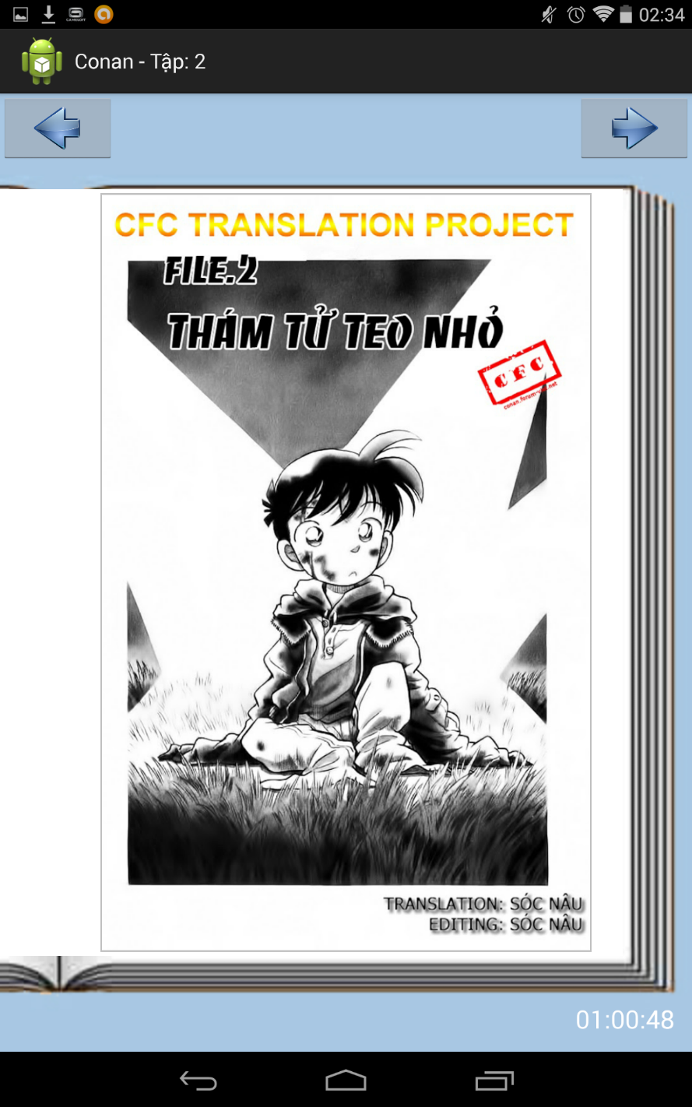

**2**

**1**

Figure 62: Mobile App - Read ebook user interface

**Buttons/Hyperlinks**

|  |  |  |  |  |
| --- | --- | --- | --- | --- |
| **No** | **Function** | **Description** | **Validation** | **Outcome** |
| 1 | Previous chapter button | Load previous chapter | N/A | Navigate to previous chapter page. |
| 2 | Next chapter button | Load next chapter | N/A | Navigate to next chapter page. |

#### <User/ Guest> Read book – Watch video

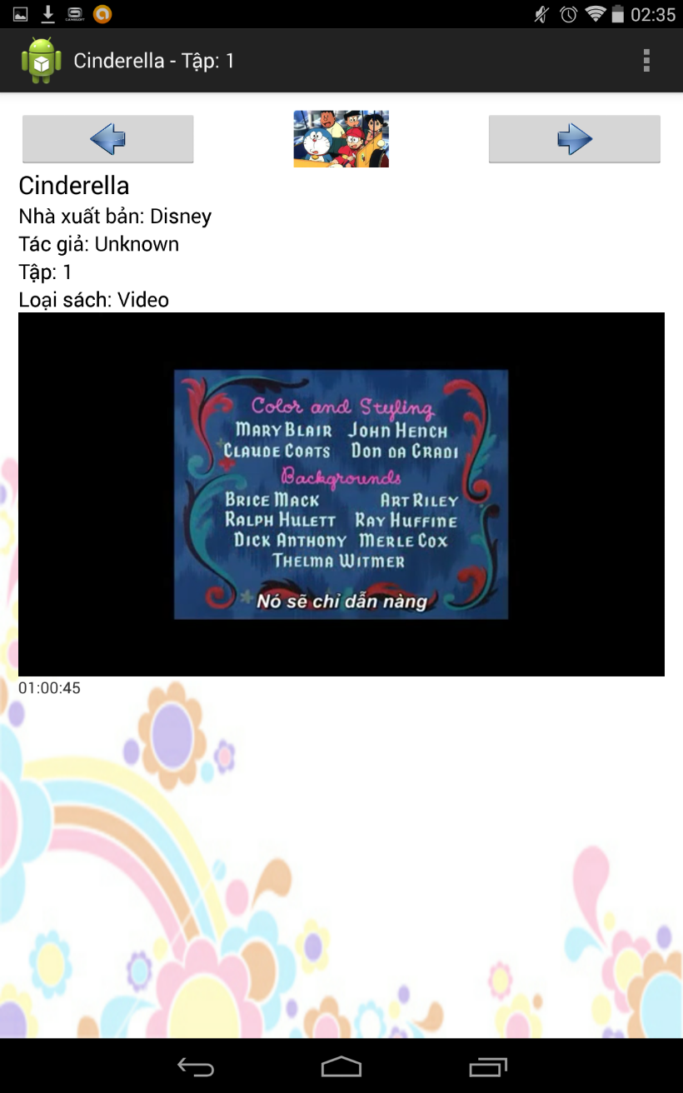

**2**

**1**

Figure 63: Mobile App - watch video user interface

**Buttons/Hyperlinks**

|  |  |  |  |  |
| --- | --- | --- | --- | --- |
| **No** | **Function** | **Description** | **Validation** | **Outcome** |
| 1 | Previous chapter button | Load previous chapter | N/A | Navigate to previous chapter page. |
| 2 | Next chapter button | Load next chapter | N/A | Navigate to next chapter page. |

#### <User/ Guest> Read book – Play audio

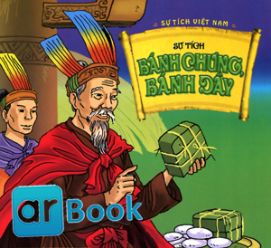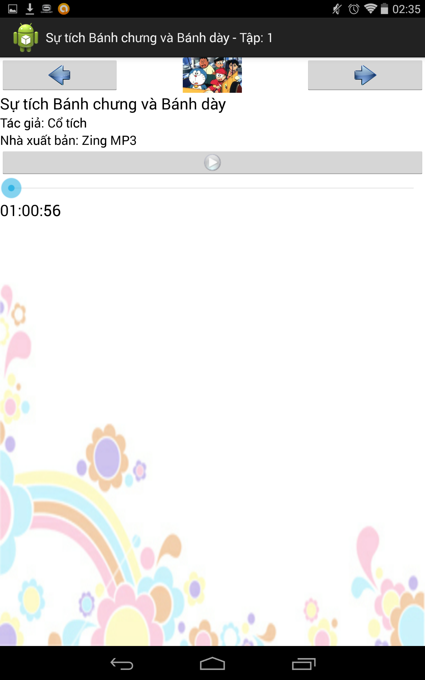

**4**

**3**

**2**

**1**

Figure 64: Mobile App - Play audio user interface

**Buttons/Hyperlinks**

|  |  |  |  |  |
| --- | --- | --- | --- | --- |
| **No** | **Function** | **Description** | **Validation** | **Outcome** |
| 1 | Previous chapter button | Load previous chapter | N/A | Navigate to previous chapter page. |
| 2 | Next chapter button | Load next chapter | N/A | Navigate to next chapter page. |
| 3 | Play/ Pause button | Play/ pause audio book | N/A | Play/ Pause audio. |
| 4 | Process bar | Indicate process of reading book | N/A | Play audio with identify time. |

#### <User>Configure schedule

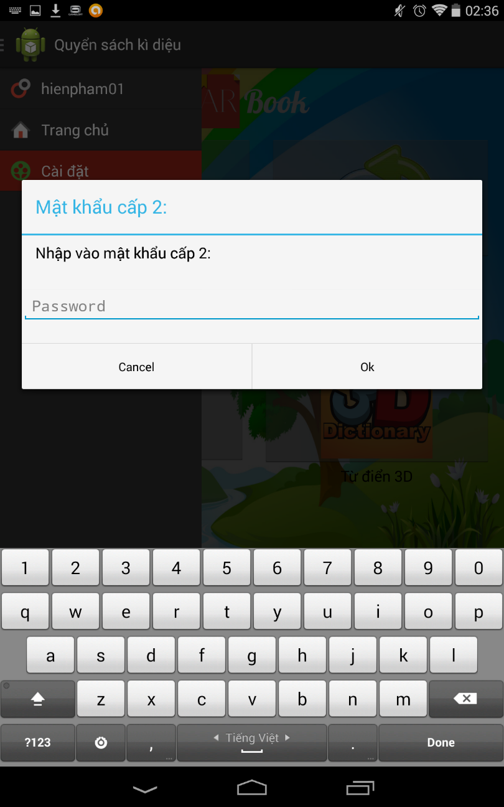

**3**

**2**

**1**

Figure 65: Mobile App - Enter secondary password user interface

**Fields:**

|  |  |  |  |  |  |  |  |
| --- | --- | --- | --- | --- | --- | --- | --- |
| **No** | **Field Name** | **Description** | **Read only** | **Mandatory** | **Control Type** | **Data Type** | **Length** |
| 1 | Input secondary password | Fill secondary password | No | Yes | Edit Text | String | N/A |

**Buttons/Hyperlinks**

|  |  |  |  |  |
| --- | --- | --- | --- | --- |
| **No** | **Function** | **Description** | **Validation** | **Outcome** |
| 2 | OK button | Confirm and send check secondary password | N/A | Navigate to reading schedule page |
| 3 | Cancel button | Cancel input password | N/A | Return home page. |

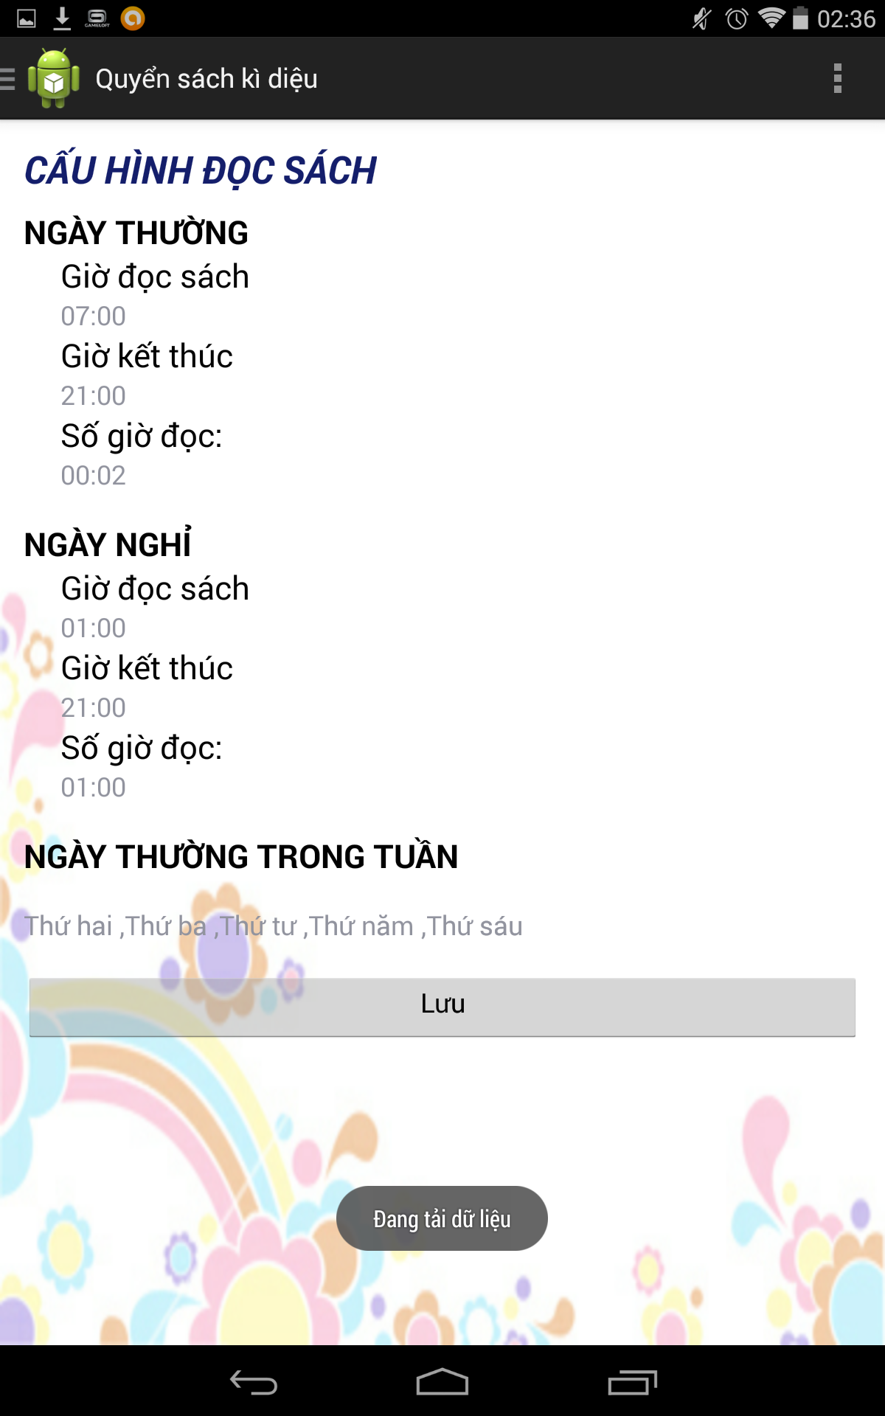

8

7

4

3

2

1

6

5

Figure 66: Mobile App - Set schedule user interface

**Fields:**

|  |  |  |  |  |  |  |  |
| --- | --- | --- | --- | --- | --- | --- | --- |
| **No** | **Field Name** | **Description** | **Read only** | **Mandatory** | **Control Type** | **Data Type** | **Length** |
| 1 | Start time reading for working day field | Choose reading start time for working day | No | Yes | Time Dialog | Time | N/A |
| 2 | End time reading for working day field | Choose reading end time for working day | No | Yes | Time Dialog | Time | N/A |
| 3 | Reading duration for working day field | Choose reading duration for working day | No | Yes | Time Dialog | Time | N/A |
| 4 | Start time reading for holiday field | Choose reading start time for holiday | No | Yes | Time Dialog | Time | N/A |
| 5 | End time reading for holiday field | Choose reading end time for holiday | No | Yes | Time Dialog | Time | N/A |
| 6 | Reading duration for holiday field | Choose reading duration for holiday | No | Yes | Time Dialog | Time | N/A |
| 7 | Working day chosen field | Choose which day in week is working day | No | Yes | Alert Dialog | ArrayList<String> | N/A |

**Buttons/Hyperlinks**

|  |  |  |  |  |
| --- | --- | --- | --- | --- |
| **No** | **Function** | **Description** | **Validation** | **Outcome** |
| 2 | Save button | Save schedule | N/A | Navigate to home page. |

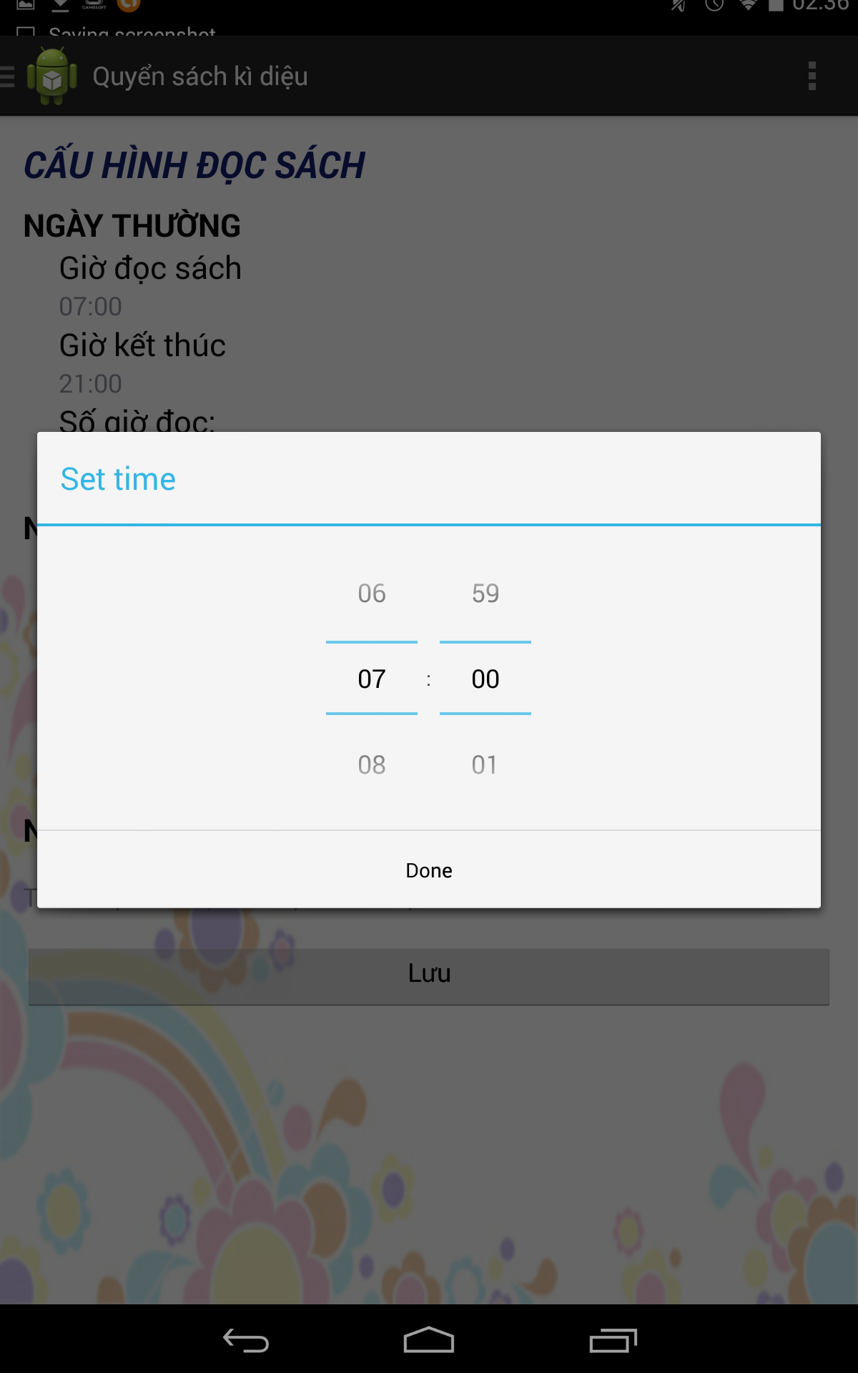

**2**

**1**

Figure 67: Mobile App - choose time user interface

**Fields:**

|  |  |  |  |  |  |  |  |
| --- | --- | --- | --- | --- | --- | --- | --- |
| **No** | **Field Name** | **Description** | **Read only** | **Mandatory** | **Control Type** | **Data Type** | **Length** |
| 1 | Input duration/ start time/ end time for working day (or holiday) | Choose time | No | Yes | Time Picker | Time | N/A |

**Buttons/Hyperlinks**

|  |  |  |  |  |
| --- | --- | --- | --- | --- |
| **No** | **Function** | **Description** | **Validation** | **Outcome** |
| 2 | Done button | Confirm and set duration/ start time/ end time for working day (or holiday) | N/A | Return setting page |

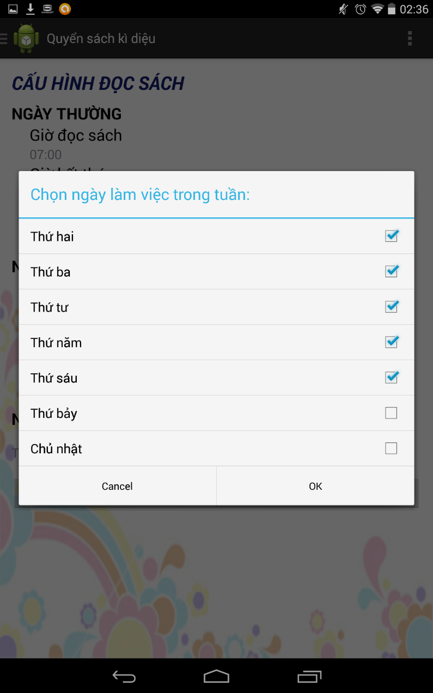

**3**

**2**

**1**

Figure 68: Mobile App - Choose working day user interface

**Fields:**

|  |  |  |  |  |  |  |  |
| --- | --- | --- | --- | --- | --- | --- | --- |
| **No** | **Field Name** | **Description** | **Read only** | **Mandatory** | **Control Type** | **Data Type** | **Length** |
| 1 | Working day check list | Choose working day | No | Yes | Check list | ArrayList<String> | N/A |

**Buttons/Hyperlinks**

|  |  |  |  |  |
| --- | --- | --- | --- | --- |
| **No** | **Function** | **Description** | **Validation** | **Outcome** |
| 2 | OK button | Confirm and set working day | N/A | Return setting page |
| 3 | Cancel button | Cancel choose working day | N/A | Return setting page |

#### 3D Dictionary



**1**

Figure 69: Mobile App - Recognize image 3D user interface

**Fields**

|  |  |  |  |  |  |  |  |
| --- | --- | --- | --- | --- | --- | --- | --- |
| **No** | **Field Name** | **Description** | **Read only** | **Mandatory** | **Control Type** | **Data Type** | **Length** |
| 1 | Camera | Put the camera on the image to recognize | Yes | Yes | N/A | View | N/A |

**Buttons/Hyperlinks**

Auto navigate to read book page

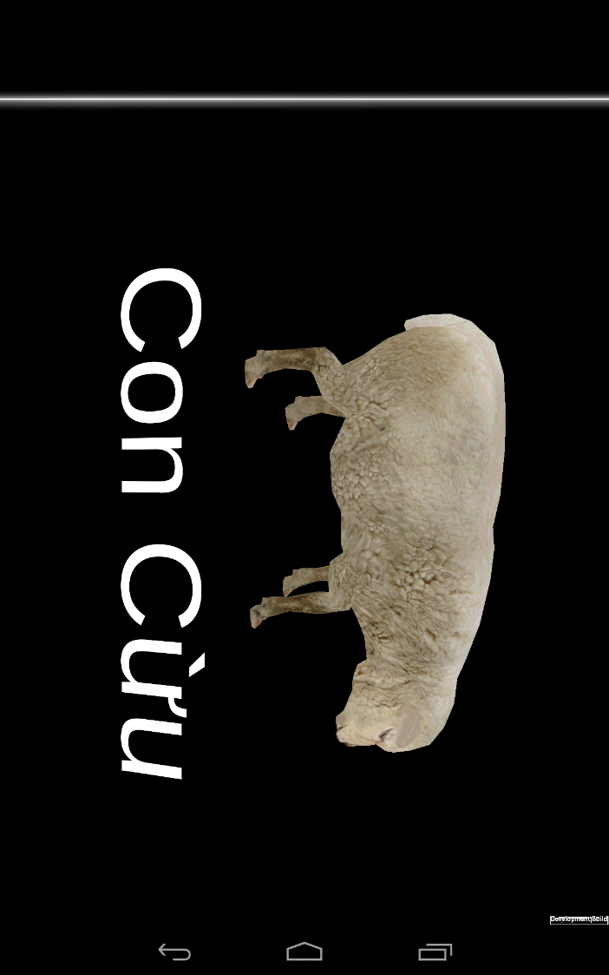

**1**

Figure 70: Mobile App - 3D model user interface

**Buttons/Hyperlinks**

|  |  |  |  |  |
| --- | --- | --- | --- | --- |
| **No** | **Function** | **Description** | **Validation** | **Outcome** |
| 1 | 3D model | Touch 3D model even | N/A | 3D model change state (run/ Idle) and play sound |

## Database Design

### Webservice

#### Entity Relationship Diagram

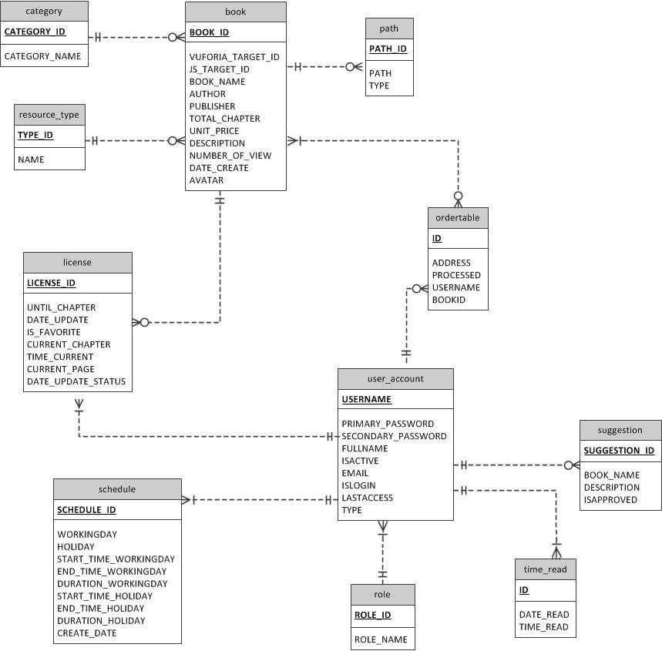

Figure 71: Entity Relationship Diagram

#### Data Dictionary

|  |  |  |
| --- | --- | --- |
| **Entity Data dictionary: describe content of all entities** | | |
| No | Entity Name | Description |
| 1 | Order | Describe all users’ purchasing history. |
| 2 | Book | Describe all books in the system. |
| 3 | Category | Describe all categories in the system. |
| 4 | Path | Describe all paths of each book. |
| 5 | Resource_type | Describe resource types of each book. |
| 6 | License | Describe all licenses of each user. |
| 7 | Schedule | Describe all schedule of each user. |
| 8 | User_account | Describe all user accounts in the system. |
| 9 | Suggestion | Describe all suggestion books user sent. |
| 10 | Time_read | Describe last reading time of user. |
| 11 | Role | Describe all user roles of each user. |

Table 32: Data dictionary

### Mobile Application

Using Webservice Database

### Web Application

Using Webservice Database

## Algorithms

### Upload target image to Cloud Target Database:

#### Definition:

After creating an account in the Target Manager UI, the developer is presented with a choice: use device-based databases or cloud based databases. You will not be able to convert a database to the other type later on, so be clear on which capabilities you need.

**Device databases** provide Vuforia applications with a locally accessible database of image targets.

If you know what the application will be expected “see,” and the target set of images is fewer than 100, then a local device database is the right solution.  Device database use cases include promotional campaigns for a specific set of products or print material, i.e., anything that will be identified and scanned with a lower set of images.  Device databases receive more immediate responses since the images are stored locally.

**Cloud databases** provide Vuforia applications with a large number of targets.  Cloud databases are stored in the Internet and support over a million image targets.

If the application supports a retail or catalog use case where there are more than 100 images, or the images are updated frequently, then a cloud database is the right solution for you.  Cloud image targets may take a little longer to identify (depending on network connectivity), but they provide a strong image recognition capability.

#### Define problem:

When we upload image target to Cloud target database, we have to access to Target Manager UI of Vuforia. We need a REST service to upload image target and book Information the same time.

Input of algorithm: Image target, metadata file, book detail information.

Output:

Image target must be saved in Cloud target Database

Book must be saved in Database with target code is target code on cloud.

#### Solution:

To solve this problem, we should follow these steps:

* + - Define **book** is book instant.
    - Define **image** is image stream received from local storage.
    - Define **metadata** file (text file, stored as key: value format)
    - Add target to Cloud Database:

Send HTTP POST request to <https://vws.vuforia.com/targets>. The request header should include:

Access_key: received when create database from Target Manager

Secret_key: received when create database from Target Manager

And declare an application/json content type. The body of the request needs to be a JSON object that defines the properties of the targets as specified here.

Vuforia's Cloud Recognition service also enables you to add a digital content payload to your target. You can include up to 1 MB of base 64 encoded content, such as images or mobile-optimized 3D models, as metadata attached to the target's search result. This enables you to host your content with your targets in the Cloud Recognition service.

The developer CMS performs an HTTPS POST on <https://vws.vuforia.com/targets>, with the header containing the usual HTTP header fields plus the Authorization field, and the JSON body containing the new target information, including the image. The PostNewTarget.java sample shows this.

The JSON body is defined as follows:

| **Field name** | **Type** | **Mandatory** | **Description** |
| --- | --- | --- | --- |
| name | String [1 - 64] | Yes | Name of the target, unique within a database |
| width | Float | Yes | Width of the target in scene unit |
| image | Base64 encoded binary image file in JPG or PNG format | No* | Contains the base64 encoded binary recognition image data |
| active_flag | Boolean | No | Indicates whether or not the target is active for query |
| application_metadata | Base64 encoded data | No** | The base64 encoded application metadata associated with the target |

The request message body is provided below. The Vuforia Web Services API will only accept a valid post request whose image size is within 2.25Mbytes (or 3Mbytes base64 encoded) and whose application metadata size is within 1Mbytes (or 1.3Mbytes base64 encoded).

Only 8-bit greyscale and 24-bit RGB JPG or PNG image files will be accepted.

The response contains the ID of the resulting target.  Confirm that the status is “Success”; otherwise an error has occurred.

The resulting JSON body is structured as follows:

| **Field** | **Type** | **Mandatory** | **Description** |
| --- | --- | --- | --- |
| result_code | String [1 - 64] | Yes | One of the Vuforia [Common Result Codes](https://developer.vuforia.com/resources/dev-guide/common-result-codes)(*) |
| transaction_id | 32-character String (UUID) | Yes | ID of the transaction |
| Results | target_id [0..unbounded] | Yes | List of target IDs for the target within the developer project |

The supported result_code and its corresponding HTTP status code follow.

| **result_code** | **HTTP status code** | **Description** |
| --- | --- | --- |
| “Success” | OK (200) | Transaction succeeded |
| “TargetCreated” | Created (201) | Target created (target POST response) |
| “AuthenticationFailure” | Authentication failure (401) | Signature authentication failed |
| “RequestTimeTooSkewed” | Forbidden (403) | Request timestamp outside allowed range |
| “TargetNameExist” | Forbidden (403) | The corresponding target name already exists (target POST/PUT response) |
| “UnknownTarget” | Not Found (404) | The specified target ID does not exist (target PUT/GET/DELETE response) |
| “BadImage” | Unprocessable Entity (422) | Image corrupted or format not supported (target POST/PUT response) |
| “ImageTooLarge” | Unprocessable Entity (422) | Image size exceeds maximum limit (target POST/PUT response) |
| “MetadataTooLarge” | Unprocessable Entity (422) | Target metadata size exceeds maximum limit (target POST/PUT response) |
| "DateRangeError" | Unprocessable Entity (422) | Start date is after the end date |
| “Fail” | Internal Server Error (500) | The server encountered an internal error; please retry the request |

When we receive target_id from service, add book to database with book information and target code.

#### Flow chart

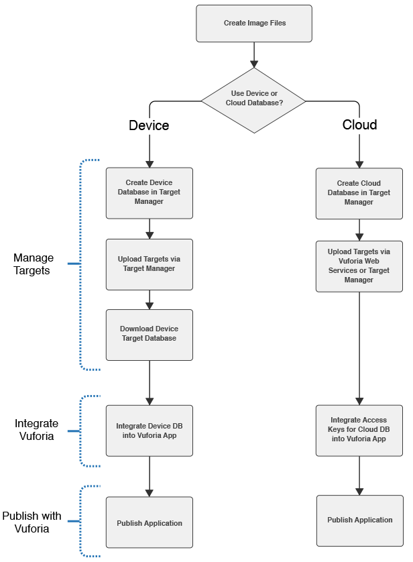

#### Example:

We add a target name “tarmac”

Input:

|  |
| --- |
| POST /targets HTTP/1.1  Host: vws.vuforia.com  Date: Mon, 23 Apr 2012 12:45:19 GMT  Authorization: VWS df8d23140eb443505c0661c5b58294ef472baf64:jHX6oLeqTXpynyqcvVC2MSHarhU  Content-Type: application/json  {  “name”:”tarmac”,  “width:32.0,  “image”:”0912ba39x….”,  “application_metadata”:“496fbb6532b3863460a984de1d980bed5ebcd507”  } |
|  |

Response:

HTTP/1.1 201 Created

Content-Type: application/json

{

“result_code”:”Success”,

“transaction_id”:”550e8400e29b41d4a716446655440452”,

“target_id”: ”550e8400e29b41d41626446655440000”

}

Then add book with target Id 550e8400e29b41d41626446655440000 into database.

### Recognize image to book resource

#### Define problem

In our solution, there is a function call “Recognize book”. This function allow user to use physical camera device to recognize image into target code. This code is used to get book resource from webservice. This algorithm is using 2 platform: Vuforia (Mobile Application) and JS Toolkit (Web application). Here we can decribe the problem below:

We have a picture which printed on the book. We have to recognize that book is which book in our book library. Find the way to recognize book image to a book code, then match the code with our code in library.

Input of algoriths: Image to recognize

Output format must be:

Book: <book name>

<Book detail information>

<Book target code>

#### Solution

##### Vuforia platform

To solve this problem, we should follow these steps:

* + - Call **targetId** is targetId to be recognized.
    - Create connection to Vuforia cloud service by Vuforia SDK with parameter: “Access_key” and “Secret_key”.
    - Initial **tracker**, **QCAR** **update**.
    - Create new **Vuforia** **app** **session**.
    - Open device camera, receive camera frame.
    - Convert Camera frame to pixel format
    - Loop: Send pixel format to Vuforia tracker service until matching return target code:
      * Matching pixel format with pixel format of all the target uploaded before in Cloud Target Database.
    - If match, set targetId is target_id received from response.
    - Call getBook API of REST API:

Get book by target id

Response book json as format:

{

"author": "UNKNOW",

"avatar": "http://doctorcomicsdotcom.files.wordpress.com/2011/09/doraemon.jpg",

"bookId": 1,

"bookName": "Doraemon",

"category": "Truyen Tranh",

"description": "kajajs",

"pathList": [

{

"chapter": 1,

"type": 1,

"url": "23Sc34gvRsQ"

}

],

"publisher": "Kim Dong",

"status": 1,

"totalChapter": 50,

"type": "Video",

"unitPrice": "2000",

"vufoId": "eeec4e0aa0de428e9236e019b810da7d"

}

Below is Vuforia SDK architecture diagram

(bounded red is what we use)

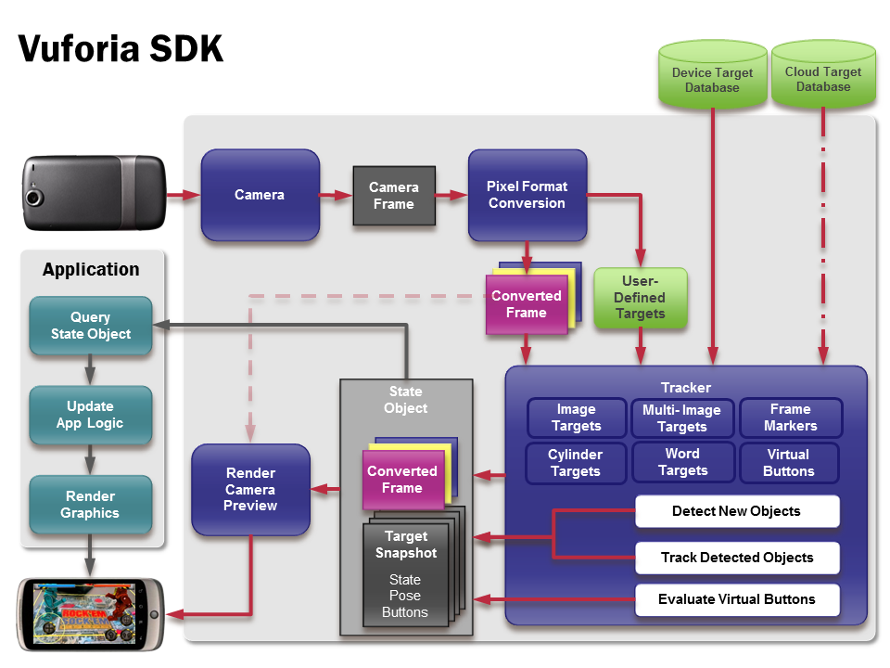

##### JS AR Toolkit

To resolve this problem on web, we should follow these steps:

* + - Define **raster** = new NyARRgbRaster_Canvas2D(canvas) to set up JSAR Toolkit
    - Init **dector**, then begin camera
    - Using getUserMedia to access webcam
    - Begin detect maker:
      * Get camera frame from webcam
      * Detect marker into matrix
    - Loops: Matrix mapping: use Thee.js of JSAR toolkit until matrix mapping with 100 matrix from makers default.

#### Example

##### Mobile Application:

Image frame from camera:



Convert image into pixel:

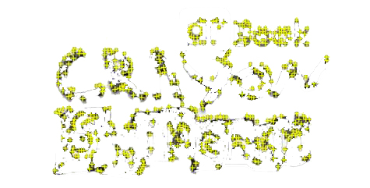

Then matching on image on cloud database



Return book:

{

"author": "Unknown",

"avatar": "http://evan.vnexpress.net/news/tin-tuc/trong-nuoc/2011/11/10227-shin-cau-be-but-chi-tro-lai-gioi-han-do-tuoi-tren-12/shin.jpg",

"bookId": 21,

"bookName": "Shin - Cậu bé bút chì",

"category": "Truyen Tranh",

"description": "Hoat hinhTruyện tranh Nhật Bản",

"pathList": [

{

"chapter": 1,

"type": 1,

"url": "https://www.youtube.com/watch?v=SD9Z1p1MvpQ"

},

{

"chapter": 2,

"type": 1,

"url": "https://www.youtube.com/watch?v=LO5XNC4pkBg"

},

{

"chapter": 3,

"type": 1,

"url": "https://www.youtube.com/watch?v=wctmzLxX71c"

},

{

"chapter": 4,

"type": 1,

"url": "https://www.youtube.com/watch?v=5sntBiLVYXw"

},

{

"chapter": 5,

"type": 1,

"url": "https://www.youtube.com/watch?v=6vbtQECoFX4"

},

{

"chapter": 6,

"type": 1,

"url": "https://www.youtube.com/watch?v=qa-FMyQ2Ls4"

},

{

"chapter": 7,

"type": 1,

"url": "https://www.youtube.com/watch?v=65v2Rzg5P40"

},

{

"chapter": 8,

"type": 1,

"url": "https://www.youtube.com/watch?v=JWd0kqebp8A"

},

{

"chapter": 9,

"type": 1,

"url": "https://www.youtube.com/watch?v=D3gh-41at_c"

},

{

"chapter": 10,

"type": 1,

"url": "https://www.youtube.com/watch?v=ncaTq43n7Go"

},

{

"chapter": 11,

"type": 1,

"url": "https://www.youtube.com/watch?v=hgnqNLlGXis"

},

{

"chapter": 12,

"type": 1,

"url": "https://www.youtube.com/watch?v=V7LRJeVUWj8"

},

{

"chapter": 13,

"type": 1,

"url": "https://www.youtube.com/watch?v=W6bxhkU3Hpk"

},

{

"chapter": 14,

"type": 1,

"url": "https://www.youtube.com/watch?v=Wni8yBqrYqo"

}

],

"publisher": "Kim Đồng",

"status": 1,

"totalChapter": 14,

"type": "Video",

"unitPrice": "2000",

"vufoId": "6d7f07d91cd84b7a9d113de5876103af"

}

##### Web application

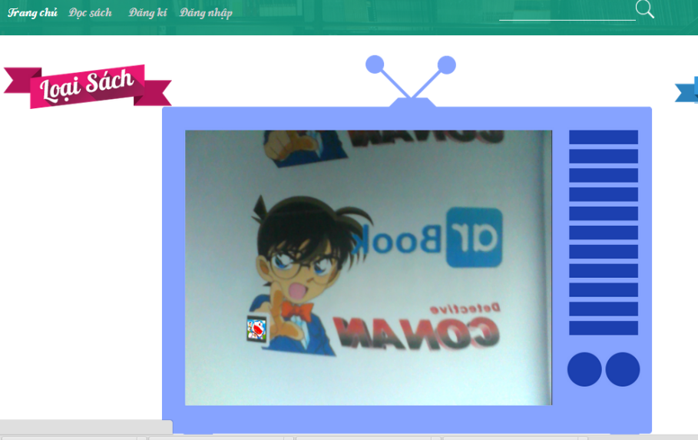

Detecting marker and mapping with matrix



Return matrix code

Send request to REST Web service to get book with js toolkit code.

# System Implementation & Test

## Introduction

### System Overview

This section provides in detail al2l necessary information about test plans, test cases, test result, test environments, pass/fail criteria and risks estimations as well as a checklist to cover all possible cases of ARB.

### Test Approach

- Goal: To test the whole system based on the core workflow.

- Method: System Testing, Black-box Testing.

## Database Relationship Diagram

### Diagram

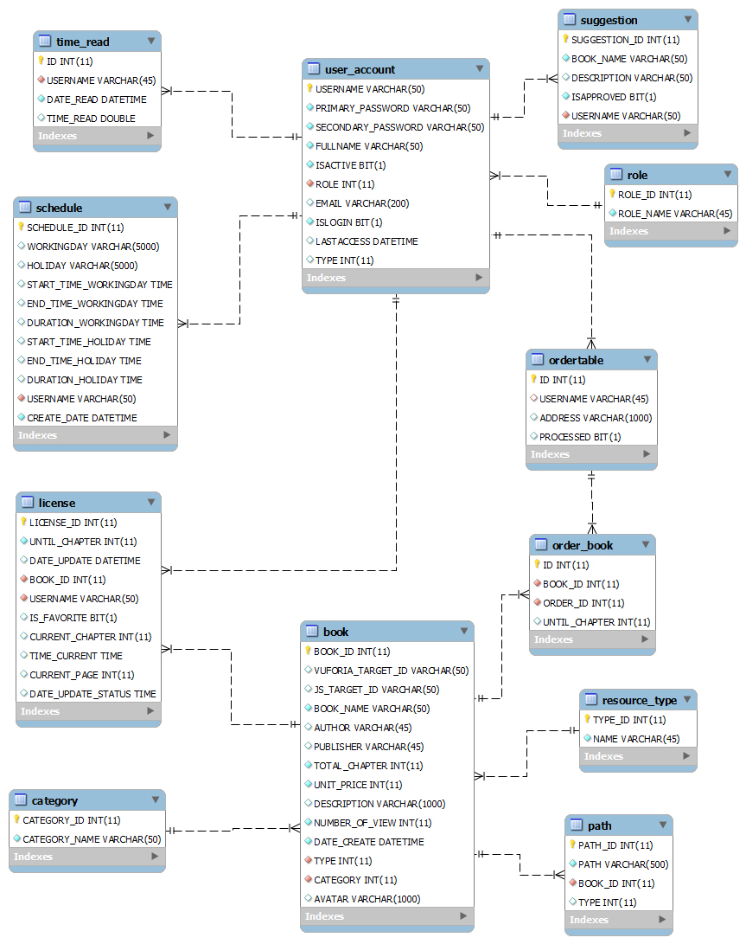

Figure 72: Database Relationship Diagram

### Data Dictionary

|  |  |
| --- | --- |
| **Entity Data dictionary: describe content of all entities** | |
| Entity Name | Description |
| OrderTable | Describe all users’ purchasing history. |
| Book | Describe all books in the system. |
| Category | Describe all categories in the system. |
| Path | Describe all paths of each book. |
| Resource_type | Describe resource types of each book. |
| License | Describe all licenses of each user. |
| Schedule | Describe all schedule of each user. |
| User_account | Describe all user accounts in the system. |
| Suggestion | Describe all suggestion books user sent. |
| Time_read | Describe last reading time of user. |
| Role | Describe all user roles of each user. |
| OrderBook | Describe all users’ purchasing history book. |

Table 33: Data Dictionary

|  |  |  |  |  |
| --- | --- | --- | --- | --- |
| **Entity name** | **Attributes** | **Description** | **Domain** | **Null** |
| order_table | ID {PK} | Unique identifier of an OrderTable, auto increment. | Int(11) | No |
| USERNAME | User’s name | Varchar(45) | No |
| ADDRESS | User’s address | Varchar(1000) | No |
| PROCESSED | Order status | Bit | No |
| book | BOOK_ID {PK} | Unique identifier of a Book, auto increment. | Int | No |
| VUFORIA_TARGET_ID | Vuforia’s Id | Varchar(50) | No |
| JS_TARGET_ID | Js’ Id | Varchar(50) | No |
| BOOK_NAME | Book’s name | Varchar(50) | No |
| AUTHOR | Book’s author | Varchar(45) | Yes |
| PUBLISHER | Book’s publisher | Varchar(45) | Yes |
| TOTAL_CHAPTER | Total chapter of book | Int(11) | No |
| UNIT_PRICE | Price of per chaper | Int(11) | No |
| DESCRIPTION | Book’s description | Varchar(1000) | Yes |
| NUMBER_OF_VIEW | Number of view book | Int(11) | No |
| DATE_CREATE | Book’s create date | DateTime | No |
| TYPE {FK} | Foreign key, resource_type identifier. | Int(11) | No |
| CATEGORY {FK} | Foreign key, category identifier. | Int(11) | No |
| AVATAR | Book’s avatar | Varchar(1000) | Yes |
| category | CATEGORY_ID {PK} | Unique identifier of a category, auto increment. | Int(11) | No |
| CATEGORY_NAME | Category’s name | Varchar(1000) | No |
| path | PATH_ID {PK} | Unique identifier of a path, auto increment. | Int(11) | No |
| PATH | Book’s path | Varchar(500) | No |
| BOOK_ID {FK} | Foreign key, book identifier. | Int(11) | No |
| TYPE | Path’s type | Int(11) | No |
| CHAPTER | Book’s chapter | Int(11) | No |
| resource_type | TYPE_ID {PK} | Unique identifier of a resource type, auto increment. | Int(11) | No |
| NAME | Resource type’s name | Varchar(45) | No |
| license | LICENSE_ID {PK} | Unique identifier of a license, auto increment. | Int(11) | No |
| UNTIL_CHAPTER | Number of chapter | Int(11) | No |
| DATE_UPDATE | License’s update date | DateTime | No |
| BOOK_ID {FK} | Foreign key, book identifier. | Int(11) | No |
| USERNAME {FK} | Foreign key, user account indentifier | Varchar(11) | No |
| IS_FAVORITE | Favorite status | Bit | No |
| CURRENT_CHAPTER | Status’s chapter | Int(11) | No |
| TIME_CURRENT | Status’s time | Time | No |
| CURRENT_PAGE | Status’s page | Int(11) | No |
| DATE_UPDATE_STATUS | Status’s update date | DateTime | No |
| Schedule | SCHEDULE_ID {PK} | Unique identifier of a schedule, auto increment. | Int(11) | No |
| WORKINGDAY | Working days | Varchar(5000) | No |
| HOLIDAY | Holidays | Varchar(5000) | No |
| START_TIME_WORKINGDAY | Working day’s start time | Time | No |
| END_TIME_WORKINGDAY | Working day’s end time | Time | No |
| START_TIME_HOLIDAY | Holiday’s start time | Time | No |
| END_TIME_HOLIDAY | Holiday’s end time | Time | No |
| DURATION_WORKINGDAY | Working day’s duration time | Time | No |
| DURATION_HOLIDAY | Holiday’s duration time | Time | No |
| CREATE_DATE | Schedule’s create date | DATETIME | No |
| USERNAME {FK} | Foreign key, user account indentifier | Varchar(11) | No |
| user_account | USERNAME {PK} | Unique identifier of a user account | Varchar(50) | No |
| PRIMARY_PASSWORD | User’s primary password | Varchar(50) | No |
| SECONDARY_PASSWORD | User’s secondary password | Varchar(50) | No |
| FULLNAME | User’s full name | Varchar(50) | No |
| ISACTIVE | User’s status | Bit | No |
| ROLE {FK} | Foreign key, role indentifier | Int(11) | No |
| EMAIL | User’s email | Varchar(200) | No |
| ISLOGIN | User’s login status | Bit | No |
| LASSACCESS | User’s last access time | DateTime | Yes |
| TYPE | User’s type | Int(11) | No |
| suggestion | SUGGESTION_ID {PK} | Unique identifier of a suggestion, auto increment. | Int(11) | No |
| BOOK_NAME | Book’s name | Varchar(50) | No |
| DESCRIPTION | Book’s description | Varchar(50) | Yes |
| ISAPPROVE | Approve’s status | Bit | No |
| USERNAME {FK} | Foreign key, user account indentifier | Varchar(50) | No |
| time_read | ID {PK} | Unique identifier of a time read, auto increment. | Int(11) | No |
| USERNAME {FK} | Foreign key, user account indentifier | Varchar(45) | No |
| DATE_READ | Read book’s date | DateTime | No |
| TIME_READ | Read book’s time | DOUBLE | No |
| role | ROLE_ID {PK} | Unique identifier of a role | Int(11) | No |
| ROLE_NAME | Role’s name | Varchar(45) | No |
| order_book | ID {PK} | Unique identifier of a order book, auto increment | Int(11) | No |
| BOOK_ID {FK} | Foreign key, book indentifier | Int(11) | No |
| ORDER_ID {FK} | Foreign key, order table indentifier | Int(11) | No |
| UNTIL_CHAPTER | Number of order chapter | Int(11) | No |

Table 34: Attribute data dictionary

## Performance Measures

### Vuforia recognize

* + - Recognizing image is not exceed 5 seconds.
    - Work well with low light.
    - Recognize sucessfully 95%.

### JS Toolkit recognize

* + - Recognizing image is not exceed 7 seconds.
    - Recognize sucessfully 90%.

### Send request to REST Web service

* + - All API response within 2 seconds.

## Test Plan

The purpose of this section is to verify and ensure that ARB meets its design specification and other requirements from user. The following part will describe which features to be tested and which will not.

### Features to be tested

We will test the entire system based on the following core workflow.

Based on the workflow, all following features will be tested, which can include one or more functions. These features will be focused and tested thoroughly during the test phase.

* Guest: search book, input code to read book
* User: setting schedule, read book, add to cart, update license, 3D dictionary.

### Features not to be tested

* Login, Logout.
* Change Password.
* Manage book.
* Manage order.
* Manage user.

### Acceptance test criteria

The project is accepted if:

* All test cases have been executed
* All found defects have been analysed and resolved.
* All defect-related test cases have been re-executed.

## System Testing Test Case

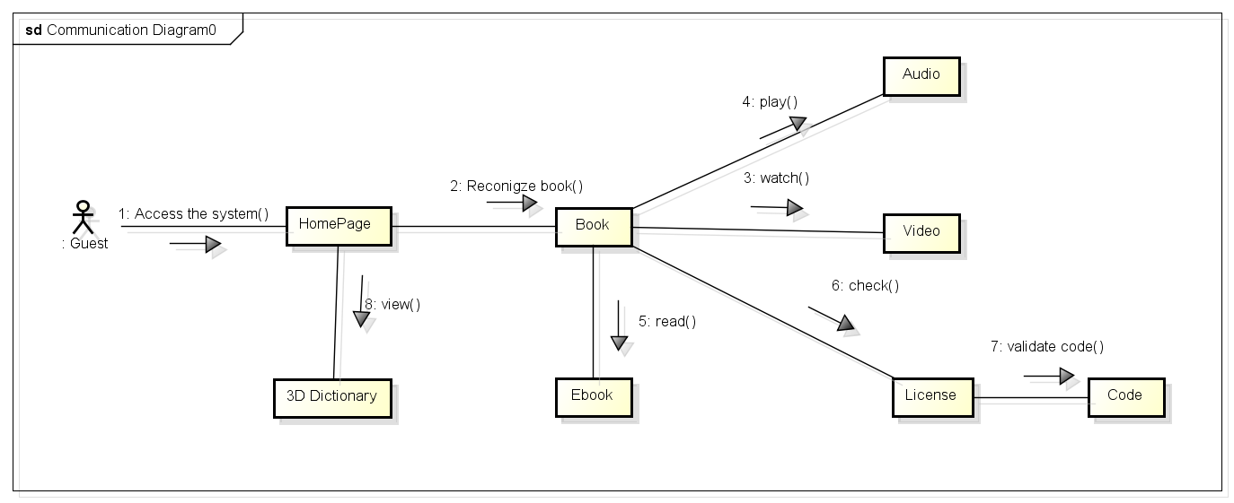

Figure 73: GUEST CORE FLOW

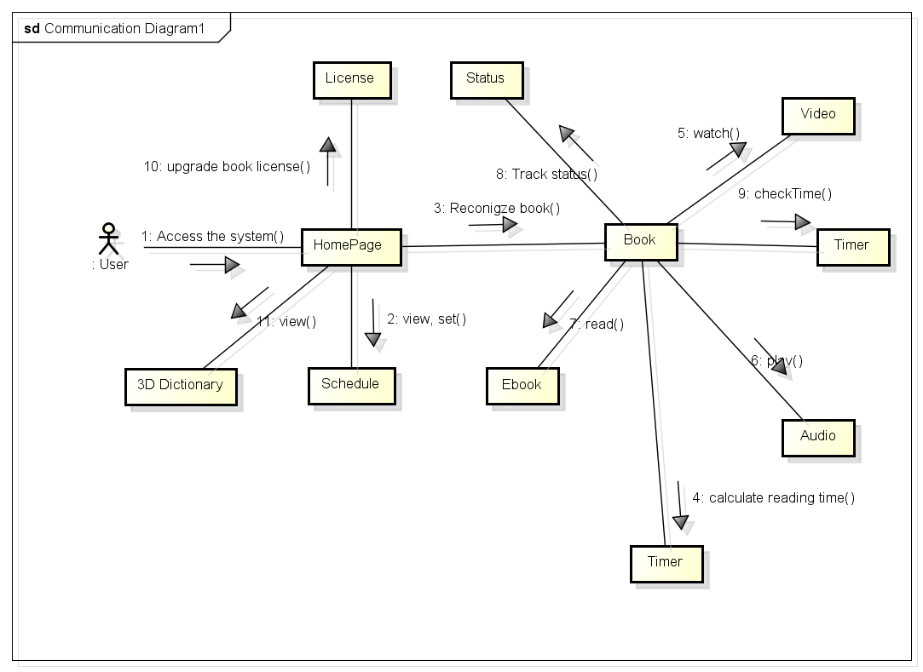

Figure 74: USER CORE FLOW

### Web application

#### Guest test case

##### Search book

|  |  |  |  |  |  |  |  |
| --- | --- | --- | --- | --- | --- | --- | --- |
| **ID** | **Test Case Description** | **Test Case Procedure** | **Expected output** | **Inter-test Case Dependence** | **Result** | **Test Date** | **Note** |
| SB01 | Guest searches book | 1 – On the home page, Input name of book on search textbox  2 – Click “**Search**” button or press enter key | - After step 2, show search result with book name, price |  | Passed | 16/08/2014 |  |
| SB02 | Member searches book | 1 – Login with user role  2 – On the home page, Input name of book on search textbox  3 – Click “**Search**” button or press enter key | - After step 3, show search result with book name, price |  | Passed | 16/08/2014 |  |

Table 35: Web App - Search book test case

##### Input code to read book

|  |  |  |  |  |  |  |  |
| --- | --- | --- | --- | --- | --- | --- | --- |
| **ID** | **Test Case Description** | **Test Case Procedure** | **Expected output** | **Inter-test Case Dependence** | **Result** | **Test Date** | **Note** |
| CB01 | Guest input code | 1 – Select book which is bought  2 – Execute to recognize book  3 – Select “**Nhập mã code**” in message box  4 – Input wrong code to textbox and press Enter key | - After step 4, guest can read book which is bought |  | Passed | 16/08/2014 |  |
| CB02 | Member input code | 1 – Login with user role  2 – Select book which is bought  3 – Execute to recognize book  4 – Select “**Nhập mã code**” in message box  5 – Input wrong code to textbox and press Enter key | - After step 5, guest can read book which is bought |  | Passed | 16/08/2014 |  |
| CB03 | Guest input wrong code | 1 – Select book which is bought  2 – Execute to recognize book  3 – Select “**Nhập mã code**” in message box  4 – Input wrong code to textbox and press Enter key | - After step 4, display warning box to guest |  | Passed | 16/08/2014 |  |
| CB04 | Member input wrong code | 1 – Login with user role  2 – Select book which is bought  3 – Execute to recognize book  4 – Select “**Nhập mã code**” in message box  5 – Input wrong code to textbox and press Enter key | - After step 5, display warning box to member |  | Passed | 16/08/2014 |  |
| CB05 | Guest doesn’t input code | 1 – Select book which is bought  2 – Execute to recognize book  3 – Select “**Nhập mã code**” in message box  4 – Doesn’t input code to textbox and press Enter key | - After step 4, display warning box to member |  | Passed | 16/08/2014 |  |
| CB06 | Member doesn’t input code | 1 – Login with user role  2 – Select book which is bought  3 – Execute to recognize book  4 – Select “**Nhập mã code**” in message box  5 –Doesn’t input to textbox and press Enter key | - After step 5, display warning box to member |  | Passed | 16/08/2014 |  |

Table 36: Web App - Input code to read book test case

#### User test case

##### Setting schedule

|  |  |  |  |  |  |  |  |
| --- | --- | --- | --- | --- | --- | --- | --- |
| **ID** | **Test Case Description** | **Test Case Procedure** | **Expected output** | **Inter-test Case Dependence** | **Result** | **Test Date** | **Note** |
| SS01 | Check Setting screen | 1 – Login with user role  2 – Select “**Cài đặt**” in menu bar | - After step 2, display setting screen |  | Passed | 16/08/2014 |  |
| SS02 | Check switch day | 1 – Login with user role  2 – Select “**Cài đặt**” in menu bar  3 – Click “**Chủ Nhật**” icon | - After step 3, “**Chủ Nhật**” will be switch to working day | “**Chủ Nhật**” is holiday day | Passed | 16/08/2014 |  |
| SS03 | Check increase duration time | 1 – Login with user role  2 – Select “**Cài đặt**” in menu bar  3 – Click increase button of duration time | - After step 3, duration time will be increased one unit |  | Passed | 16/08/2014 |  |
| SS04 | Check decrease duration time | 1 – Login with user role  2 – Select “**Cài đặt**” in menu bar  3 – Click decrease button of duration time | - After step 3, duration time will be decreased one unit |  | Passed | 16/08/2014 |  |
| SS05 | Check increase duration time with abnormal case | 1 – Login with user role  2 – Select “**Cài đặt**” in menu bar  3 – Click increase button of duration time | - After step 3, duration time won’t be increased | Duration time is 12 | Passed | 16/08/2014 |  |
| SS06 | Check decrease duration time with abnormal case | 1 – Login with user role  2 – Select “**Cài đặt**” in menu bar  3 – Click decrease button of duration time | - After step 3, duration time won’t be decreased | Duration time is 1 | Passed | 16/08/2014 |  |
| SS07 | Check increase “From” time | 1 – Login with user role  2 – Select “**Cài đặt**” in menu bar  3 – Click increase button of “From” time | - After step 3, “From” time will be increased one unit |  | Passed | 16/08/2014 |  |
| SS08 | Check decrease “From” time | 1 – Login with user role  2 – Select “**Cài đặt**” in menu bar  3 – Click decrease button of “From” time | - After step 3, “From” time will be decreased one unit |  | Passed | 16/08/2014 |  |
| SS09 | Check increase “From” time with abnormal case | 1 – Login with user role  2 – Select “**Cài đặt**” in menu bar  3 – Click increase button of “From” time | - After step 3, “From” time won’t be increased | “From” time is 12 | Passed | 16/08/2014 |  |
| SS10 | Check decrease “From” time with abnormal case | 1 – Login with user role  2 – Select “**Cài đặt**” in menu bar  3 – Click decrease button of “From” time | - After step 3, “From” time won’t be decreased | “From” time is 1 | Passed | 16/08/2014 |  |
| SS11 | Check increase “To” time | 1 – Login with user role  2 – Select “**Cài đặt**” in menu bar  3 – Click increase button of “To” time | - After step 3, “To” time will be increased one unit |  | Passed | 16/08/2014 |  |
| SS12 | Check decrease “To” time | 1 – Login with user role  2 – Select “**Cài đặt**” in menu bar  3 – Click decrease button of “To” time | - After step 3, “To” time will be decreased one unit |  | Passed | 16/08/2014 |  |
| SS13 | Check increase “To” time with abnormal case | 1 – Login with user role  2 – Select “**Cài đặt**” in menu bar  3 – Click increase button of “To” time | - After step 3, “To” time won’t be increased | “To” time is 12 | Passed | 16/08/2014 |  |
| SS14 | Check decrease “To” time with abnormal case | 1 – Login with user role  2 – Select “**Cài đặt**” in menu bar  3 – Click decrease button of “To” time | - After step 3, “To” time won’t be decreased | “To” time is 1 | Passed | 16/08/2014 |  |
| SS14 | Check save setting | 1 – Login with user role  2 – Select “**Cài đặt**” in menu bar  3 – Click save button | - After step 3, setting will be saved |  | Passed | 16/08/2014 |  |

Table 37: Web App - Setting schedule test case

##### Read book

|  |  |  |  |  |  |  |  |
| --- | --- | --- | --- | --- | --- | --- | --- |
| **ID** | **Test Case Description** | **Test Case Procedure** | **Expected output** | **Inter-test Case Dependence** | **Result** | **Test Date** | **Note** |
| RB01 | Read ebook | 1 – Login with user role  2 – Select ebook which is bought  3 – Execute to recognize book | - After step 3, show book to user |  | Passed | 16/08/2014 |  |
| RB02 | Read audio book | 1 – Login with user role  2 – Select audio book which is bought  3 – Execute to recognize book | - After step 3, show audio book to user |  | Passed | 16/08/2014 |  |
| RB03 | Read video book | 1 – Login with user role  2 – Select video book which is bought  3 – Execute to recognize book | - After step 3, show video book to user |  | Passed | 16/08/2014 |  |

Table 38: Web App - Read book test case

##### Add to cart

|  |  |  |  |  |  |  |  |
| --- | --- | --- | --- | --- | --- | --- | --- |
| **ID** | **Test Case Description** | **Test Case Procedure** | **Expected output** | **Inter-test Case Dependence** | **Result** | **Test Date** | **Note** |
| AC01 | Adds book to cart | 1 – On the search page, click on “**Mua sách**” button on search result row. | - After step 1, added book to cart. |  | Passed | 28/03/2014 |  |
| AC02 | Adds book to cart when the product has existed in cart | 1 – On the search page, click on “**Mua sách**” button on search result row. | - After step 1, update book of the product in cart. |  | Passed | 28/03/2014 |  |

Table 39: Web App - Add to cart test case

##### Update license

|  |  |  |  |  |  |  |  |
| --- | --- | --- | --- | --- | --- | --- | --- |
| **ID** | **Test Case Description** | **Test Case Procedure** | **Expected output** | **Inter-test Case Dependence** | **Result** | **Test Date** | **Note** |
| UL01 | Update license to ebook | 1 – Login with user role  2 – Select ebook which is bought  3 – Select chapter which user want to update | - After step 3, ebook will be update license to chapter which is chosen in step 3 |  | Passed | 28/03/2014 |  |
| UL02 | Update license to audio book | 1 – Login with user role  2 – Select audio book which is bought  3 – Select chapter which user want to update | - After step 3, audio book will be update license to chapter which is chosen in step 3 |  | Passed | 28/03/2014 |  |
| UL03 | Update license to video book | 1 – Login with user role  2 – Select video book which is bought  3 – Select chapter which user want to update | - After step 3, video book will be update license to chapter which is chosen in step 3 |  | Passed | 28/03/2014 |  |

Table 40: Web App - Update license test cases

### Mobile application

#### Guest test case

##### Recognize book

|  |  |  |  |  |  |  |  |
| --- | --- | --- | --- | --- | --- | --- | --- |
| **ID** | **Test case Description** | **Test case Procedure** | **Expected output** | **Inter-test case dependence** | **Result** | **Test Date** | **Note** |
| RB01 | Actor open camera to recognize | 1 – On the home page, click on “Đọc sách” | - Open camera, begin track image from camera.  - Show book information’s page |  | Passed | 14/07/2014 |  |

Table 41: Mobile App - <Guest>Recoginze book test case

##### Read ebook

|  |  |  |  |  |  |  |  |
| --- | --- | --- | --- | --- | --- | --- | --- |
| **ID** | **Test case Description** | **Test case Procedure** | **Expected output** | **Inter-test case dependence** | **Result** | **Test Date** | **Note** |
| RE01 | Guest read book | 1 – On the book’s information page, choose “Đọc sách” - book resource is ebook  2 – Input license code | Require license code  - Navigate to read ebook page.  - Download image from dropbox.  - Show ebook with curl page effect. | RB01 | Passed | 14/07/2014 |  |

Table 42: Mobile App - <Guest>Read ebook test case

##### Watch video

|  |  |  |  |  |  |  |  |
| --- | --- | --- | --- | --- | --- | --- | --- |
| **ID** | **Test case Description** | **Test case Procedure** | **Expected output** | **Inter-test case dependence** | **Result** | **Test Date** | **Note** |
| WV01 | Guest read book | 1 – On the book’s information page, choose “Đọc sách” - book resource is video  2 – Input license code | Require license code  - Navigate to read video page.  - Get video streaming from youtube.  - Show video and autoplay | RB01 | Passed | 14/07/2014 |  |

Table 43: Mobile App - <Guest>Watch video test case

##### Play audio

|  |  |  |  |  |  |  |  |
| --- | --- | --- | --- | --- | --- | --- | --- |
| **ID** | **Test case Description** | **Test case Procedure** | **Expected output** | **Inter-test case dependence** | **Result** | **Test Date** | **Note** |
| PA01 | Guest read book | 1 – On the book’s information page, choose “Đọc sách” - book resource is audio  2 – Input license code  3 – Click play button  4 – Click pause button | Require license code  - Navigate to read audio page.  - Get audio streaming from MP3 Zing.  - Streaming audio  - Play audio  - Change play button into pause.  - pause playing audio | RB01 | Passed | 14/07/2014 |  |

Table 44: Mobile App - <Guest> Play audio test case

##### 3D dictionary

|  |  |  |  |  |  |  |  |
| --- | --- | --- | --- | --- | --- | --- | --- |
| **ID** | **Test case Description** | **Test case Procedure** | **Expected output** | **Inter-test case dependence** | **Result** | **Test Date** | **Note** |
| TDD01 | Recognize image | 1 – Put camera on image to recognize | Recognize image and show 3D model |  | Passed | 14/07/2014 |  |
| TDD02 | Play sound and change 3D model state | 1 – On the 3D model, touch 3D model | 3D model change state (run/ walk/ idle) and play animal sound |  | Passed | 14/07/2014 |  |

Table 45: Mobile App - 3D dictionary test case

#### User test case

##### Set reading schedule

|  |  |  |  |  |  |  |  |
| --- | --- | --- | --- | --- | --- | --- | --- |
| **ID** | **Test case Description** | **Test case Procedure** | **Expected output** | **Inter-test case dependence** | **Result** | **Test Date** | **Note** |
| SRS01 | User set reading schedule | 1 – On the home slider, choose “Cài đặt”  2 – Input secondary password  3 – Touch on reading schedule (duration, start time, end time of holiday (or working day))  4 – Choose reading schedule (duration, start time, end time of holiday (or working day)) then choose OK  5 – Choose working day in week  6 – check working day, then choose OK  7 – choose “Lưu” button | Require secondary password  Show reading schedule (duration, start time, end time of holiday (or working day) and working day in week)  Show time dialog to input  - Show new reading schedule (duration, start time, end time of holiday (or working day))  - Show check list dialog  -Show new working day  - Store new reading schedule. |  | Passed | 14/07/2014 |  |

Table 46: Mobile App - <User> Setting schedule test case

##### Recognize book

Reference to test case RB01 of Guest test case

##### Read ebook

|  |  |  |  |  |  |  |  |
| --- | --- | --- | --- | --- | --- | --- | --- |
| **ID** | **Test case Description** | **Test case Procedure** | **Expected output** | **Inter-test case dependence** | **Result** | **Test Date** | **Note** |
| URE01 | User read book | 1 – On the book’s information page, choose “Đọc sách” - book resource is ebook. Book’s license is not exist.  2 – Input license code  3- Reading time out | Require license code  - Synchronize license code to user  - Check reading time. Start time count down  - Get reading status  - Navigate to read ebook page.  - Download image from dropbox.  - Show ebook with curl page effect with previous reading status.  - Notify to user, store reading status, then navigate to homepage | RB01 | Passed | 14/07/2014 |  |
| URE02 | User read book | 1 – On the book’s information page, choose “Đọc sách” - book resource is ebook. Book’s license is exist.  3- Reading time out | - Check reading time. Start time count down  - Get reading status  - Navigate to read ebook page.  - Download image from dropbox.  - Show ebook with curl page effect with previous reading status.  - Notify to user, store reading status, then navigate to homepage | RB01 | Passed | 14/07/2014 |  |

Table 47: Mobile App - <User> Read ebook test case

##### Watch video

|  |  |  |  |  |  |  |  |
| --- | --- | --- | --- | --- | --- | --- | --- |
| **ID** | **Test case Description** | **Test case Procedure** | **Expected output** | **Inter-test case dependence** | **Result** | **Test Date** | **Note** |
| UWV01 | User read book | 1 – On the book’s information page, choose “Đọc sách” - book resource is video. Book’s license is not exist.  2 – Input license code  3 - Reading time out | Require license code  - Check reading time. Start time count down  - Get reading status  - Navigate to read video page.  - Get video streaming from youtube.  - Show video and autoplay with previous reading status  - Notify to user, store reading status, then navigate to homepage | RB01 | Passed | 14/07/2014 |  |
| UWV02 | User read book | 1 – On the book’s information page, choose “Đọc sách” - book resource is video. Book’s license is exist.  3 - Reading time out | - Check reading time. Start time count down  - Get reading status  - Navigate to read video page.  - Get video streaming from youtube.  - Show video and autoplay with previous reading status  - Notify to user, store reading status, then navigate to homepage | RB01 | Passed | 14/07/2014 |  |

Table 48: Mobile App - <User> Watch video test case

##### Play audio

|  |  |  |  |  |  |  |  |
| --- | --- | --- | --- | --- | --- | --- | --- |
| **ID** | **Test case Description** | **Test case Procedure** | **Expected output** | **Inter-test case dependence** | **Result** | **Test Date** | **Note** |
| UPA01 | User read book | 1 – On the book’s information page, choose “Đọc sách” - book resource is audio. Book’s license is not exist.  2 – Input license code  3 – Click play button  4 – Click pause button | Require license code  - Check reading time. Start time count down  - Get reading status  - Navigate to read audio page.  - Get audio streaming from MP3 Zing.  - Streaming audio  - Play audio with previos status  - Change play button into pause.  - pause playing audio | RB01 | Passed | 14/07/2014 |  |
| UPA02 | User read book | 1 – On the book’s information page, choose “Đọc sách” - book resource is audio. Book’s license is exist.  3 – Click play button  4 – Click pause button | - Check reading time. Start time count down  - Get reading status  - Navigate to read audio page.  - Get audio streaming from MP3 Zing.  - Streaming audio  - Play audio with previos status  - Change play button into pause.  - pause playing audio | RB01 | Passed | 14/07/2014 |  |

Table 49: Mobile App - <User> Play audio

##### 3D dictionary

* Reference to test case TDD01 of Guest test case

# Software User’s Manual

## Installation guide

### Setting up environment at server side and client side

The following software must be installed into the server machine:

|  |  |  |
| --- | --- | --- |
| * Windows | Minimum Requirements | Recommended |
| Internet Connection | Cable, Wifi (4 Mbps) | Cable, Wifi (8 Mbps) |
| Operating System | XP, Vista, 7, 8 | XP, Vista, 7, 8 |
| Computer Processor | Intel® Core 2 Duo | Intel® Core(TM) i5 CPU , M 460 @ 2.53GHz |
| Computer Memory | 1GB RAM | 3GB or more |

Table 50: Hardware Requirement for Server

**For Mobile Application**

|  |  |  |
| --- | --- | --- |
| Mobile | Minimum Requirements | Recommended |
| Internet Connection | Wifi (2Mbps) | Wifi (4Mbps) |
| Operating System | Android 4.2 | Android 4.2 |
| Hardware | Touchscreen | Touchscreen |
| Memory | 512 MB or more | 1 GB or more |

Table 51: Hardware Requirement for Mobile App

### Deployment at server side

#### Prepare deployment package

* Copy binary cpm.war file to webapps directory of Tomcat server.
* Restart Tomcat server for Tomcat run up the website. Tomcat server will create new directory of CPM to run the service.
* Run on browser for checking. Example: <http://localhost:port/cpm>

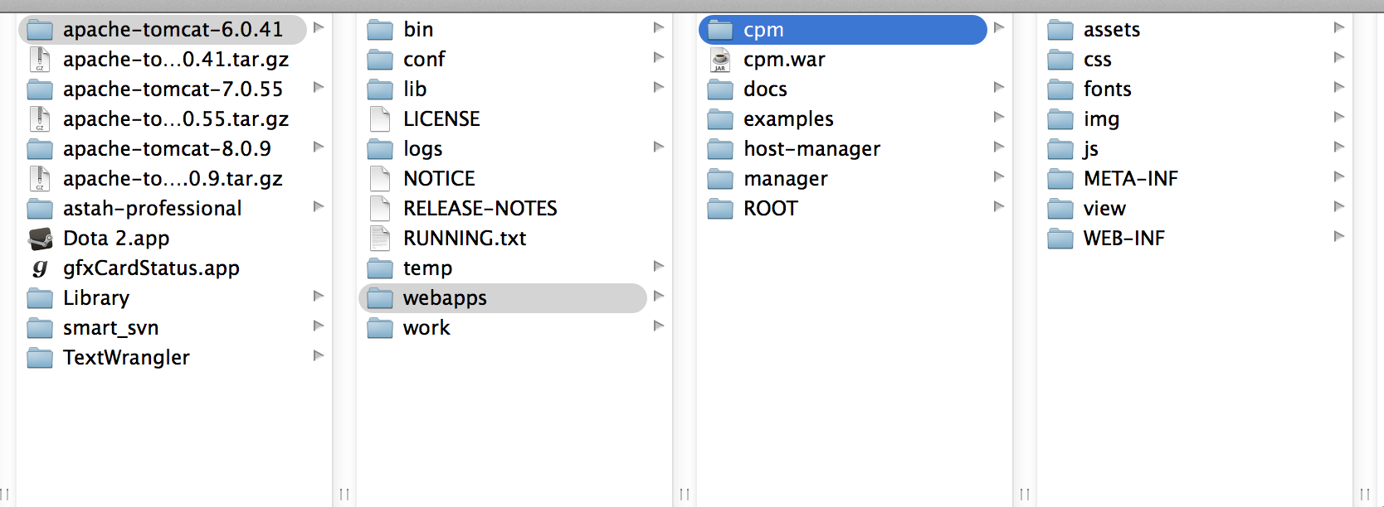

Figure 75: CPM package and deploy directory

#### Deploy database

* Install MySQL into the server.
* Copy script file onto directory of the deploy server.
* Using command line to dump script into MySQL to create database for the CPM system.
* Command: mysql –u [user_name] –p –h [mysql_host] cpm < CPM_database_dump.sql

Example: Run mysql in localhost, user name of mysql is root, password is 12345. So we has command like below:

mysql –u root –p –h localhost cpm < CPM_database_dump.sql

### Deploy at client side

* Change setting to install unknown source apk. Go to Setting / Security, tick check box Unknow sources.

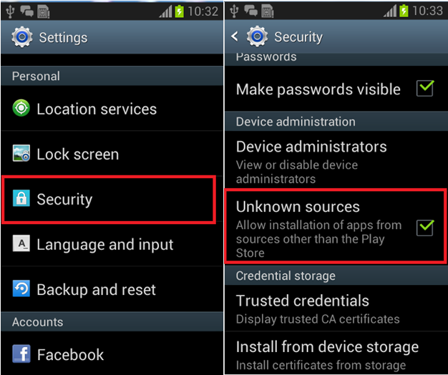

Figure 76: Installation - Change security setting

Download apk setup file at: <http://www.mediafire.com/download/9py50d0t1re1pwx/arbmobileapp.apk>. Copy to sdcard:

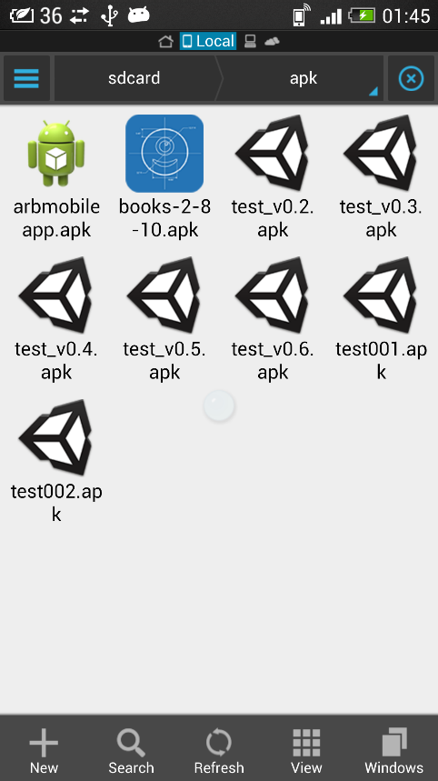

Figure 77: Installation - Copy arbmobile.arb to sdCard

Open arbmobileapp.apk file. Choose package installer.

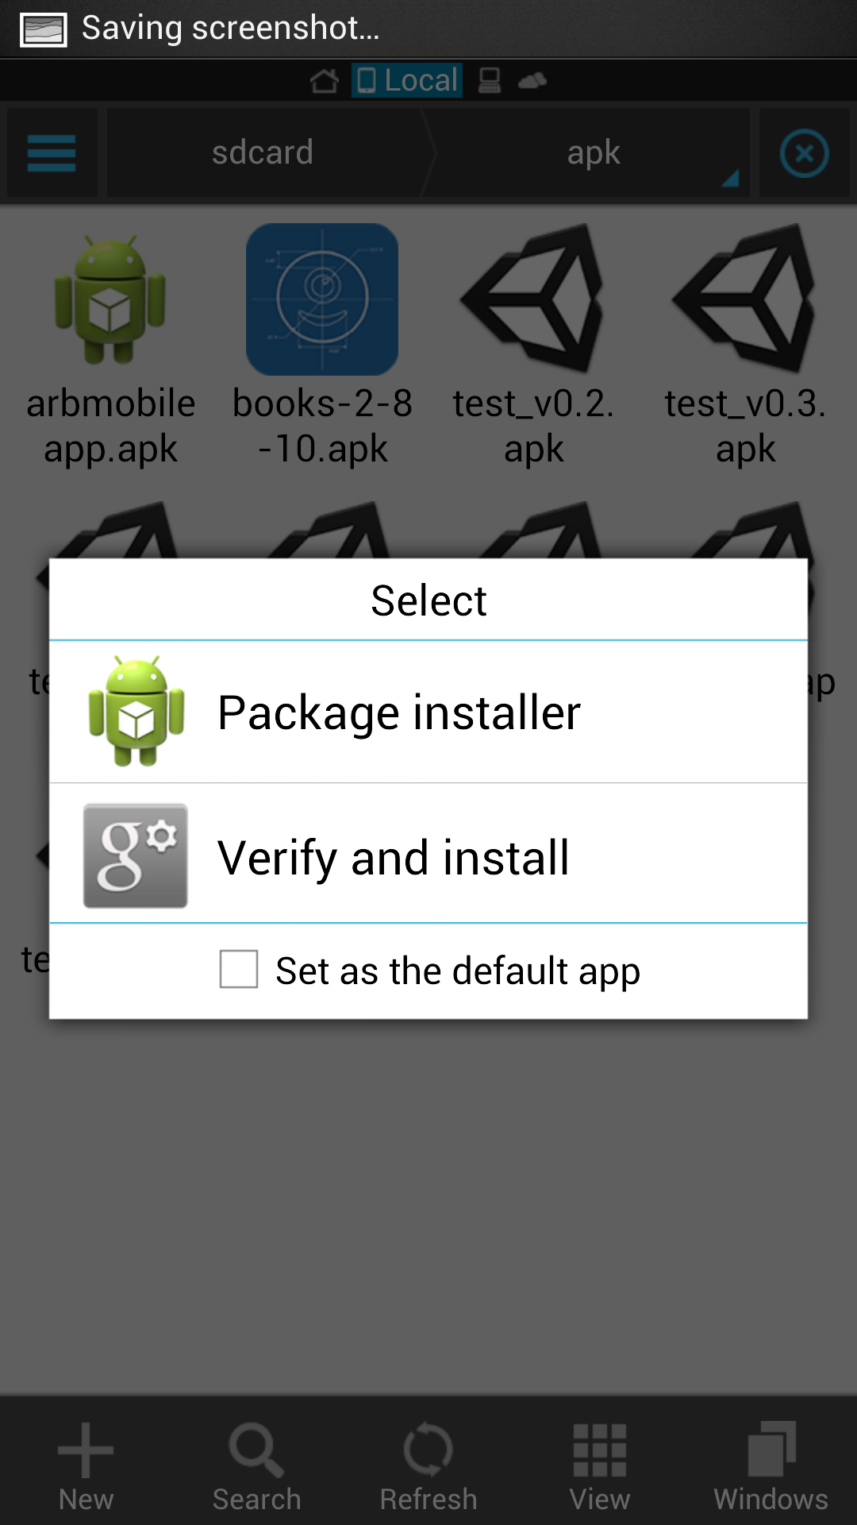

Figure 78: Installation - choose package installer

Choose install application

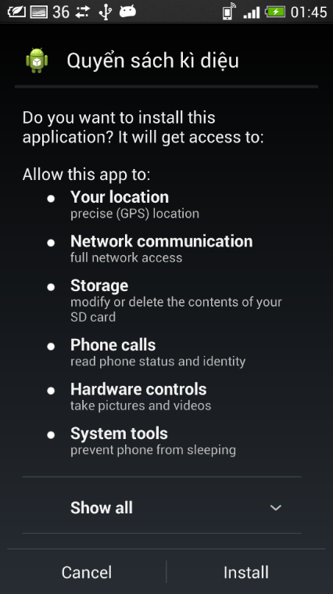

Figure 79: Installation - Instal Mobile App

Install completed

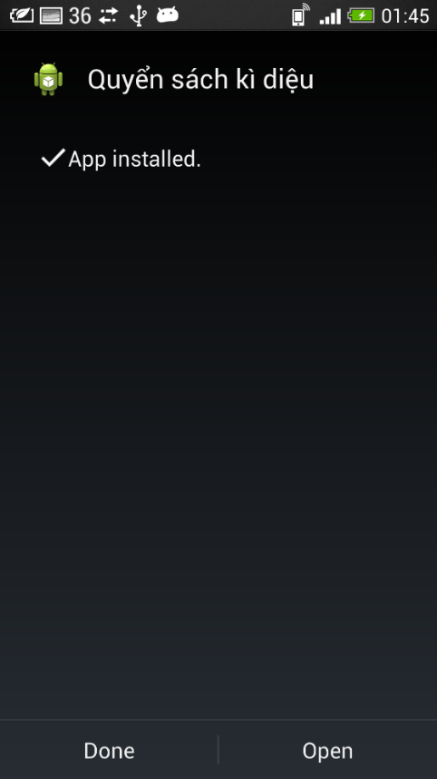

Figure 80: Finish install

## User Guide

The user guide is based on the normal workflow of the system

### Web application guide

#### Login



Figure 81: Login Page

|  |  |
| --- | --- |
| **Step** | **Description** |
| 1 | Click “**Đăng nhập**” on menu bar to go to login page |
| 2 | Fill “Username” and “Password” |
| 3 | Click button “Login” |

Table 52: Login Steps

#### Setting schedule

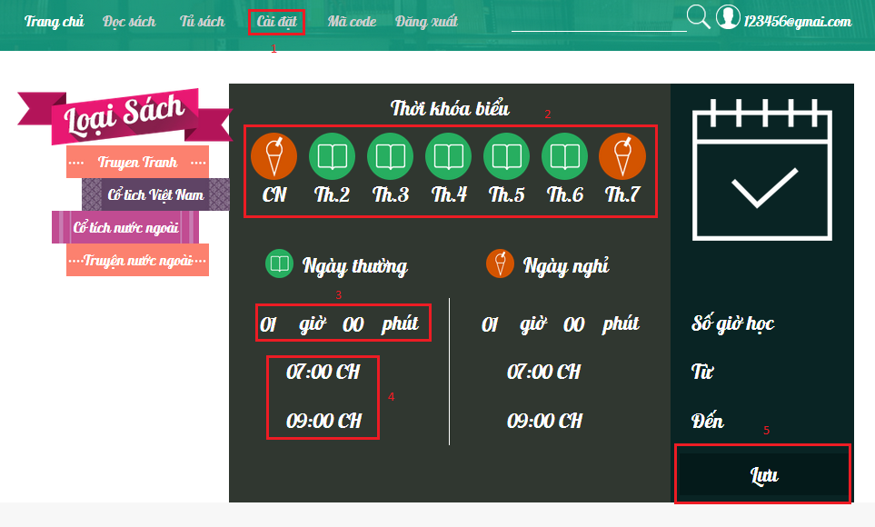

Figure 82: Setting schedule page

|  |  |
| --- | --- |
| **Step** | **Description** |
| 1 | Click “**Cài đặt**” button on menu bar to go to setting page |
| 2 | Select working day and holiday day |
| 3 | Select duration time |
| 4 | Select “from” time and “to” time |
| 5 | Click “Lưu” button to save setting |

Table 53: Setting schedule Steps

#### Recognize book



Figure 83: Recognize UI

|  |  |
| --- | --- |
| **Step** | **Description** |
| 1 | Click “Đọc sách” button on menu bar to go to Recognize page |
| 2 | Put image which is image of book to camera to recognize |

Table 54: Recognize steps

#### Read book

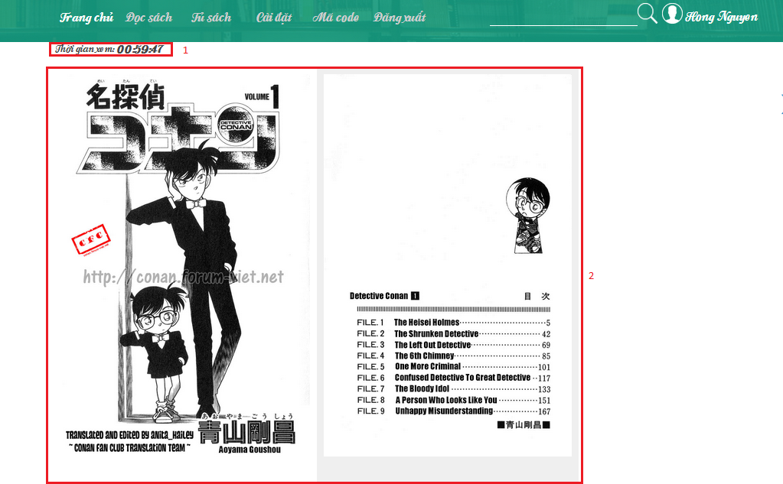

Figure 84: Read book page

|  |  |
| --- | --- |
| **Step** | **Description** |
| 1 | Remain time to read book |
| 2 | Ebook to read book |

Table 55: Read book info

#### Update license

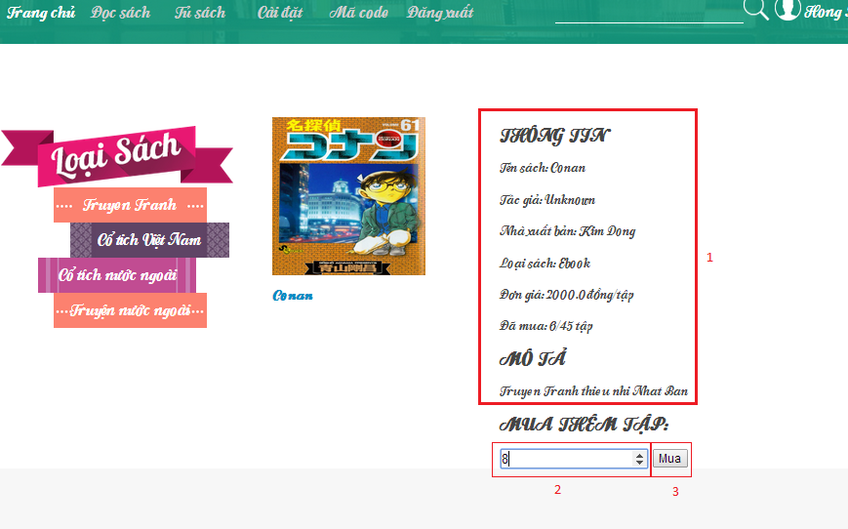

Figure 85: Update license page

|  |  |
| --- | --- |
| **Step** | **Description** |
| 1 | Information of book |
| 2 | Number of chapter which is user wanna update |
| 3 | Click “Mua” button to update license |

Table 56: Update license info

#### View Cart

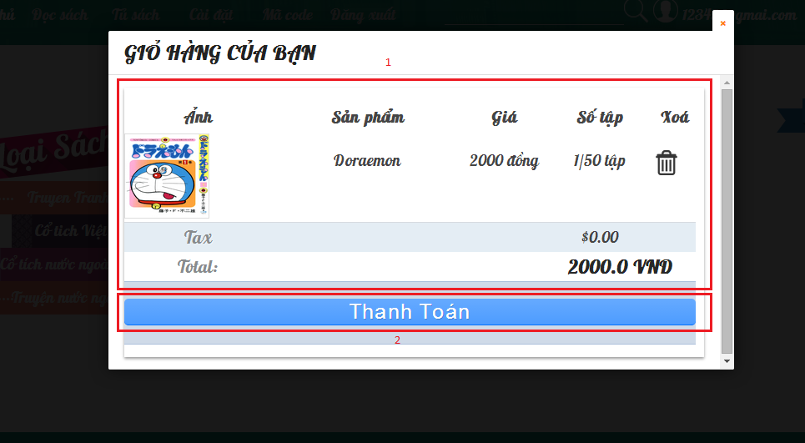

Figure 86: View Cart Page

|  |  |
| --- | --- |
| **Step** | **Description** |
| 1 | View cart info |
| 2 | Click button “Thanh toán” to buy book |
| 3 | Click Delete icon to remove book from cart |

Table 57: View Cart Info

### Mobile User Guide

#### <Guest> Login



**2**

**1**

**3**

Figure 87: Mobile App – Login user guide

|  |  |
| --- | --- |
| **Step** | **Description** |
| 1 | Click “**Đăng nhập**” on slider bar to go to login page |
| 2 | Fill “Username” and “Password” |
| 3 | Click button “Login” |

Table 58: Mobile App - Login user guide steps

#### <User/ Guest> Recognize book



**1**

Figure 88: Mobile App - Recognize book user guide

|  |  |
| --- | --- |
| **Step** | **Description** |
| 1 | User put camera on image to recognize image |

Table 59: Mobile App - Recognize book user guide steps



**1**

Figure 89: Mobile App - Book detail user guide

|  |  |
| --- | --- |
| **Step** | **Description** |
| 1 | User click on “Đọc sách” to go to read book page |

Table 60: Mobile App - Read book user guide steps



**2**

**1**

Figure 90: Mobile App - Enter license code user guide

|  |  |
| --- | --- |
| **Step** | **Description** |
| 1 | User fill license code |
| 2 | Click on “OK” button to confirm and check license |

Table 61: Mobile App - Enter license code user guide steps

#### <User/ Guest> Read book – Read ebook



**2**

**1**

Figure 91: Mobile App - Read ebook user guide

|  |  |
| --- | --- |
| **Step** | **Description** |
| 1 | Click on previous button to go to previous chapter |
| 2 | Click on next button to go to next chapter |

Table 62: Mobile App - Read ebook user guide steps

#### <User/ Guest> Read book – Watch video



**2**

**1**

Figure 92: Mobile App - watch video user guide

|  |  |
| --- | --- |
| **Step** | **Description** |
| 1 | Click on previous button to go to previous chapter |
| 2 | Click on next button to go to next chapter |

Table 63: Mobile App - watch video user guide steps

#### <User/ Guest> Read book – Play audio



**4**

**3**

**2**

**1**

Figure 93: Mobile App - Play audio user guide

|  |  |
| --- | --- |
| **Step** | **Description** |
| 1 | Click on previous button to go to previous chapter |
| 2 | Click on next button to go to next chapter |
| 3 | Click on play button to play audio |
| 4 | Click on process bar to play an identify time |

Table 64: Mobile App - Play audio user guide steps

#### <User>Configure schedule



**2**

**1**

Figure 94: Mobile App - Enter secondary password user guide

|  |  |
| --- | --- |
| **Step** | **Description** |
| 1 | Fill secondary password |
| 2 | Click OK button to check secondary password |

Table 65: Mobile App - Enter secondary password user guide steps



2

1

3

Figure 95: Mobile App - Set schedule user guide

|  |  |
| --- | --- |
| **Step** | **Description** |
| 1 | Choose duration, start time, end time of holiday (or working day) |
| 2 | Choose which day is working day |
| 3 | Click “Lưu” button to save schedule. |

Table 66: Mobile App - Set schedule user guide steps



**2**

**1**

Figure 96: Mobile App - choose time user guide

|  |  |
| --- | --- |
| **Step** | **Description** |
| 1 | Choose time |
| 2 | Click “Done” button |

Table 67: Mobile App - choose time user guide steps



**2**

**1**

Figure 97: Mobile App - Choose working day user guide

|  |  |
| --- | --- |
| **Step** | **Description** |
| 1 | Check in working day |
| 2 | Click on “OK” button |

Table 68: Mobile App - choose working day steps

#### 3D Dictionary



**1**

Figure 98: Mobile App - Recognize image 3D user guide

|  |  |
| --- | --- |
| **Step** | **Description** |
| 1 | Put camera on image to recognize |

Table 69: Mobile App - Recognize image 3D user guide steps



**1**

Figure 99: Mobile App - 3D model user guide

|  |  |
| --- | --- |
| **Step** | **Description** |
| 1 | Touch on 3D model to change state and play sound |

Table 70: Mobile App - 3D model user guide steps

# Appendix

1. Vuforia platform: <https://developer.vuforia.com/resources/api/main>
2. Vuforia SDK architecture: <https://developer.vuforia.com/resources/dev-guide/vuforia-ar-architecture>
3. JSAR Toolkit: <http://www.html5rocks.com/en/tutorials/webgl/jsartoolkit_webrtc/>